

**AHSANULLAH UNIVERSITY OF SCIENCE AND TECHNOLOGY**

DEPARTMENT

OF

ELECTRICAL AND ELECTRONIC ENGINEERING

LAB REPORT

COURSE NO : EEE 2226

COURSE NAME : Numerical Technique Laboratory

EXPERIMENT NO : 01

DATE OF SUBMISSION : 14/07/2025

Submitted by :

Name : Rafayet Ahammad

ID : 20230105206

Year : 2nd

Semester : 2nd

Section : D(2)

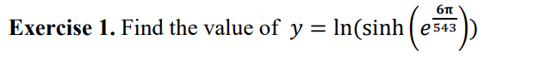

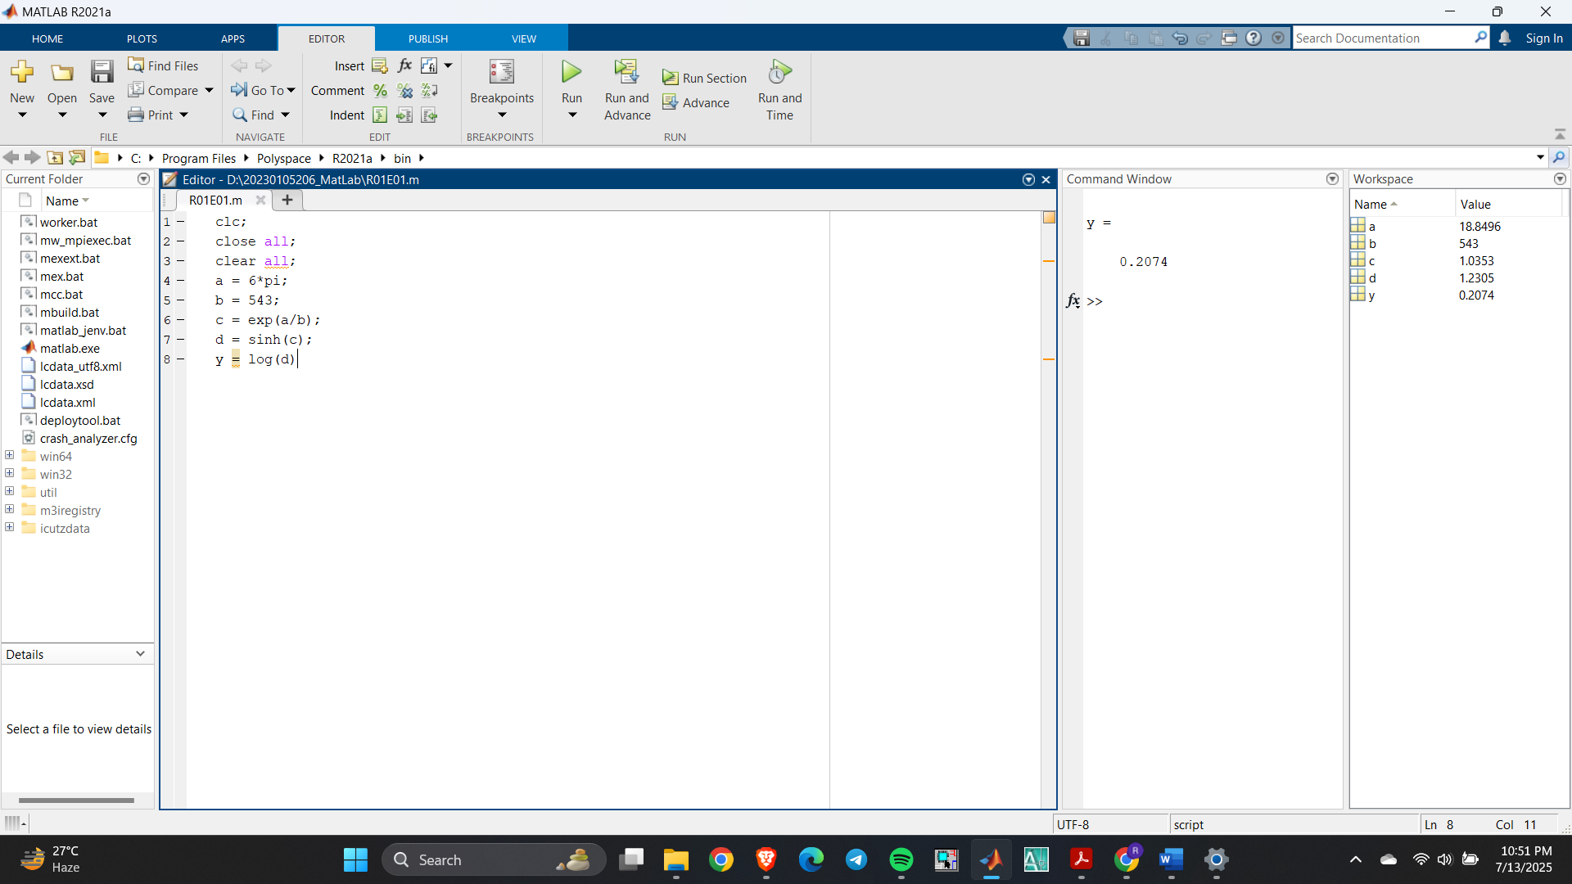



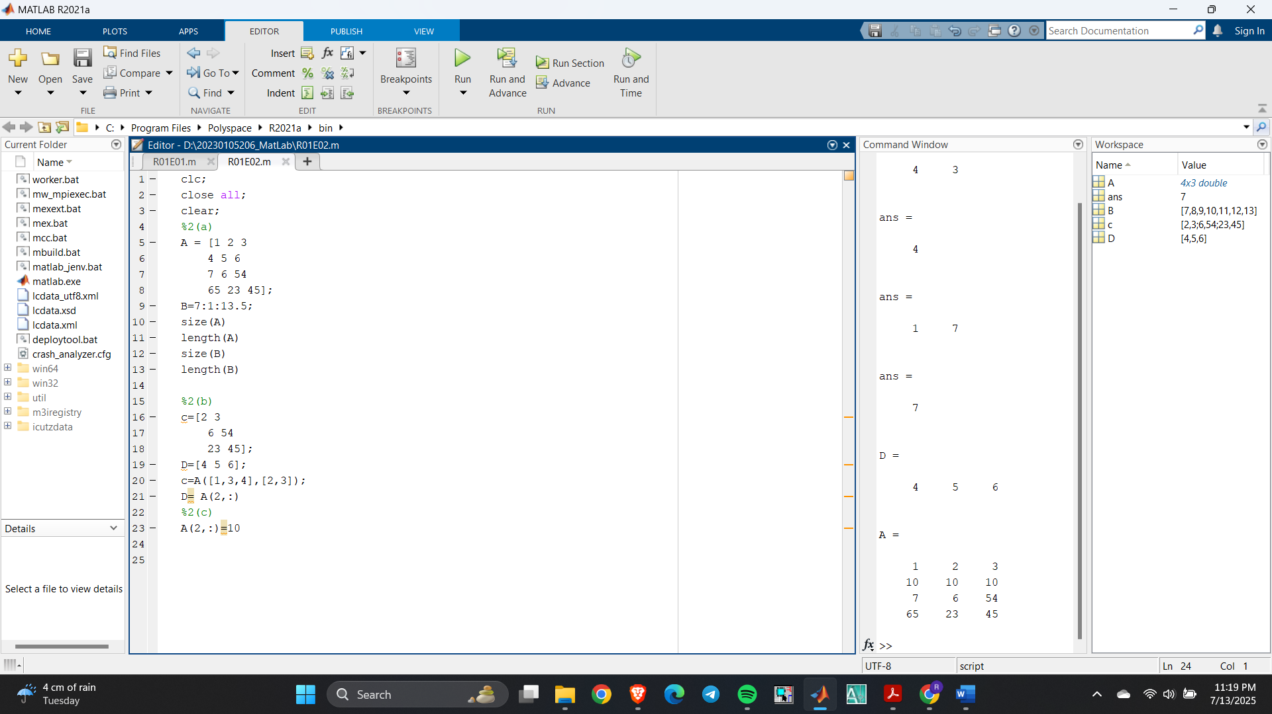

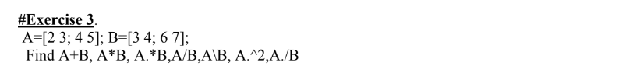

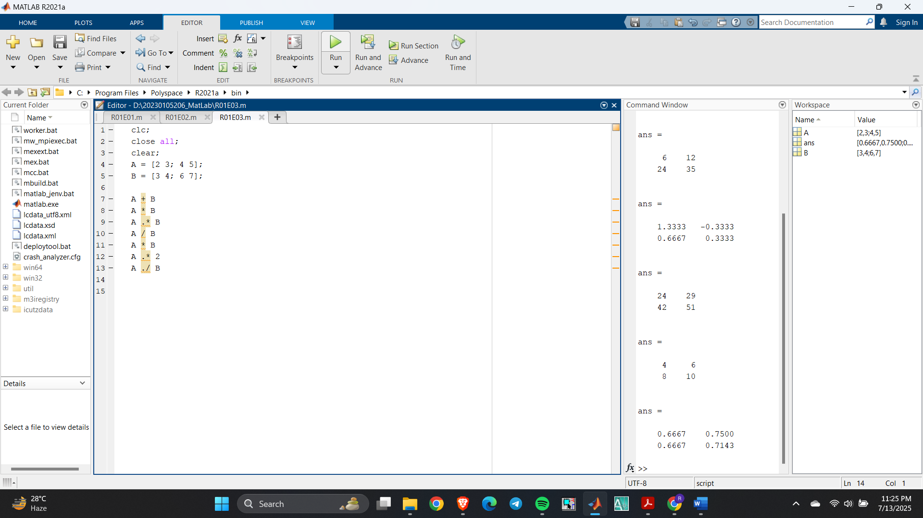



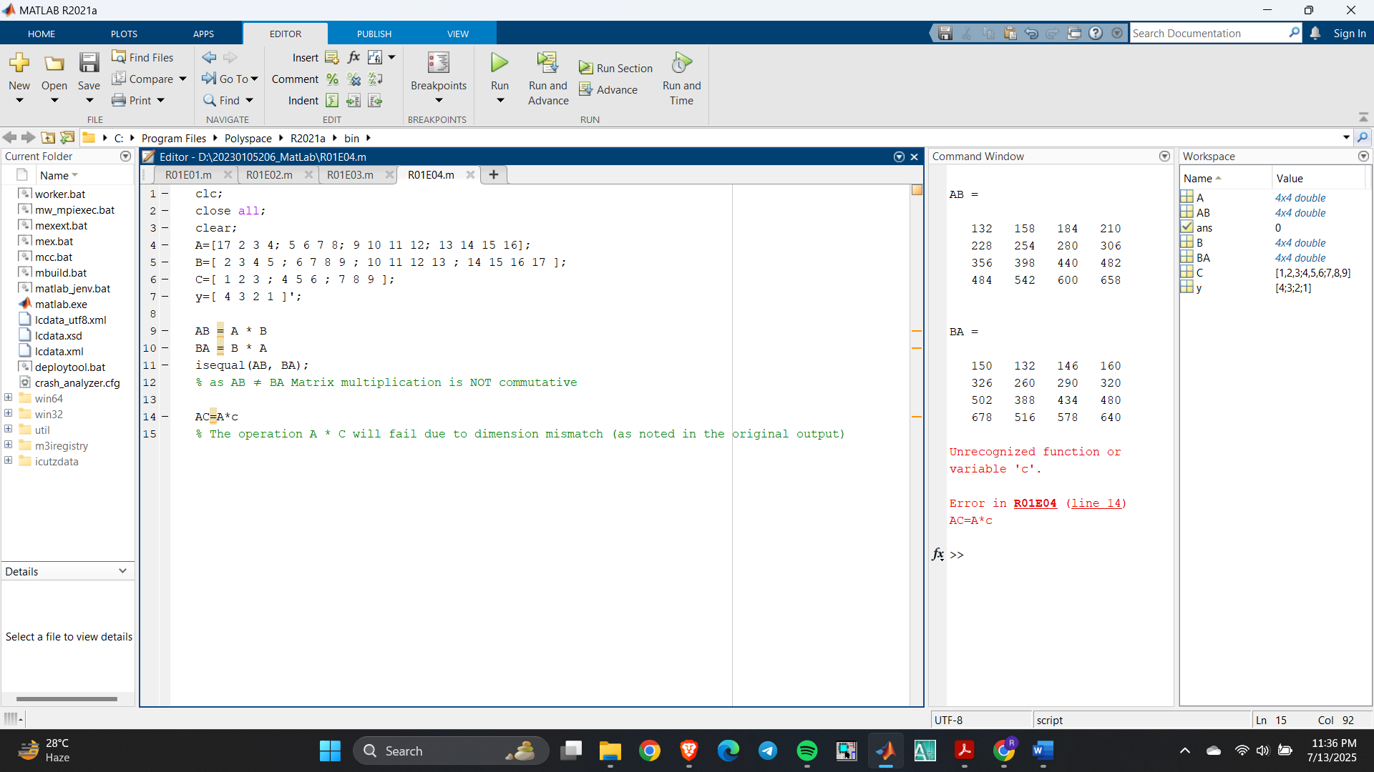



For (b) using mesh analysis,

Loop_1: 3i1 - i2 - 2i3 = 1

Loop_2: i1 - 6i2 + 3i3 = 0

Loop_3: 2i1 + 3i2 - 6i3 = - 6

