

**AHSANULLAH UNIVERSITY OF SCIENCE AND TECHNOLOGY**

DEPARTMENT

OF

ELECTRICAL AND ELECTRONIC ENGINEERING

LAB REPORT

COURSE NO : EEE 2226

COURSE NAME : Numerical Technique Laboratory

EXPERIMENT NO : 04

DATE OF SUBMISSION : 22/07/2025

Submitted by :

Name : Rafayet Ahammad

ID : 20230105206

Year : 2nd

Semester : 2nd

Section : D(2)



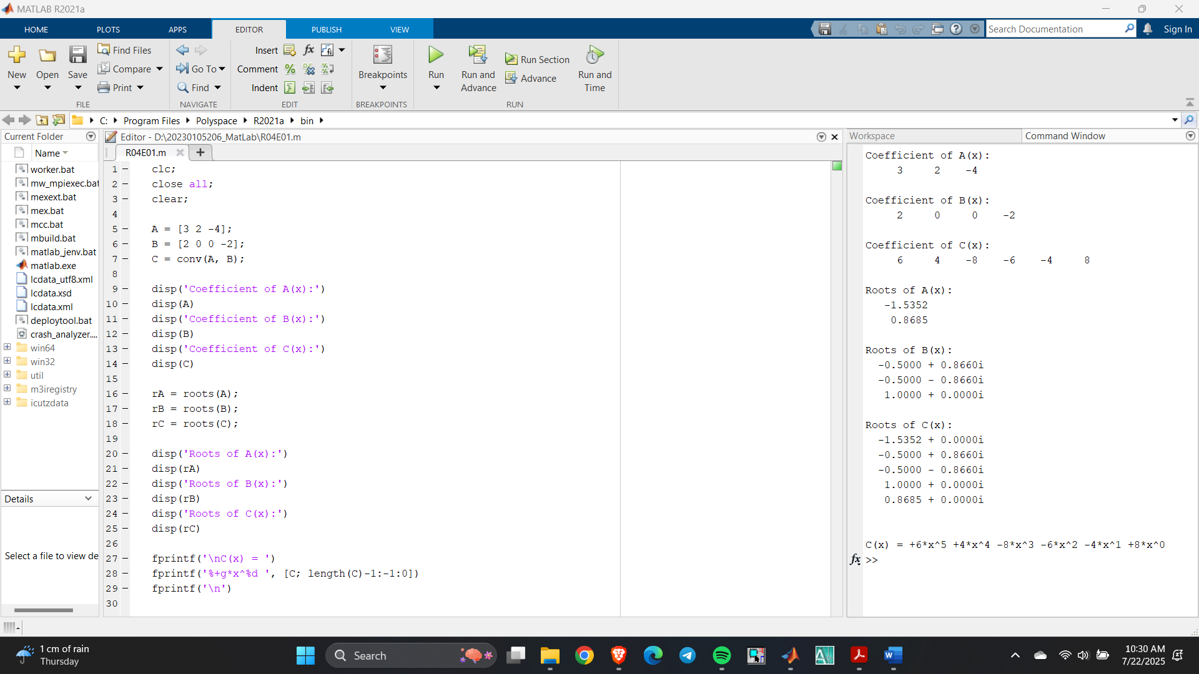





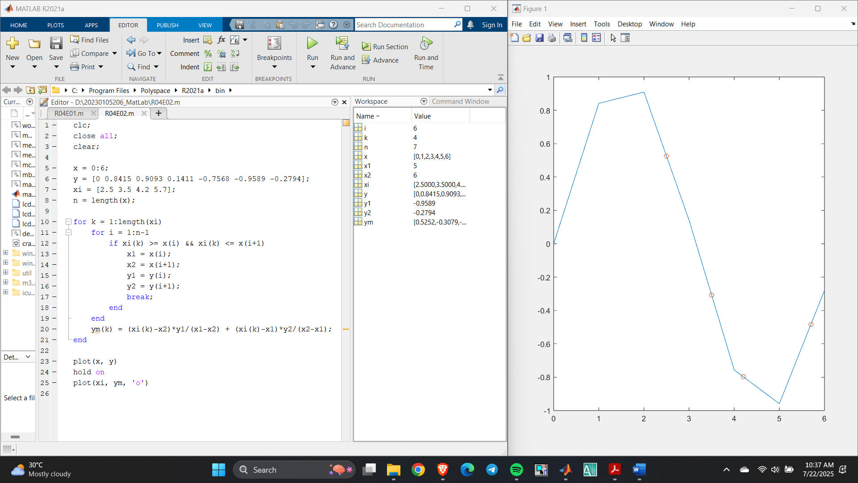



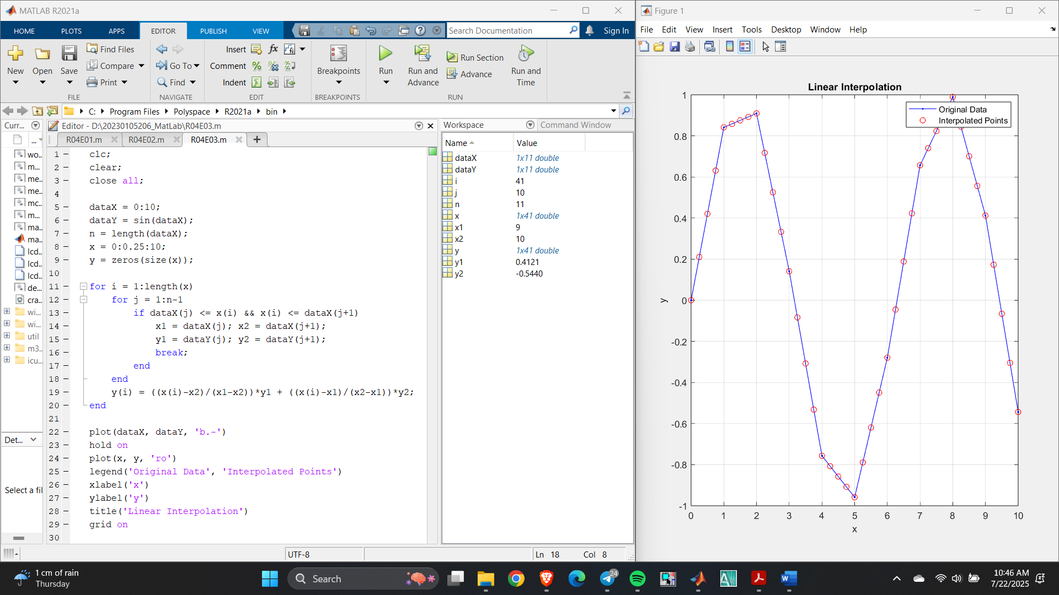

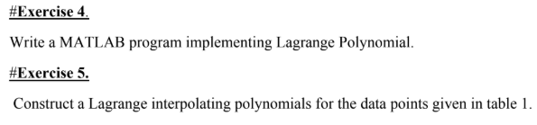



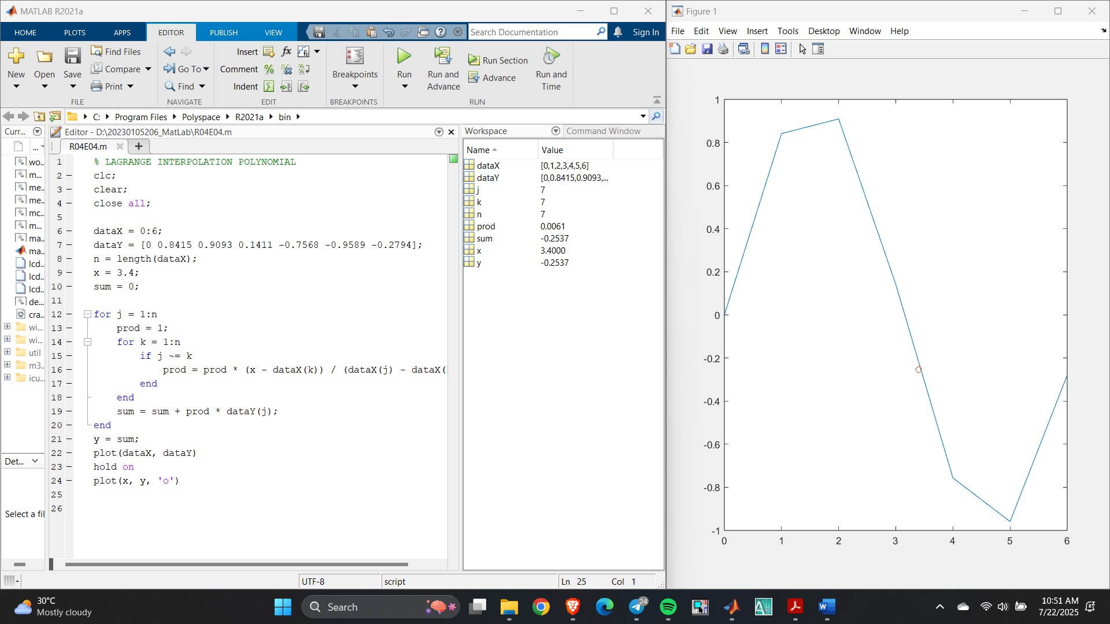Taking random value X=3.4;

some random values of x (here x = [2.5 3 3.5 4 4.5] is taken)

