

**AHSANULLAH UNIVERSITY OF SCIENCE AND TECHNOLOGY**

DEPARTMENT

OF

ELECTRICAL AND ELECTRONIC ENGINEERING

LAB REPORT

COURSE NO : EEE 2226

COURSE NAME : Numerical Technique Laboratory

EXPERIMENT NO : 05

DATE OF SUBMISSION : 22/08/2025

Submitted by :

Name : Rafayet Ahammad

ID : 20230105206

Year : 2nd

Semester : 2nd

Section : D(2)

1.Positive and negative roots of non-linear equations:

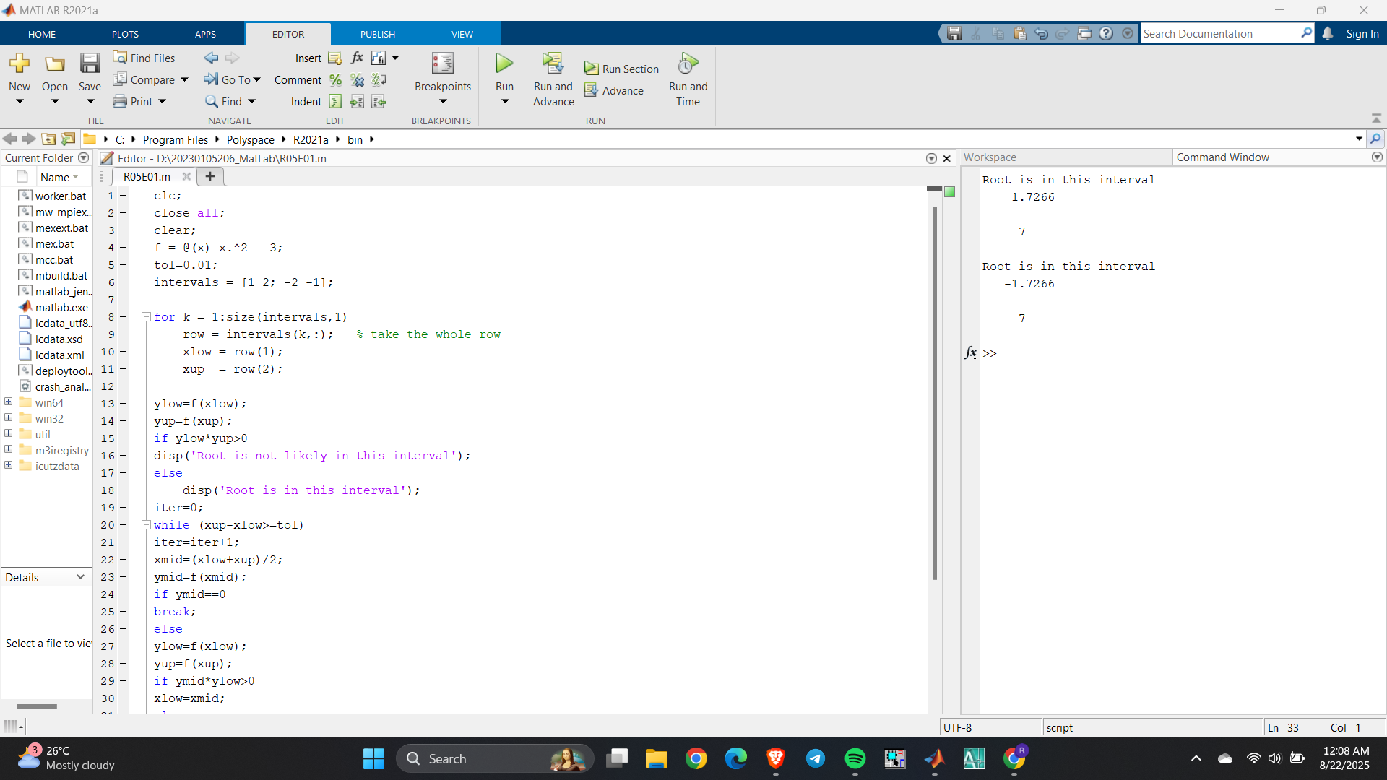

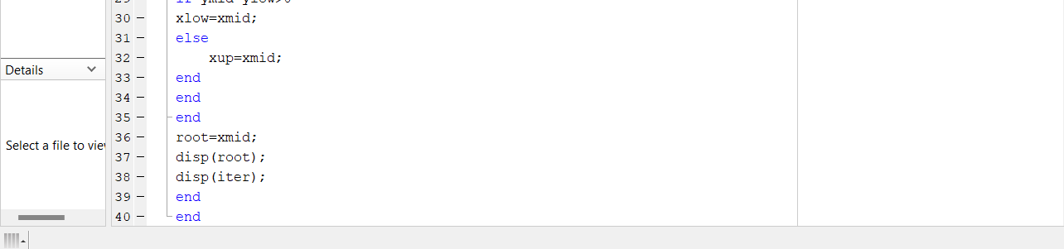

2. Equation with imaginary roots can’t be solved using bisection method or false position method.