

**AHSANULLAH UNIVERSITY OF SCIENCE AND TECHNOLOGY**

DEPARTMENT

OF

ELECTRICAL AND ELECTRONIC ENGINEERING

LAB REPORT

COURSE NO : EEE 2226

COURSE NAME : Numerical Technique Laboratory

EXPERIMENT NO : 07

DATE OF SUBMISSION : 24/09/2025

Submitted by :

Name : Rafayet Ahammad

ID : 20230105206

Year : 2nd

Semester : 2nd

Section : D(2)

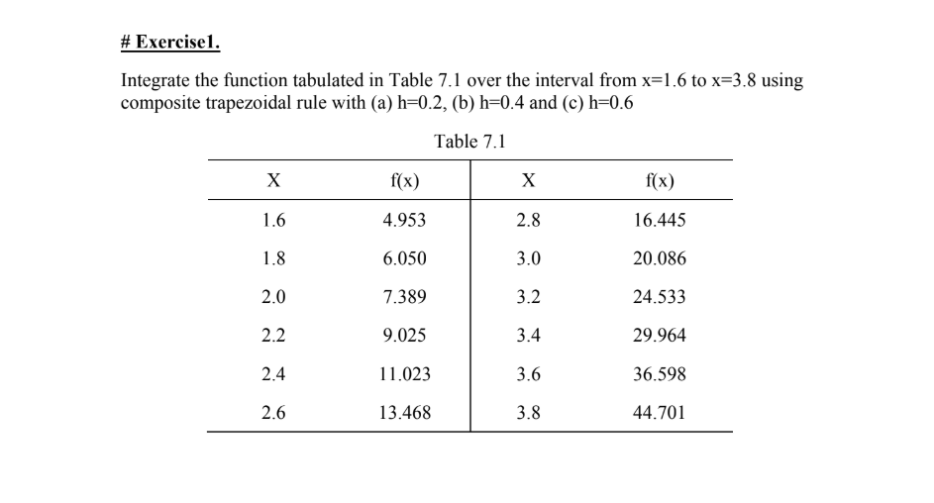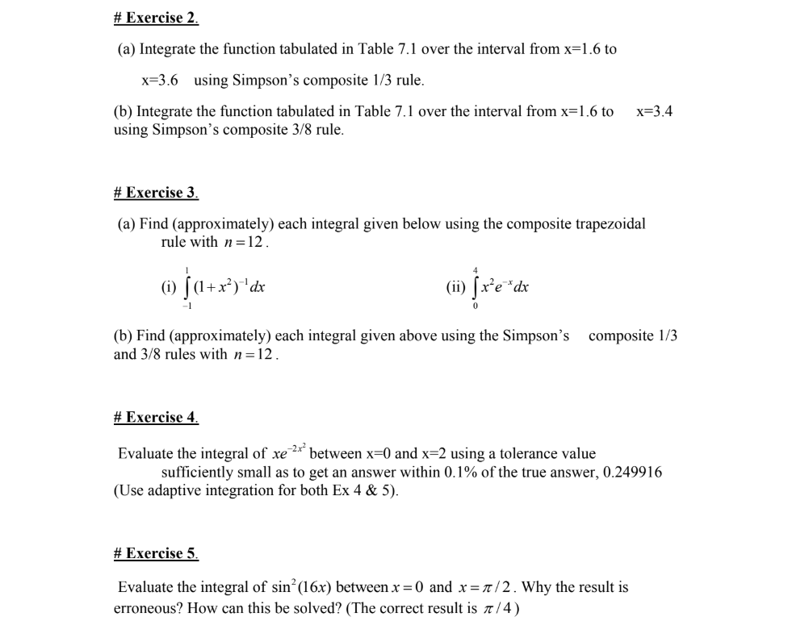

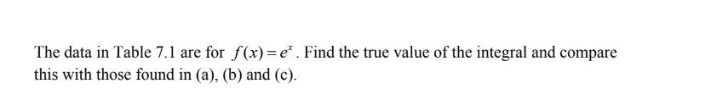

Excercise01:

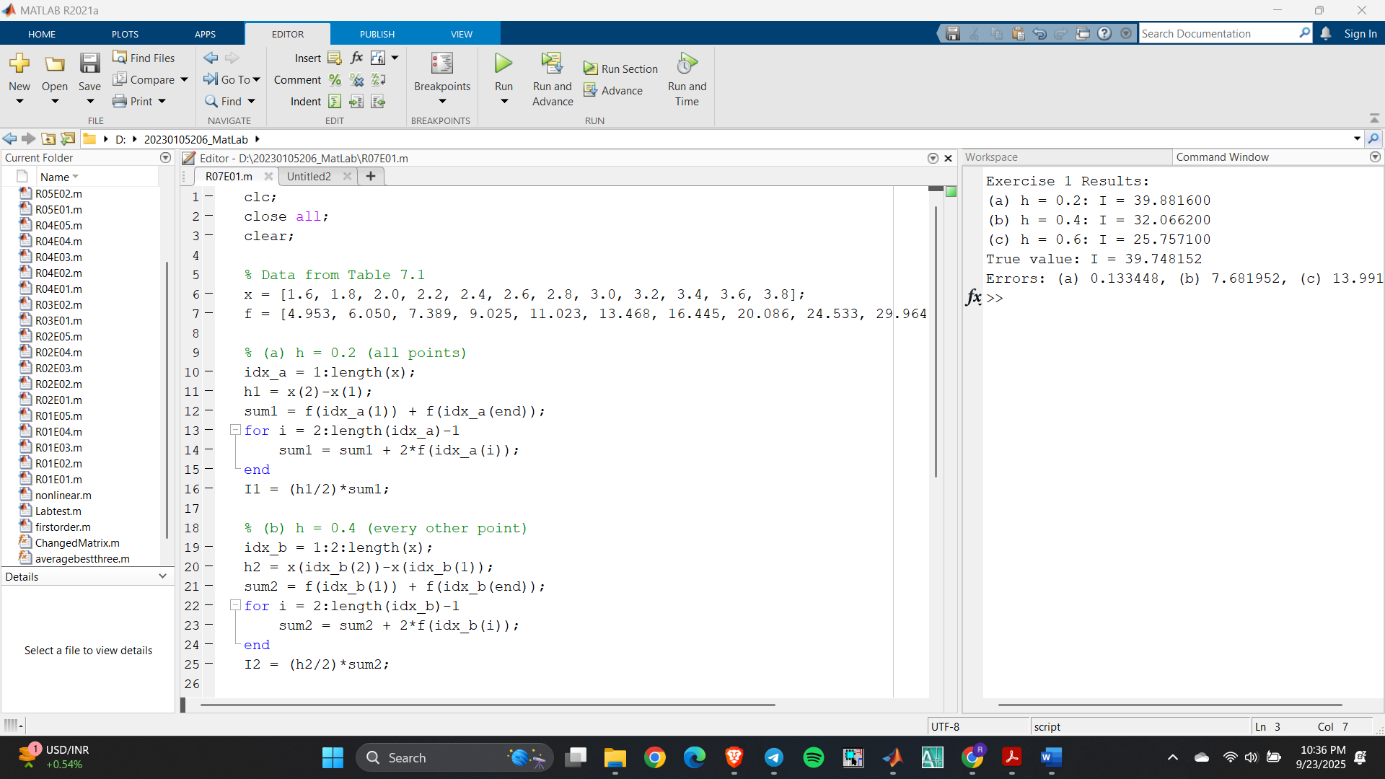

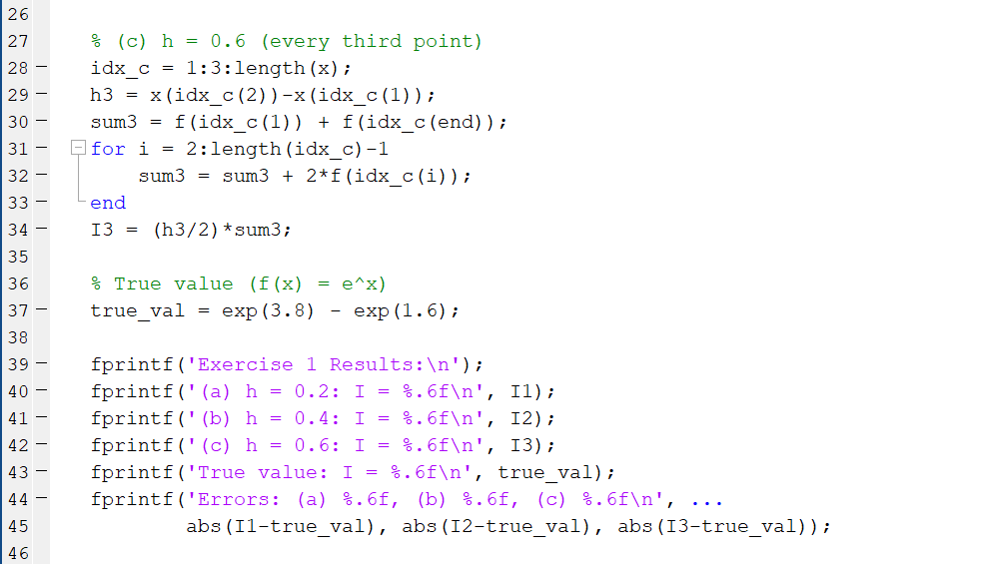

Excercise02:

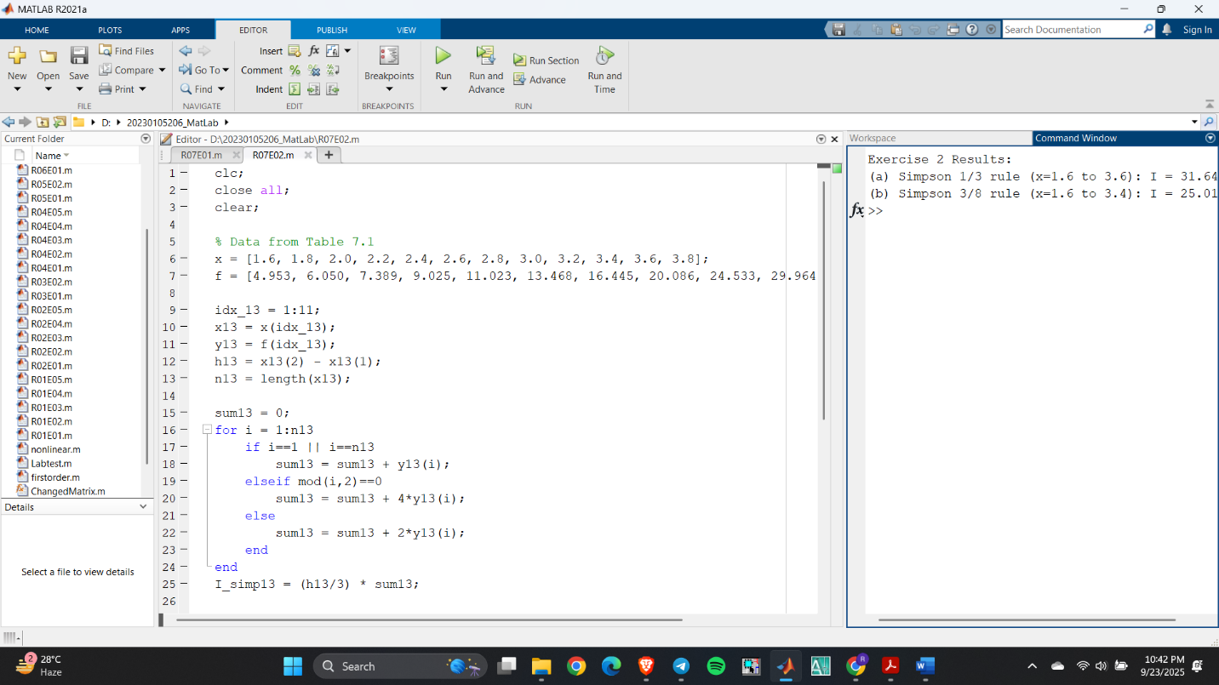

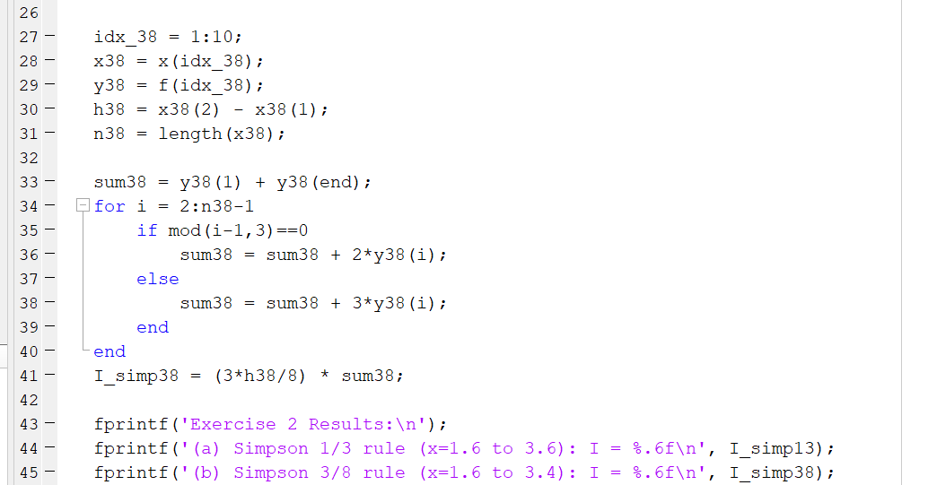

Exercise 03:

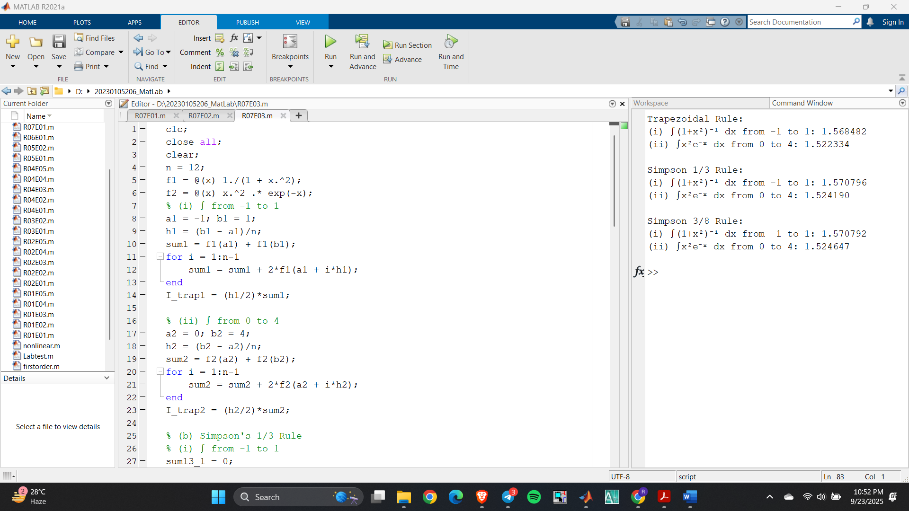

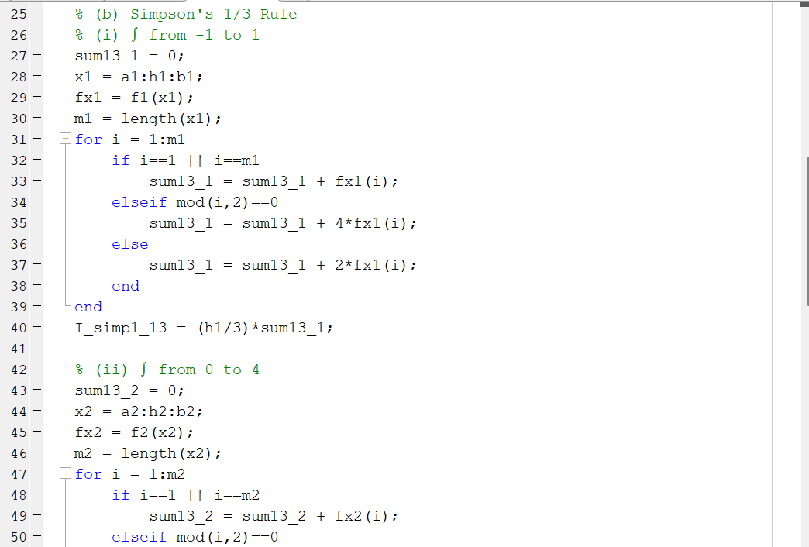

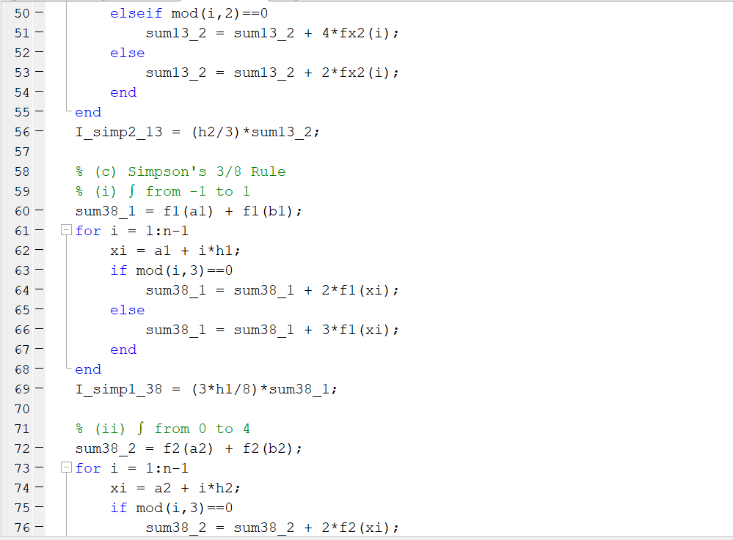

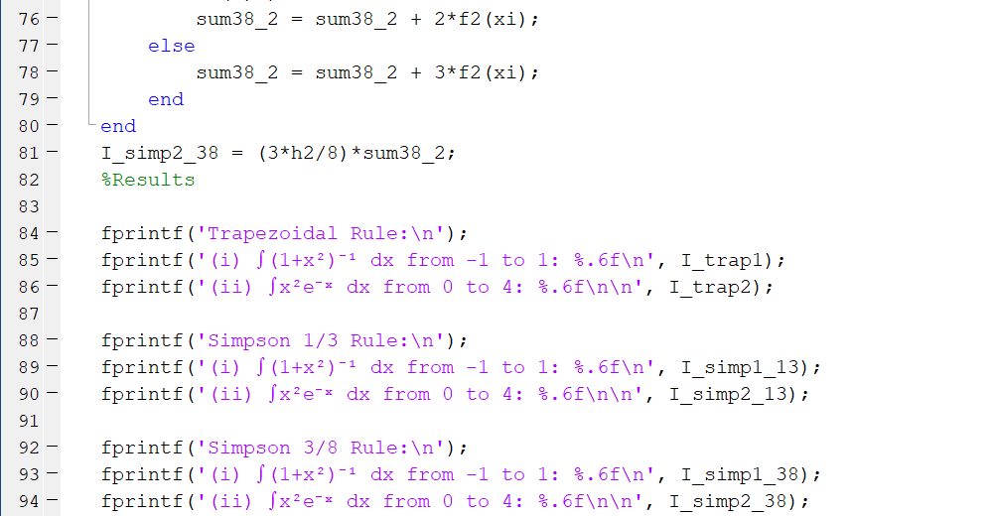

Exercise 04:

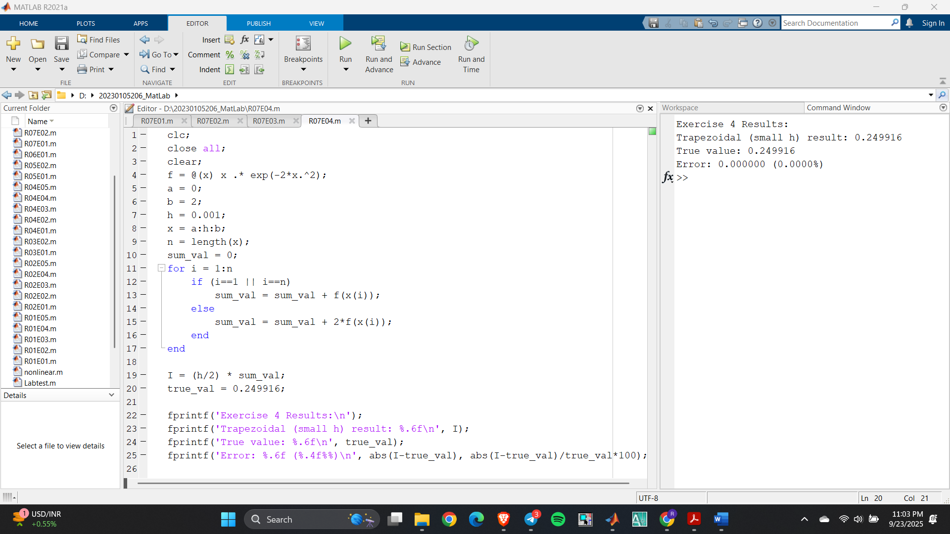

Exercise 05:

