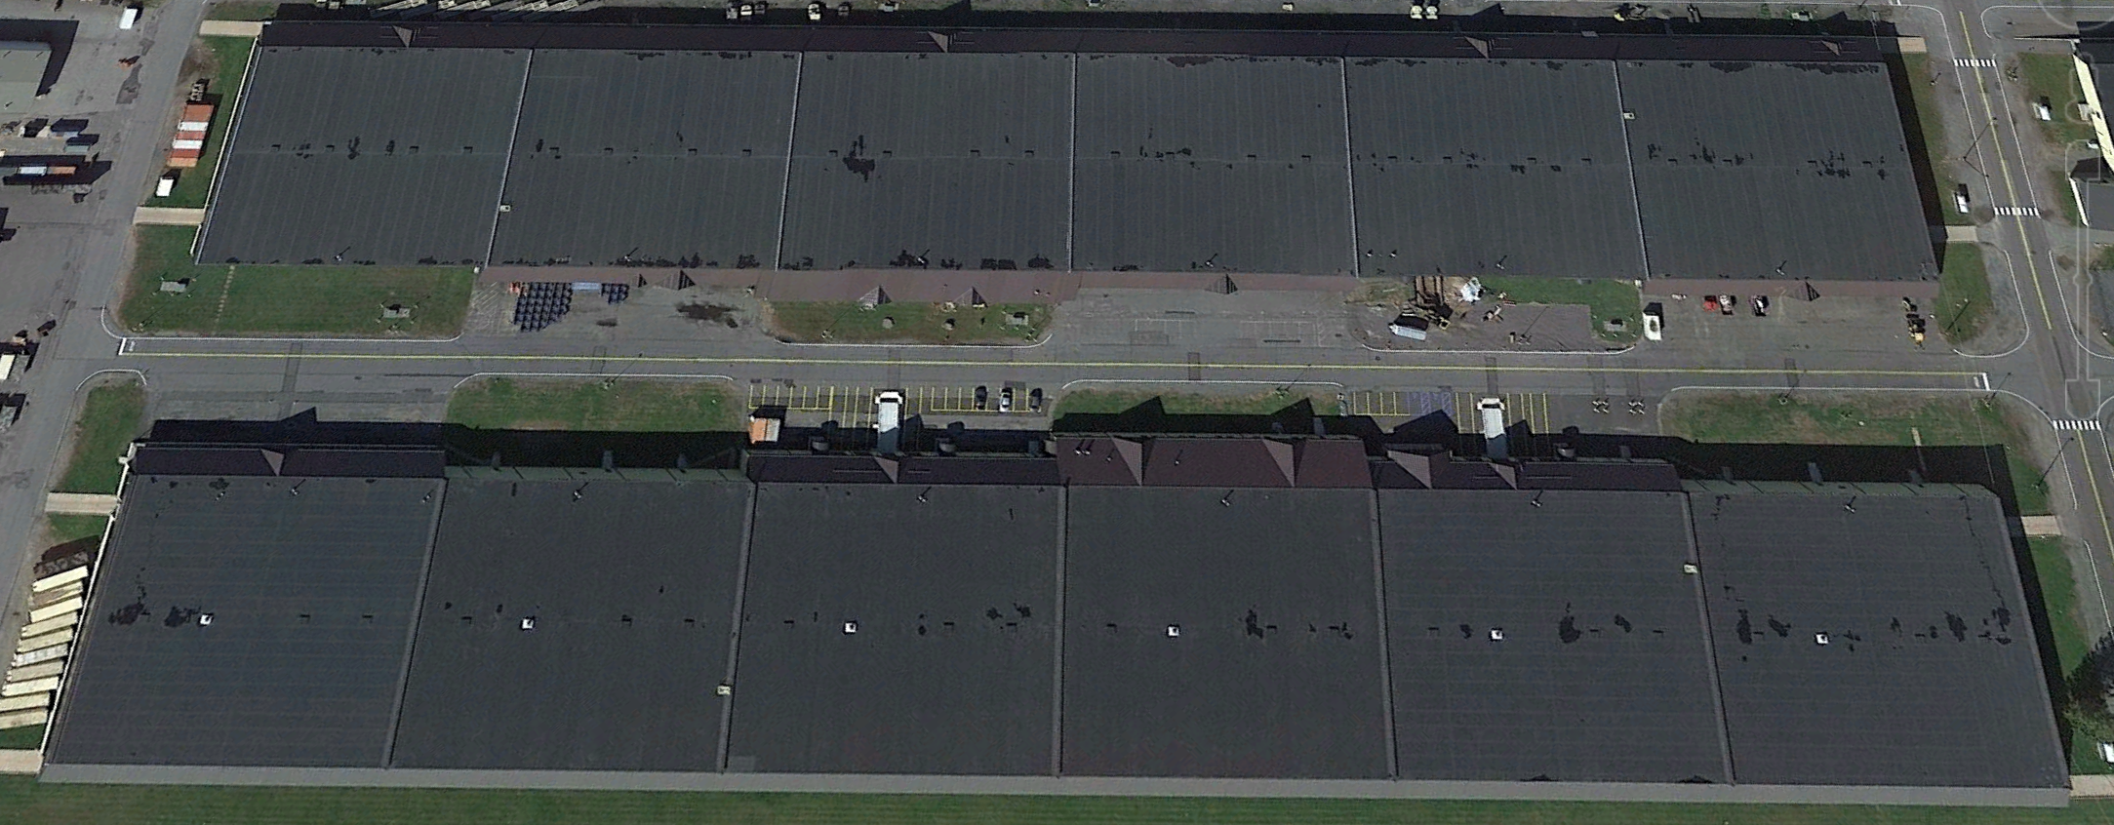
2-6

2-5

2-4

2-3

2-2

2-1

2
1

1-1

1-2

1-3

1-4

1-5

1-6

The above ESH is just an example. It is not located at Thun. Thun is used only for a hypothetical model. No data provided in this response is authentic in any manner and except that actual facilities and manufacturers are used to generate a random data sample. To avoid any confusion the dataset used to generate the models and exhibits in our response will not be shared in detail. The models where built strictly to provide tangible demonstration of LavaPi’s capabilities and concepts and for no other reason.

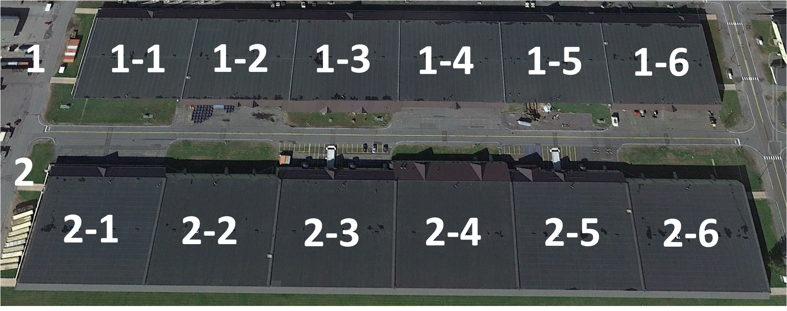

Security
Offline Database
Encryption
Cost Effectiveness
Robustness
Interoperability
To build a warehouse data entry solution within Microsoft where data is collected by individuals who are at off-site warehouses, there are several steps you can take:

- Design the Access database: Start by designing the Access database that will hold the data. Identify the tables, fields, and relationships needed to store the data.

- Create forms for data entry: Use Microsoft Forms to create forms for data entry. You can create custom forms for each warehouse that captures the specific data that needs to be collected. Forms can be created quickly and easily, and can be customized to fit your needs.

- Use Excel for data entry: For those who prefer to use Excel for data entry, create an Excel template that matches the fields in the Access database. Users can then fill out the Excel template and send it via email to the administrator of the central server.

- Use PowerApps for data entry: PowerApps is another great tool for data entry. Create a custom app that matches the fields in the Access database. Users can then fill out the app and send the data to the administrator of the central server.

- Set up a secure server: Set up a single, secure stand alone server to host the Access database. This server should have adequate security measures in place to protect the data.

- Collect the data: Once the forms, Excel templates, and PowerApps are created, distribute them to the warehouse staff. Users can then collect the data and send it to the administrator of the central server either via email or on a USB stick.

- Import the data: Once the data is received, the administrator can import it into the Access database. This can be done manually or using an automated process.

- Analyze the data: Once the data is in the Access database, you can use it to generate reports and analyze the data to make informed decisions.

By following these steps, you can build a warehouse data entry solution entirely within Microsoft and ensure that the data is collected securely and efficiently.

What is the cost range of a MS PowerApp enterprise license?
The cost of a Microsoft Power Apps enterprise license varies depending on the subscription plan and number of users. As of February 2023, the pricing for Power Apps per user per month ranges from $40 to $60. However, Microsoft also offers volume discounts for larger organizations. Additionally, there are other licensing options available such as per app/per user and per device licensing. It's recommended to consult with a Microsoft representative or partner to determine the most suitable licensing option and pricing for specific needs.

What is the Cost of MS Access for an enterprise license
As of 2022, Microsoft does not offer an enterprise license specifically for Microsoft Access. Instead, Access is included in some of their subscription plans, such as Microsoft 365 Business Premium and Microsoft 365 Apps for Enterprise. These plans start at $20 per user per month and $8 per user per month, respectively. However, the cost can vary depending on the number of users and the specific plan features that are required by the organization. It's best to check Microsoft's website or contact their sales team for the most up-to-date pricing information.

MySQL (MariaDB) and MS Access/Excel
There are several reasons why using MariaDB is better than MS Access for a global application that needs to be deployed in different types of environments:

- Cost-effective and open licensing: MariaDB is a free, open-source database management system, which means that it can be used without any licensing costs. This is particularly important for applications that need to be deployed in developing or non-western aligned countries, where software licensing costs may be prohibitive. MS Access, on the other hand, is a proprietary software that requires licensing fees.

- Scalability: MariaDB can handle large amounts of data and can scale to meet the needs of a growing application. It can be deployed on different types of servers, including cloud-based servers, which makes it suitable for applications that need to scale rapidly. MS Access, on the other hand, is not designed for large-scale applications and may not be suitable for applications that need to scale rapidly.

- Platform independence: MariaDB is platform-independent and can be run on different types of operating systems, including Windows, Linux, Raspberry Pi, and other operating systems. This makes it suitable for global applications that need to be deployed in different types of environments. MS Access, on the other hand, is a Windows-based application and may not be suitable for applications that need to run on different types of operating systems.

- Security: MariaDB offers robust security features, including encryption, authentication, and authorization, which makes it suitable for applications that handle sensitive data. MS Access, on the other hand, does not offer the same level of security features as MariaDB.

- Performance: MariaDB is known for its high performance and fast data processing capabilities, which makes it suitable for applications that need to process large amounts of data quickly. MS Access may not be able to match the performance of MariaDB for large-scale applications.

In summary, MariaDB is a cost-effective, scalable, platform-independent, secure, and high-performance database management system that is suitable for global applications. While MS Access may be suitable for small-scale applications that run on Windows-based systems, it may not be suitable for large-scale applications that need to be deployed in different types of environments.
Notwithstanding all of the above MariaDB can be made to be 100% interoperable with MS Excel and MS Access for use by the GIHCD. MariaDB supports the ODBC interface, which means that it can be easily connected to MS Excel and MS Access using an ODBC driver. Once the connection is established, the data in the MariaDB database can be used in MS Excel and MS Access as if it were stored in a native MS Office format. This allows for seamless integration of data between MariaDB and MS Office applications, while still taking advantage of the benefits of using a robust and scalable database solution like MariaDB.

Reports and Graphics
Heatmap and Matrix
IATG Section 15.2 provides an example of the Grid Locator Method.
Table 6 is an illustrative Grid Locator for the ESH example in Table 5.
Ammunition Depot: |  |  |  | Greentown
ESH |  | 21 |  | Date: |  | 23/11/09
Grid | 1 | 2 | 3 | 4 | 5 | 6 | 7
A
B
C
D
E
F
G
H
J
K |  |  | X
L
M

Table 6: Grid locator example

LavaPi and the database we are proposing can produce heatmaps to enhance the Grid Method providing for a three dimensional grid whereby in this example 1 meter pallets can be stacked as high as 4 units. The location of each individual pallet is noted in the database as follows ESH Location, Building Number, Floor Location, and Height Location.

Dashboards

Data Entry Interfaces

Specifications

Stockpile data requirements
- The system shall hold a nation’s inventory of ammunition natures in an auditable account

LavaPi has the expertise and capabilities to provide the required database in any number of formats, systems and/or platforms. Including any of the following:
MariaDB | Microsoft Azure
Microsoft Access | Amazon RDS
Oracle (MySQL) | Amazon Aurora
PostgreSQL | Amazon Redshift
SQL Server | Google Cloud
MongoDB | SQLite

Auditing
The binary log in MariaDB is a set of binary files that log all changes to the database, including DDL (Data Definition Language) and DML (Data Modification Language) statements. It records all queries that modify the data, along with the information needed to reproduce them, such as the exact SQL statement, the timestamp, and the user who executed the query.
The binary log can be used for various purposes, such as:
- Data recovery: The binary log can be used to replay transactions and recover data in the event of a crash or other failure.
- Replication: The binary log can be used to replicate changes to other servers in a master-slave or master-master configuration.
- Auditing: The binary log can be used to track changes made to the database, including who made the changes and when.
In terms of tracking who made changes and when, the binary log can record the user who executed a query, as well as the timestamp of when the query was executed. However, it's important to note that the binary log does not provide full auditing capabilities on its own, and additional tools or techniques may be needed for more detailed auditing.

- For each ammunition record the system shall hold
We have already built a sample database containing the required elements in MariaDB which we have linked to MS Access over ODBC. Below is the preliminary data structure for MariaDB and how it looks in MS Access as well.
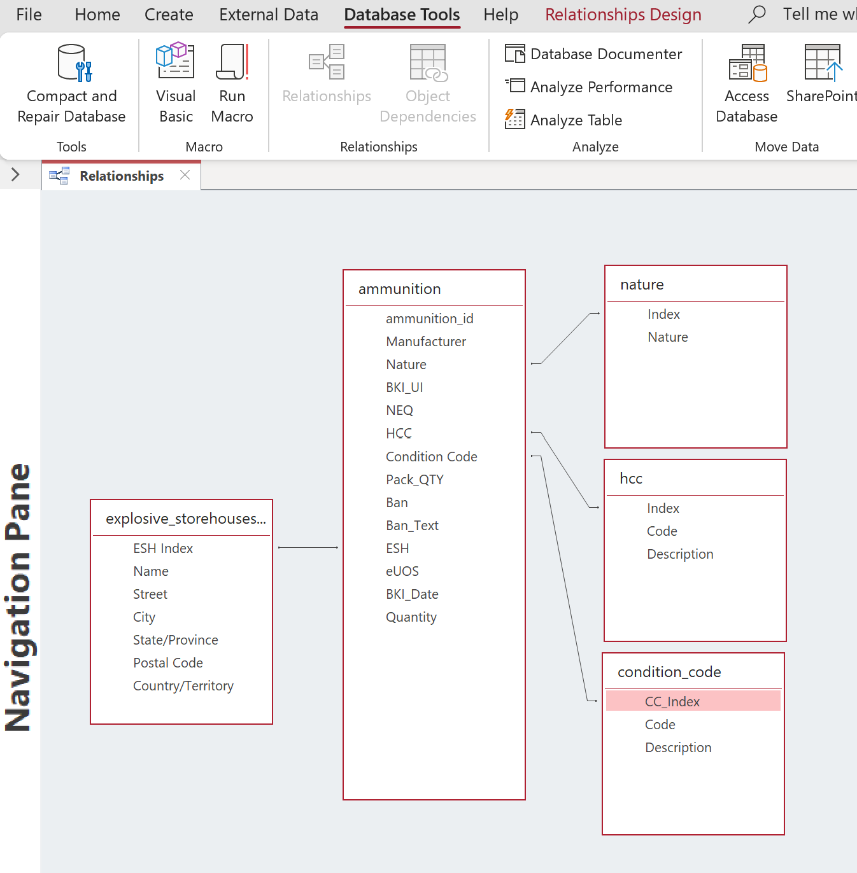

3) The system shall hold and facilitate searches on the following information for each ammunition holding unit or depot:
  - Natures held
    - The Natures are defined in a separate table using a foreign key. This controls and restricts the defined natures to only those in the list which can be amended and extended as required.
  - Quantity of each nature
    - Quantities can be tracked individually, by lot, and by pallet. Other means can be made available as desired by GICHD.
  - Quantity of nature by condition code
    - The condition code is tracked by the same metrics. Date of production and a history of climate conditions and storage can be added for more accurate condition assessment. Over time AI can be applied to the available data to better assess conditions. For example if the ESH includes environmental sensors and logs; these data sets can be added included to derive more accurate predictions on condition and even suggest methods to extend the useful life of stores.
  - Total NEQ for each nature
    - In addition for each Nature, NEQ can be calculated by ESH taking into account individual pallets, a section of pallets, a building and/or the whole facility.
  - Stock holding unit or depot’s name or identifier
    - This is provided. In our example we used a hypothetical set of ESHs using the publicly known in Switzerland.
  - Detail of updates including date
    - Date is provided for date of production, date of placement in ESH, date of movement to other ESH, date of status change, and data of data entry or modification (see binary log)
  - Detail of stock-taking activity
    - A separate table and file can be made of stock taking activities, data. Participants, date(s), time active, sectors, materials, natures, and other activities undertaken.

Introduction.
We at LavaPi are pleased to present a proposal for the AIM
We have already completed an initial mock up of the database as described in the RFQ. The mock-up helped our team understand and embrace the spirit of need and the unique attributes requested. We look forward to working with the AMAT team members and true experts to fine tune and perfect the model. Our expertise is not necessarily in Ammunition Management, although we are studying hard, using IATG, UN SafeGuard, GIHCD, and other reference materials over the last week to enhance our understanding and appreciation for this important work.
We developed a hypothetical world to populate our database using publicly disclosed ESH’s and then generated a number of ammunition datasets to associate with the locations. Then using warehouses from another part of the world we placed them at Thun to demonstrate some of the options available for managing warehouses using the UOS model from IATG 3.10 (2018).
Keys:
  - We recommend open source, but licensed and managed databases to meet the largest set of possible customers
  - In addition to the specifications in the RFQ we offer enhancements for a next generation solution once the initial project is delivered.
  - Excel and Access are directly usable by our proposed MySQL database.
  - We use acronyms and concepts from IATG 1.40 and 3.10

Our founders come from Georgia and are directly impacted by the

In your technical offer, please clarify and address the following points related to the system and the after-delivery services:
- What supporting documentation will the company provide for the system?
LavaPi will provide the following supporting documentation:
- A Project Report that describes the purpose, scope, objectives, and deliverables of the project and update as necessary.
- A General User Guide for the dashboard, query, reporting, and audit engines we developed for GICHD
- A General Data Model and Dictionary
- A Data Interoperability Guide for working with Excel and MS Access
- General Training Materials
- For each client country or entity specific information:
  - Client specific Project Report describing the scope, objectives, deliverables and the modifications made to the Generic Product to meet specific client needs and requirements
  - Client User Guide
    - Hardware As Built
      - Server
      - Data Collection/Transfer Tools (USB, Smartphone, etc)
    - Client Data Model
    - Client Data Dictionary
    - Security Plan
      - admin, user, roles and groups
      - data at rest
    - Training and Reference Materials

- How does the company envisage providing a training package for users of the system?
LavaPi is available to provide on site training, hosted training (where client travels to another location than their home location), and of course training over a Web Interface. The details depend on the needs of the specific client and what if any other assistance and consulting they may require. For example, if the technical capabilities of the country are limited or stressed; LavaPi may need to send a consultant in country to assist with technical decisions related to hardware support, data transfer, data security, etc.

- Please provide a detailed plan for how you would support the system, including any requirements that GICHD/AMAT would be expected to facilitate.
LavaPi is capable of providing Tier 1, 2, and 3 support during agreed upon working hours. If the GICHD and or the Clients require 24-7 support this can be arranged but is not included as part of the initial proposal.

- What are the minimum specifications for the hardware on which the system will be installed?
As we detail in our recommendation af MySQL (MariaDB version), it offers the widest ranges of options from PC, MAC, Chromebook, Raspberry PI, Android, Cloud, Container, etc. for the most flexibility, least cost, maximum connection options, security, and ease of use while still supporting Excel (exports and imports), and MS Access (exports, imports, and direct ODBC-DSN connectivity). This reduces licensing fees and provides a larger eco system than strictly relying on one operating system.
As for the minimum requirements. Depending on the size of the client, the database can be completely hosted on something as small as redundant Raspberry Pi with 4G of RAM, 128G of storage and USB back-up. For the ultimate security and back-up a fully encrypted back up offsite cloud archive.
Note: we are not necessarily recommending the Raspberry Pi for most, if any, implementations, but rather to stress the benefits of our solution over one based strictly on Microsoft.

- A description of your proposed solution that explains how it will satisfy the requirements

• If you have a readymade system that can meet the above requirements, what development and modifications are required to meet the system requirements, with costs and timescales for each?
• What software licences will be required to operate the system?
o Please provide indicative software licence costs where possible.
• Please indicate the programming languages to be used.
o Please provide an indication of the sustainability/supportability of the programming language.
• It is preferred that the system should operate as an Isolated Network, so please indicate how any software updates etc. will be distributed.
• The system must operate as a minimum in the English language. Please indicate how you would include an ability to add additional languages.
Whereas the undelying programming language is essentially English based using services such as Tableau, Domo, Power BI, or even in some cases a PHP web based interface we can accommodate almost any language such as Afrikaans (Afrikaans), Arabic (العربية), Basque (euskara), Bulgarian (български), Catalan (català), Chinese Simplified (中文 简体), Chinese Traditional (中文 繁體), Croatian (hrvatski), Czech (čeština), Danish (dansk), Dutch (Nederlands), English (English), Estonian (eesti), Finnish (suomi), French (français), Galician (galego), German (Deutsch), Greek (Ελληνικά), Hebrew (עברית), Hindi (हिंदी), Hungarian (magyar), Indonesian (Bahasa Indonesia), Italian (italiano), Japanese (日本語), Kazakh (қазақ), Korean (한국어), Latvian (latviešu), Lithuanian (lietuvių), Macedonian (македонски), Malay (Bahasa Melayu), Norwegian (norsk), Persian (فارسی), Polish (polski), Portuguese (Português), Romanian (română), Russian (русский), Serbian (српски), Slovak (slovenčina), Slovenian (slovenščina), Spanish (español), Swedish (svenska), Tamil (தமிழ்), Thai (ไทย), Turkish (Türkçe), Ukrainian (українська), and Vietnamese (Tiếng Việt).

Supporting Documents

