|  |
| --- |
|  |
| Content Management System Proposal  LOCK IN SEASON |
| |  |  |  | | --- | --- | --- | | CALEB MUSTAPHA | 11/11/24 | WEBD-2013 | |

CONTENTS

EXECUTIVE SUMMARY 2

INTRODUCTION 2

DESCRIPTION OF THE CMS SITE 2

WHAT TECHNOLOGIES? 2

DATABASE STRUCTURE DESCRIPTION 3

TYPES OF USERS 4

CONCLUSION 4

SOURCES 5

## EXECUTIVE SUMMARY

The Lock in Season website is a dynamic CMS platform designed to provide a seamless and engaging blogging experience. Key features include a user-friendly interface for content creation, administrative controls for website management, blog post filtering and searching. The database structure efficiently manages site content and user profiles ensuring optimal performance and scalability.

## INTRODUCTION

Lock in Season is the brand of a small group of Winnipeg-based writers, athletes, and academics. Founded in 2024, the purpose of the Lock in Season website is to serve as a library of practical tools and information that can help people build positive habits and improve their life.

## DESCRIPTION OF THE CMS SITE

The Lock in Season Platform CMS will be primarily a blog website. The key features and functionalities of the site will include:

* Administrator authentication
* Creating and editing new web pages
* Creating, editing, and deleting blog posts
* View list of pages and blog post
* Categorizing, filtering, and searching for blog posts

## WHAT TECHNOLOGIES?

* CMS
* PHP
* HTML
* JavaScript
* CSS
* MySQL

## DATABASE STRUCTURE DESCRIPTION

The database structure for the Lock in Season Platform CMS will be designed with scalability and efficiency in mind. The proposed database scema will include the following tables:

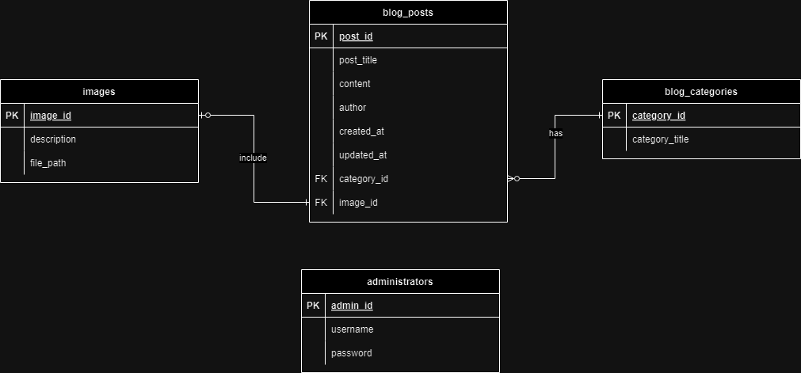

Business Rules:

* A blog post can include 0 to 1 image, and an image can be included in only 1 blog post
* A blog post can have 1 category, and a category can have 0 to many blog posts
* System administrators are the only users of the CMS authorized to manage blog posts, and they do so by signing in with a username and password

## TYPES OF USERS

The users of the CMS include the

* Site administrators/authors
  + Create and manage website content
* Users
  + View website content

## CONCLUSION

The proposed digital CMS will be a valuable resource for students, athletes, and lifelong learners seeking to optimize their performance in life.

## SOURCES

* <https://www.drawio.com/doc/faq/add-rows>
* <https://stackoverflow.com/questions/6472233/can-i-store-images-in-mysql>
* <https://www.theminimalists.com/>
* <https://www.stungeye.com/school/cms/?p=hi>