Check 1 postcode

2006

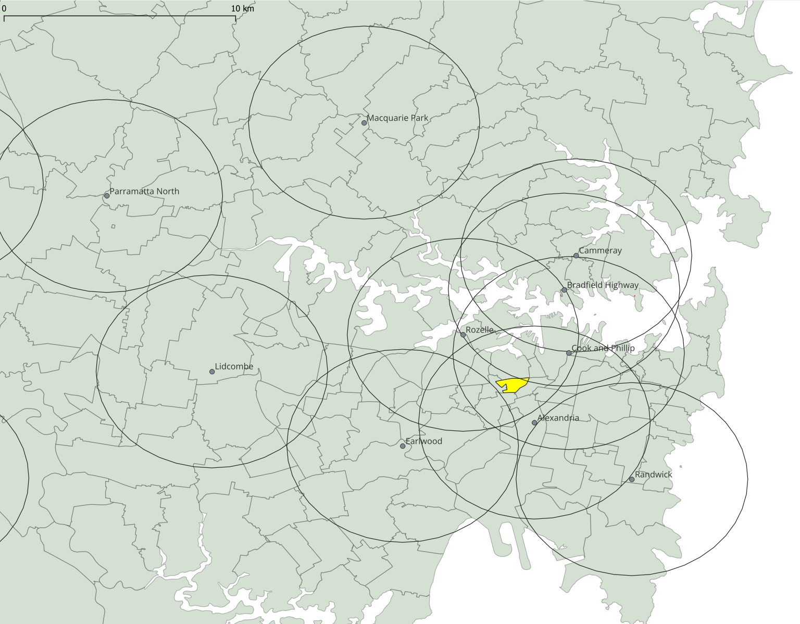

As you can see, Alexandria, Cook and Phillip, Rozelle all cover 100%. However, Bradfield Highway only covers 5%.