How to analysis PROCESS macro model 8 with processR App

Keon-Woong Moon

2019 2 18

## Homepage of processR package

The homepage of processR package is <https://github.com/cardiomoon/processR>. You can see how to analysis this model with R at this homepage.

## Where to start?

Please visit the processR App at <http://web-r.space:3838/processR> with web browser.

## Select Data

Among the example data, select disaster data(1). If you want to see the help for data, click the show help for data checkbox(2)

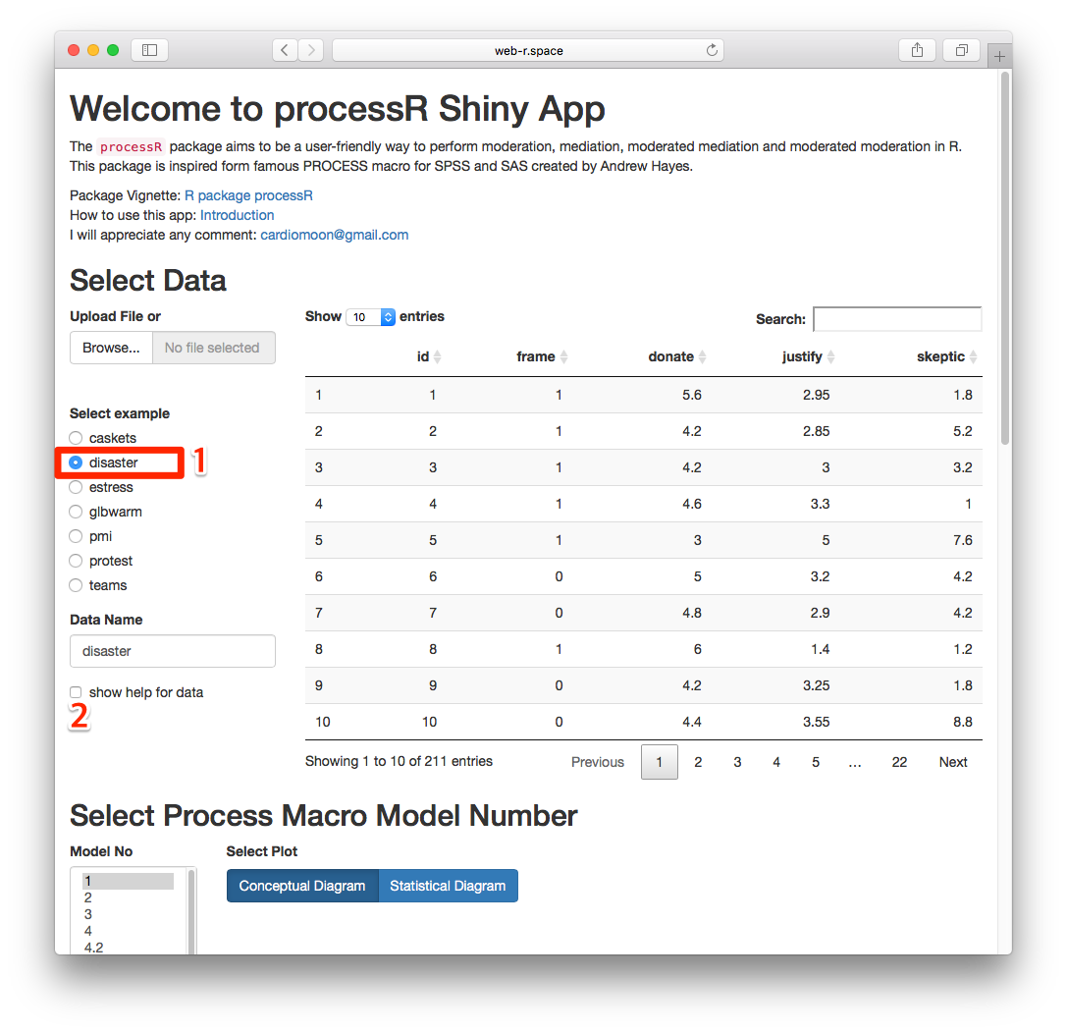

## Select Model Number

Select Process Macro Model Number 8(3). You can see the conceptual diagram. You can see the statistical diagram by press the button(4)

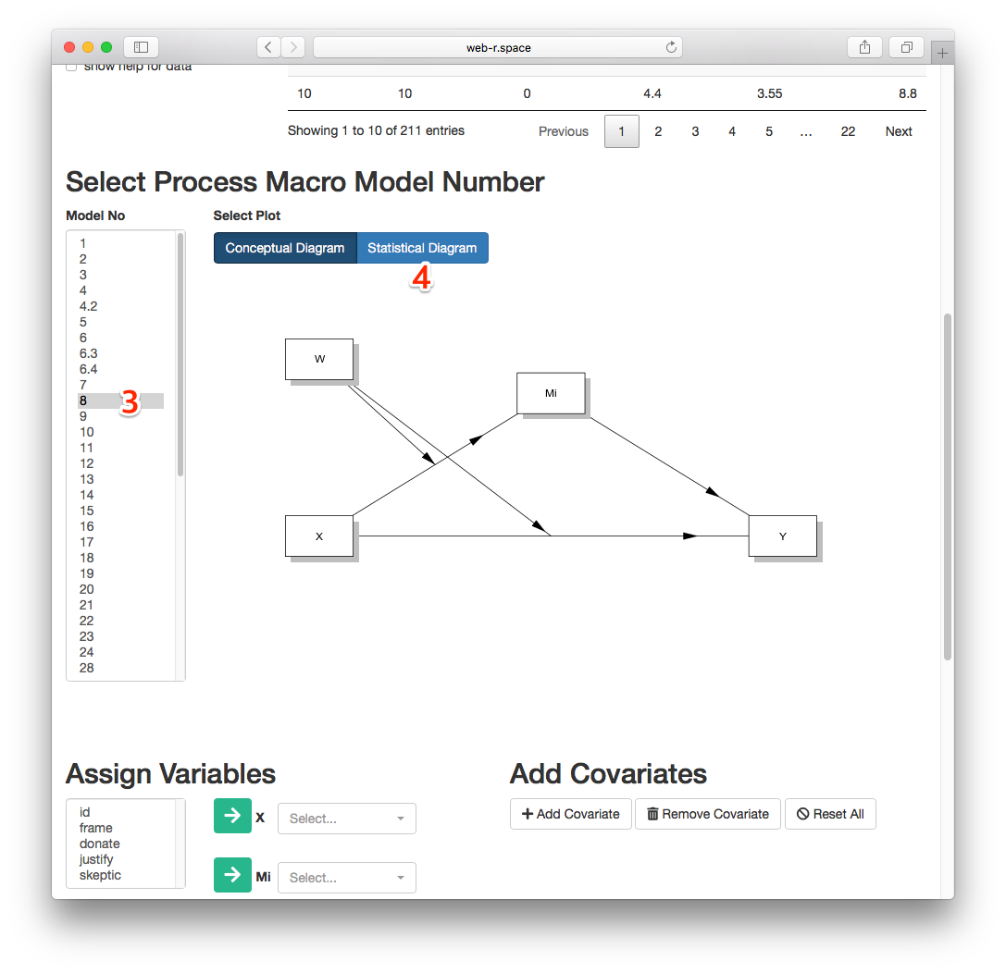

## Assign Variables

Now, you can assign variables. Select frame among variables in the selectInput(5) and press the green arrow named as **X**. Assign justify as **Mi**, donate as **Y** and skeptic as **W**.

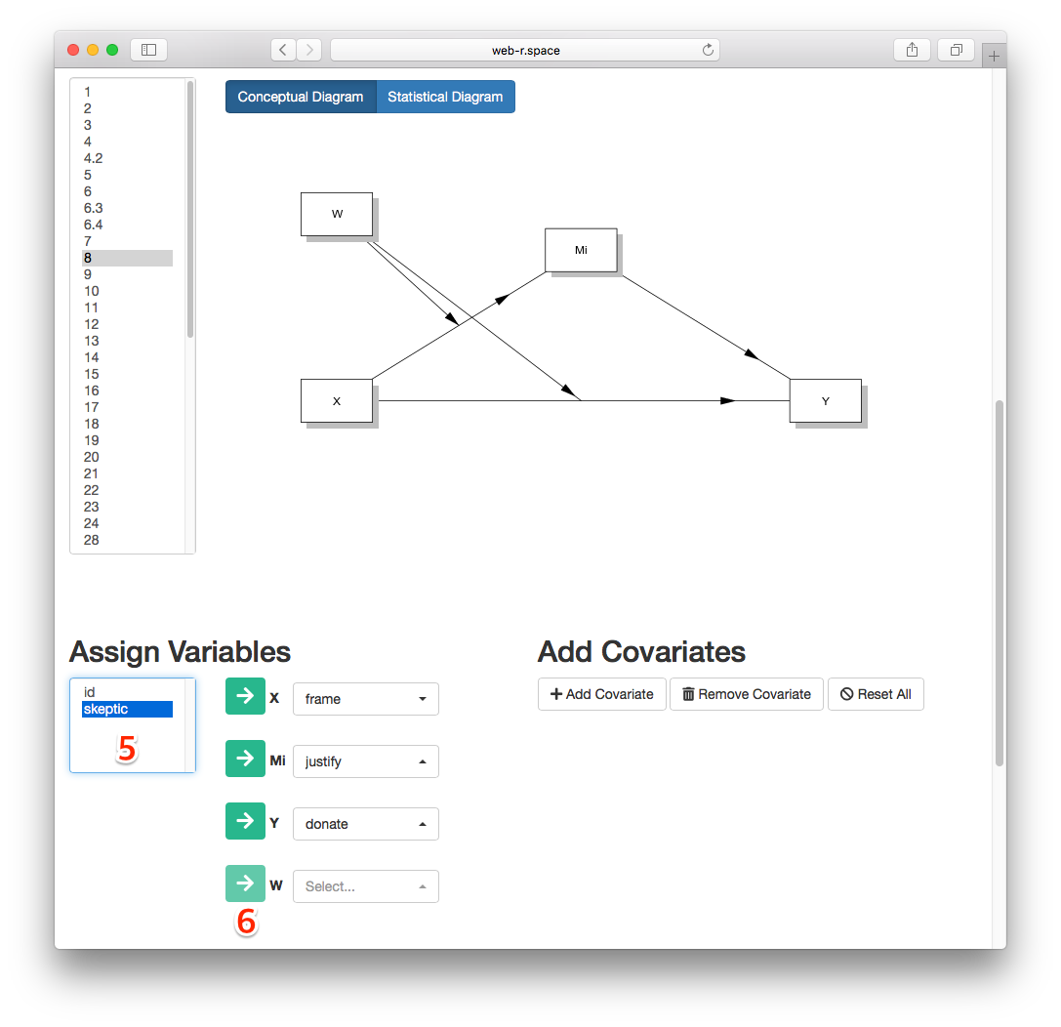

## Make Equation

Press the **make Equation** button(7). The processR app makes the equation for you. You can edit the equation if you want.

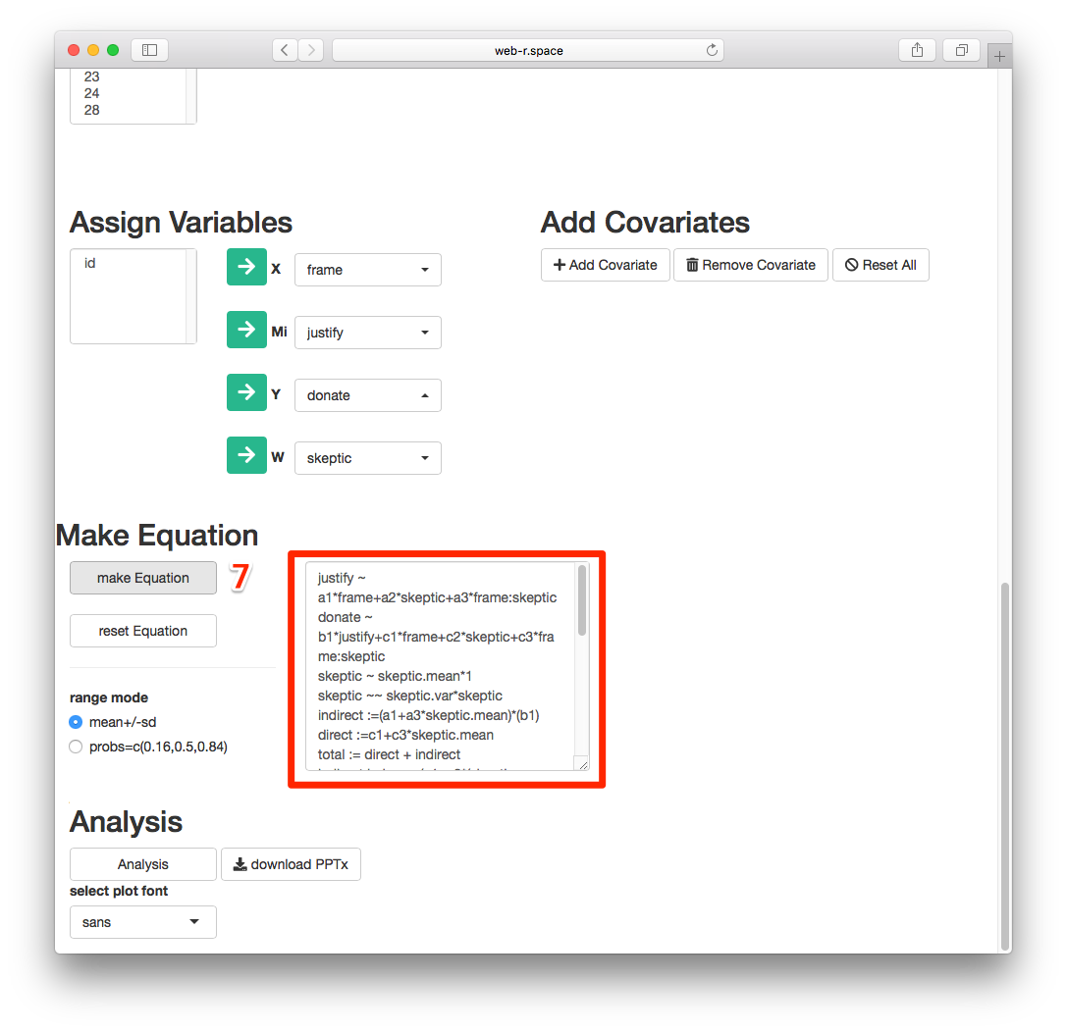

## Analyze

Press the **Analysis** Button(8). Please wait for the analysis result. It takes about 1 minutes to perform all analysis. Please be patient until the the results come.

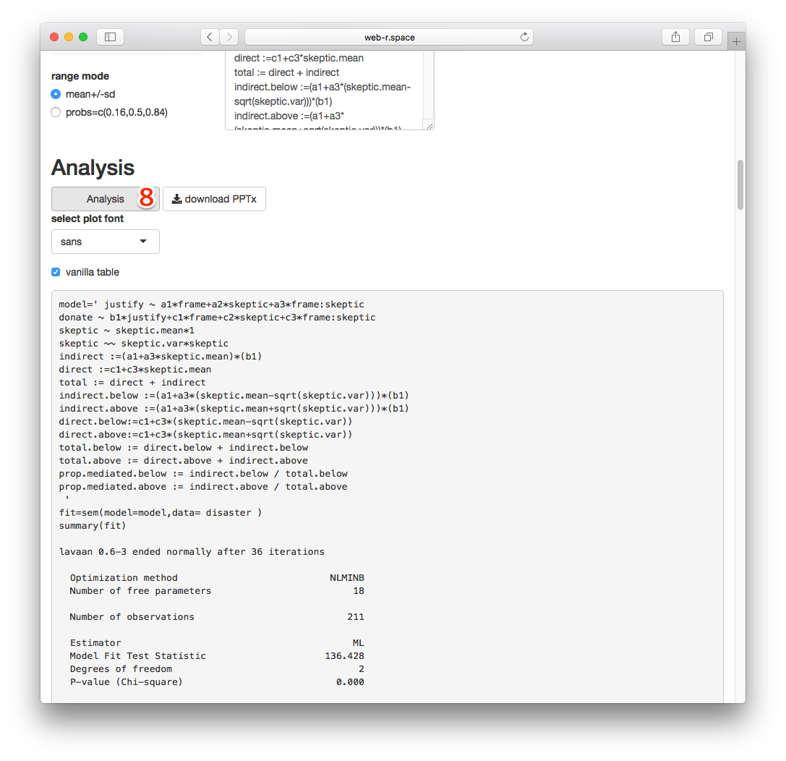

## Watch the results(1)

You can see the results including conceptual diagram, EstimatesTable(9), Statistical Diagram(10). You can select one of **est**(estimated coefficient), **std**(standardized coefficient) or **name**(label).

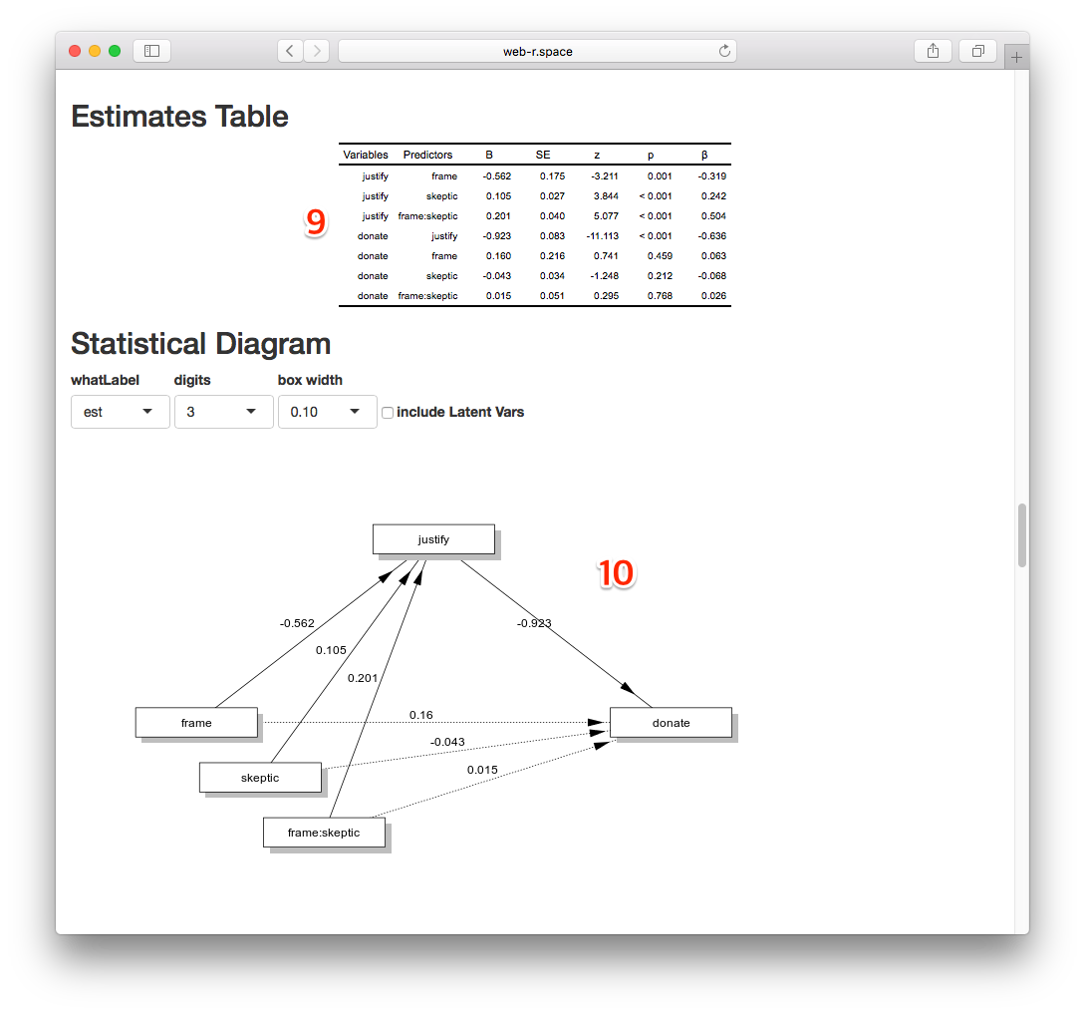

## Watch the results(2)

You can also see the Correlation Table(11), Correlation Plot(12) and Model Fit Table(13).

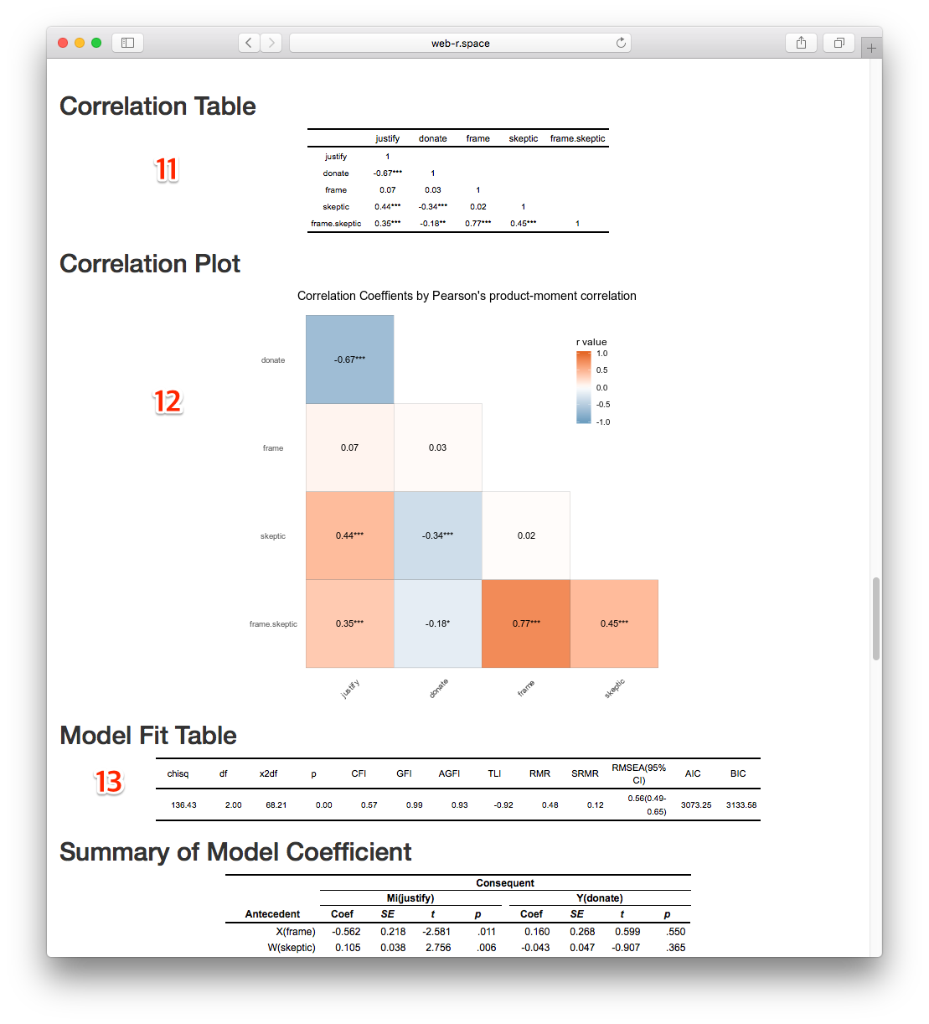

## Watch the results(3)

You can see the Summary of Medel Coefficient(14) and Plot for Moderateion Effect(15). Please try several options for moderation plot.

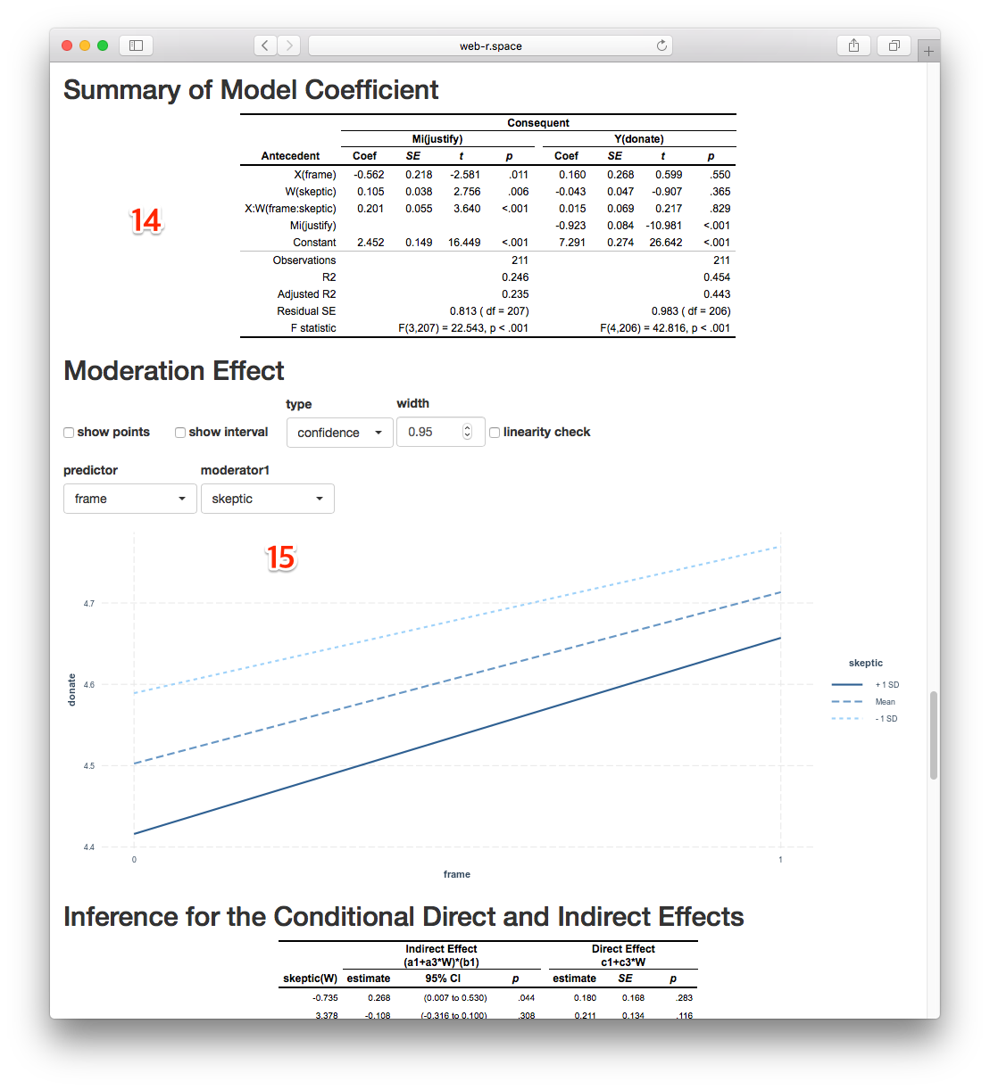

## Watch the results(4)

You can see the inference for the conditional direct and indirect effects(16). Also you can get the plot(17) with the results of anlaysis using mediation package.

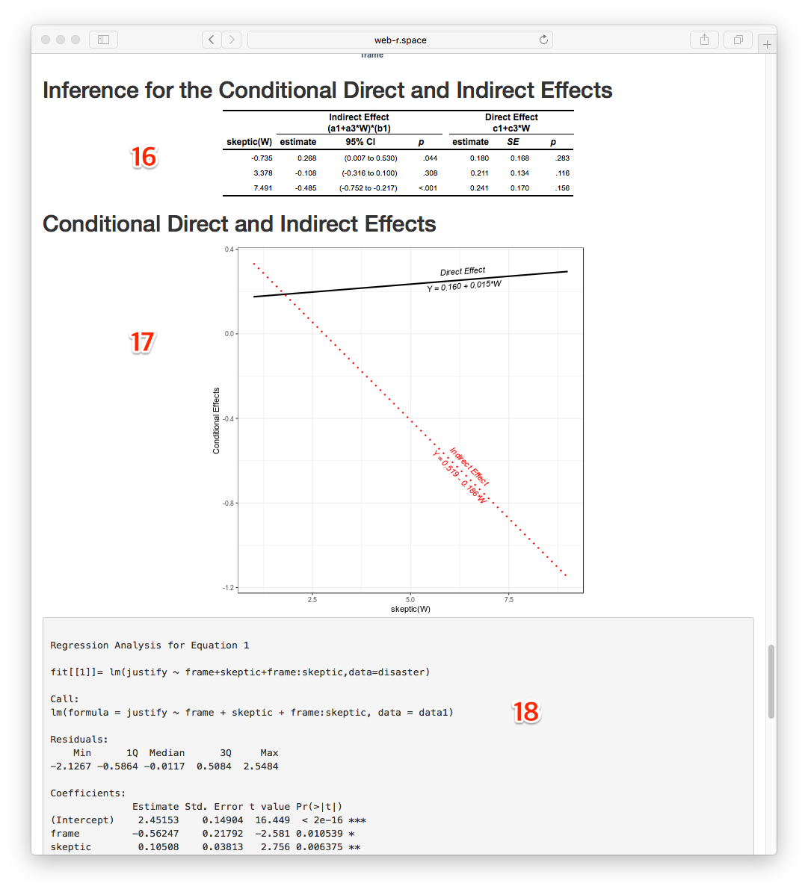

## Get the result

You can download the results of analysis as a powerpoint file by press the **download PPTx** button(19).

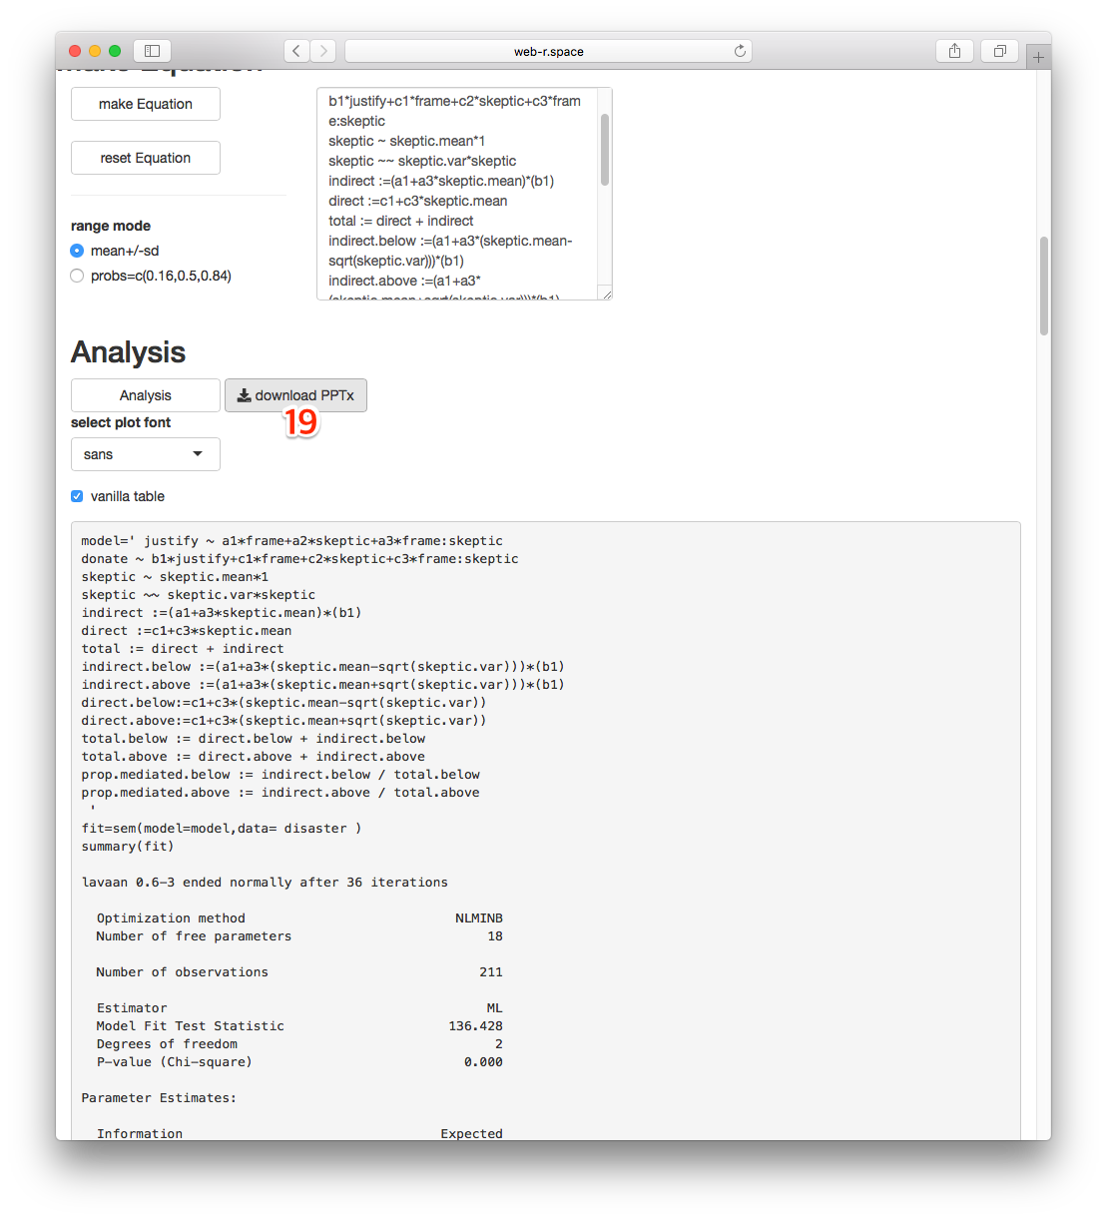

## Get/See the sample file

You can get the sample powerpoint file [model8.pptx](https://github.com/cardiomoon/processR/blob/master/inst/doc/model8.pptx?raw=true) - view with [office web viewer](https://view.officeapps.live.com/op/view.aspx?src=https://github.com/cardiomoon/processR/blob/master/inst/doc/model8.pptx?raw=true)