**sampleData2**

| **type** | **title** | **code** |
| --- | --- | --- |
| title | title | Reproducible Research with Table Data |
| author | author | Keon-Woong Moon |
| data | sampleData2 | sampleData2 |
| mytable | mytable | mytable(sex~.,data=acs) |
| data | head(iris) | head(iris) |
| plot | plot | plot(iris) |
| ggplot | ggplot | ggplot(iris,aes(x=Sepal.Length,y=Sepal.Width,color=Species))+geom_point() |
| Rcode | Regression Analysis | fit=lm(mpg~wt*hp,data=mtcars) summary(fit) |
| Rcode | Summary | summary(mtcars) |
| text | Text | This document is an example of reproducible research using rrtable package.  The home page of this project is github.com/cardiomoon/rrtable. |
| table | table | df2flextable(head(mtcars)) |
| 2ggplots | Two ggplots | ggplot(iris,aes(Sepal.Length,Sepal.Width))+geom_point() ggplot(iris,aes(Sepal.Length,Sepal.Width,colour=Species)) + geom_point() + guides(colour=FALSE) |
| 2plots | Two plots | hist(rnorm(1000)) plot(1:10) |

**mytable**

| sex | Female | Male | p |
| --- | --- | --- | --- |
| (N=287) | (N=570) |
| age | 68.7 ± 10.7 | 60.6 ± 11.2 | < 0.001 |
| cardiogenicShock |  | | 0.136 |
| - No | 275 (95.8%) | 530 (93.0%) |
| - Yes | 12 ( 4.2%) | 40 ( 7.0%) |
| entry |  | | 0.035 |
| - Femoral | 119 (41.5%) | 193 (33.9%) |
| - Radial | 168 (58.5%) | 377 (66.1%) |
| Dx |  | | 0.012 |
| - NSTEMI | 50 (17.4%) | 103 (18.1%) |
| - STEMI | 84 (29.3%) | 220 (38.6%) |
| - Unstable Angina | 153 (53.3%) | 247 (43.3%) |
| EF | 56.3 ± 10.1 | 55.6 ± 9.4 | 0.387 |
| height | 153.8 ± 6.2 | 167.9 ± 6.1 | < 0.001 |
| weight | 57.2 ± 9.3 | 68.7 ± 10.3 | < 0.001 |
| BMI | 24.2 ± 3.6 | 24.3 ± 3.2 | 0.611 |
| obesity |  | | 0.580 |
| - No | 194 (67.6%) | 373 (65.4%) |
| - Yes | 93 (32.4%) | 197 (34.6%) |
| TC | 188.9 ± 51.1 | 183.3 ± 45.9 | 0.124 |
| LDLC | 117.8 ± 41.2 | 116.0 ± 41.1 | 0.561 |
| HDLC | 39.0 ± 11.5 | 37.8 ± 10.9 | 0.145 |
| TG | 119.9 ± 76.2 | 127.9 ± 97.3 | 0.195 |
| DM |  | | 0.077 |
| - No | 173 (60.3%) | 380 (66.7%) |
| - Yes | 114 (39.7%) | 190 (33.3%) |
| HBP |  | | < 0.001 |
| - No | 83 (28.9%) | 273 (47.9%) |
| - Yes | 204 (71.1%) | 297 (52.1%) |
| smoking |  | | < 0.001 |
| - Ex-smoker | 49 (17.1%) | 155 (27.2%) |
| - Never | 209 (72.8%) | 123 (21.6%) |
| - Smoker | 29 (10.1%) | 292 (51.2%) |

**head(iris)**

| **Sepal.Length** | **Sepal.Width** | **Petal.Length** | **Petal.Width** | **Species** |
| --- | --- | --- | --- | --- |
| 5.10 | 3.50 | 1.40 | 0.20 | setosa |
| 4.90 | 3.00 | 1.40 | 0.20 | setosa |
| 4.70 | 3.20 | 1.30 | 0.20 | setosa |
| 4.60 | 3.10 | 1.50 | 0.20 | setosa |
| 5.00 | 3.60 | 1.40 | 0.20 | setosa |
| 5.40 | 3.90 | 1.70 | 0.40 | setosa |

**plot**



**ggplot**

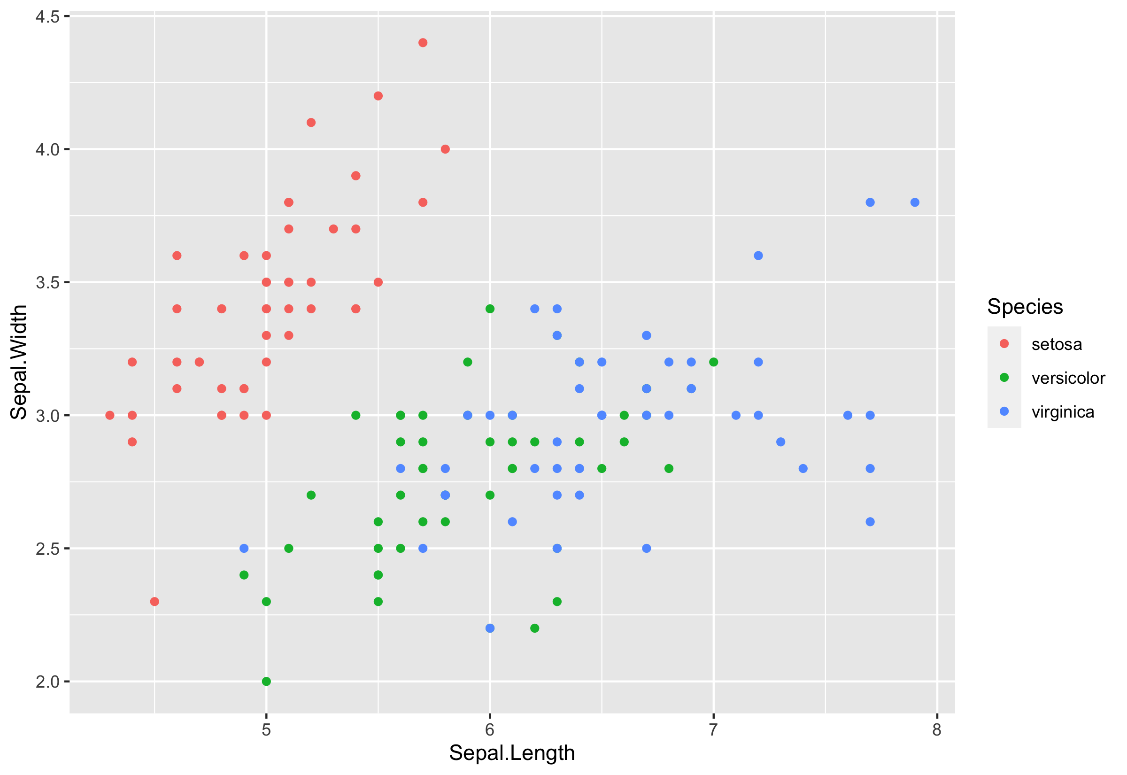

**Regression Analysis**

|  |  |
| --- | --- |
|  | fit=lm(mpg~wt*hp,data=mtcars) |
|  | summary(fit) |
|  |  |
|  | Call: |
|  | lm(formula = mpg ~ wt * hp, data = mtcars) |
|  |  |
|  | Residuals: |
|  | Min 1Q Median 3Q Max |
|  | -3.0632 -1.6491 -0.7362 1.4211 4.5513 |
|  |  |
|  | Coefficients: |
|  | Estimate Std. Error t value Pr(>|t|) |
|  | (Intercept) 49.80842 3.60516 13.816 5.01e-14 *** |
|  | wt -8.21662 1.26971 -6.471 5.20e-07 *** |
|  | hp -0.12010 0.02470 -4.863 4.04e-05 *** |
|  | wt:hp 0.02785 0.00742 3.753 0.000811 *** |
|  | --- |
|  | Signif. codes: 0 ‘***’ 0.001 ‘**’ 0.01 ‘*’ 0.05 ‘.’ 0.1 ‘ ’ 1 |
|  |  |
|  | Residual standard error: 2.153 on 28 degrees of freedom |
|  | Multiple R-squared: 0.8848, Adjusted R-squared: 0.8724 |
|  | F-statistic: 71.66 on 3 and 28 DF, p-value: 2.981e-13 |
|  |  |
|  |  |

**Summary**

|  |  |
| --- | --- |
|  | summary(mtcars) |
|  | mpg cyl disp hp drat |
|  | wt qsec vs |
|  | Min. :10.40 Min. :4.000 Min. : 71.1 Min. : 52.0 Min. :2.760 M |
|  | in. :1.513 Min. :14.50 Min. :0.0000 |
|  | 1st Qu.:15.43 1st Qu.:4.000 1st Qu.:120.8 1st Qu.: 96.5 1st Qu.:3.080 1 |
|  | st Qu.:2.581 1st Qu.:16.89 1st Qu.:0.0000 |
|  | Median :19.20 Median :6.000 Median :196.3 Median :123.0 Median :3.695 M |
|  | edian :3.325 Median :17.71 Median :0.0000 |
|  | Mean :20.09 Mean :6.188 Mean :230.7 Mean :146.7 Mean :3.597 M |
|  | ean :3.217 Mean :17.85 Mean :0.4375 |
|  | 3rd Qu.:22.80 3rd Qu.:8.000 3rd Qu.:326.0 3rd Qu.:180.0 3rd Qu.:3.920 3 |
|  | rd Qu.:3.610 3rd Qu.:18.90 3rd Qu.:1.0000 |
|  | Max. :33.90 Max. :8.000 Max. :472.0 Max. :335.0 Max. :4.930 M |
|  | ax. :5.424 Max. :22.90 Max. :1.0000 |
|  | am gear carb |
|  | Min. :0.0000 Min. :3.000 Min. :1.000 |
|  | 1st Qu.:0.0000 1st Qu.:3.000 1st Qu.:2.000 |
|  | Median :0.0000 Median :4.000 Median :2.000 |
|  | Mean :0.4062 Mean :3.688 Mean :2.812 |
|  | 3rd Qu.:1.0000 3rd Qu.:4.000 3rd Qu.:4.000 |
|  | Max. :1.0000 Max. :5.000 Max. :8.000 |
|  |  |

**Text**

This document is an example of reproducible research using rrtable package.
The home page of this project is github.com/cardiomoon/rrtable.

**table**

| **mpg** | **cyl** | **disp** | **hp** | **drat** | **wt** | **qsec** | **vs** | **am** | **gear** | **carb** |
| --- | --- | --- | --- | --- | --- | --- | --- | --- | --- | --- |
| 21.00 | 6.00 | 160.00 | 110.00 | 3.90 | 2.62 | 16.46 | 0.00 | 1.00 | 4.00 | 4.00 |
| 21.00 | 6.00 | 160.00 | 110.00 | 3.90 | 2.88 | 17.02 | 0.00 | 1.00 | 4.00 | 4.00 |
| 22.80 | 4.00 | 108.00 | 93.00 | 3.85 | 2.32 | 18.61 | 1.00 | 1.00 | 4.00 | 1.00 |
| 21.40 | 6.00 | 258.00 | 110.00 | 3.08 | 3.21 | 19.44 | 1.00 | 0.00 | 3.00 | 1.00 |
| 18.70 | 8.00 | 360.00 | 175.00 | 3.15 | 3.44 | 17.02 | 0.00 | 0.00 | 3.00 | 2.00 |
| 18.10 | 6.00 | 225.00 | 105.00 | 2.76 | 3.46 | 20.22 | 1.00 | 0.00 | 3.00 | 1.00 |

**Two ggplots**

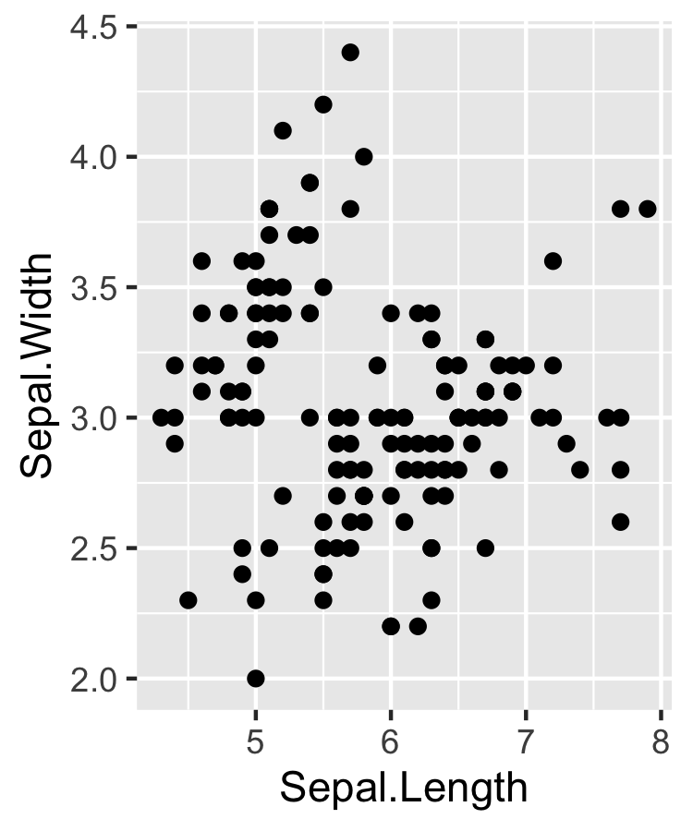

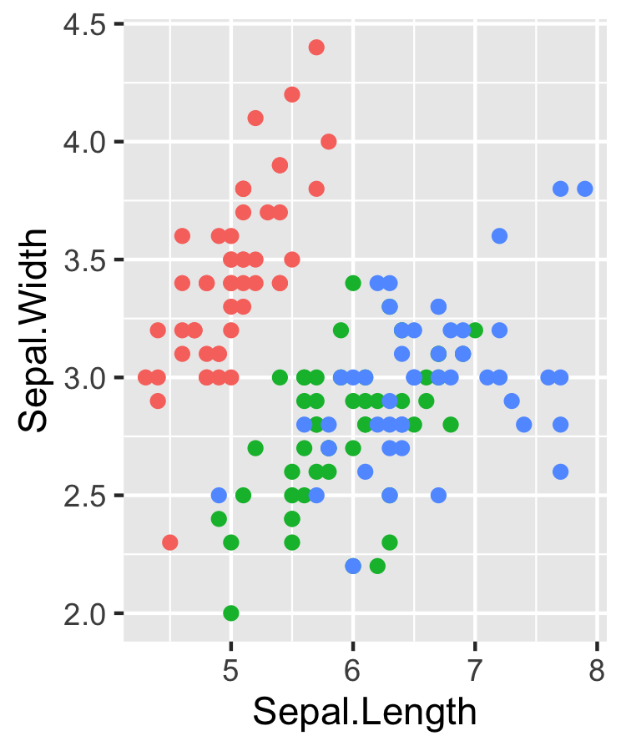

**Two plots**



