R package rrtable

Keon-Woong Moon

2018-04-12 16:50:05

require(moonBook)  
require(xtable)  
require(ztable)  
require(rrtable)  
require(ggplot2)  
options(ztable.type='latex')

### Introduction

If you are a data scientist or researcher, you will certainly be interested in reproducible research. R package rrtable makes it possible to make reports with HTML, LaTex, MS word or MS Powerpoint formats from a table of R codes.

## Package Installation

You can install R package rrtable with the following command.

if(!require(devtools)){ install.packages("devtools") }  
devtools::install_github("cardiomoon/rrtable")

## Package Loading

You can load the rrtable package with the following R command.

require(rrtable)

## Sample Data

Sample data sampleData3 is included in rrtable package. You can see the sampleData3 by folllowing R command.

str(sampleData3)

'data.frame': 15 obs. of 5 variables:  
 $ type : chr "title" "subtitle" "author" "text" ...  
 $ title : chr "" "" "" "Introduction" ...  
 $ text : chr "R package `rrtable`" "Reproducible Research with a Table of R codes" "Keon-Woong Moon" "If you are a data scientist or researcher, you will certainly be interested in reproducible research. R package"| __truncated__ ...  
 $ code : chr "" "" "" "" ...  
 $ option: chr "" "" "" "" ...

### Paragraph

You can make a paragraph with this data

ztable(sampleData3,sidewaystable=TRUE)

### mytable object

You can add mytable object with the following R code.

result= mytable(Dx~.,data=acs)   
print(ztable(result,longtable=TRUE),type='latex')

### Plot

You can insert a plot into your document.

plot(iris)

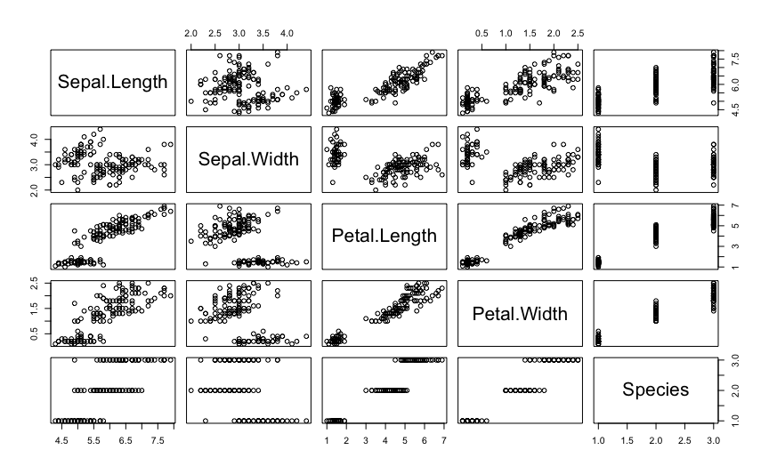

### ggplot

You can insert a ggplot into a document

ggplot(iris,aes(x=Sepal.Length,y=Sepal.Width,color=Species))+ geom_point()

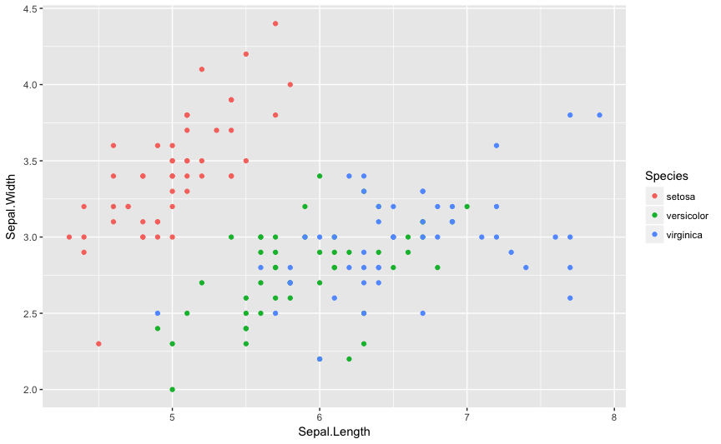

### R code

You can insert the result of R code. For example, you can insert the result of regression analysis.

fit=lm(mpg~wt*hp,data=mtcars)  
summary(fit)

Call:  
lm(formula = mpg ~ wt * hp, data = mtcars)  
  
Residuals:  
 Min 1Q Median 3Q Max   
-3.0632 -1.6491 -0.7362 1.4211 4.5513   
  
Coefficients:  
 Estimate Std. Error t value Pr(>|t|)   
(Intercept) 49.80842 3.60516 13.816 5.01e-14 ***  
wt -8.21662 1.26971 -6.471 5.20e-07 ***  
hp -0.12010 0.02470 -4.863 4.04e-05 ***  
wt:hp 0.02785 0.00742 3.753 0.000811 ***  
---  
Signif. codes: 0 '***' 0.001 '**' 0.01 '*' 0.05 '.' 0.1 ' ' 1  
  
Residual standard error: 2.153 on 28 degrees of freedom  
Multiple R-squared: 0.8848, Adjusted R-squared: 0.8724   
F-statistic: 71.66 on 3 and 28 DF, p-value: 2.981e-13

### Two ggplots

You can insert two parallel ggplots with the following code.

ggplot(iris,aes(Sepal.Length,Sepal.Width))+geom_point()  
ggplot(iris,aes(Sepal.Length,Sepal.Width,colour=Species))+ geom_point()+guides(colour=FALSE)

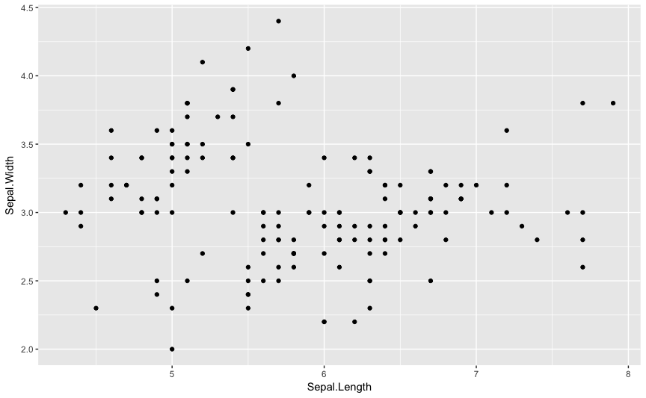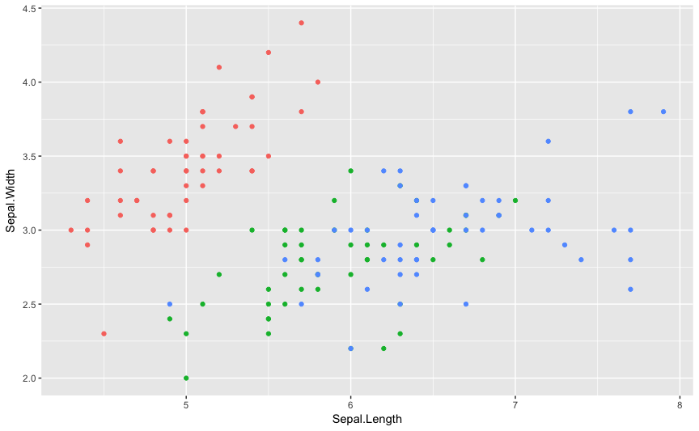

### Two plots

You can insert two parallel plots with the following code.

hist(rnorm(1000))  
plot(1:10)

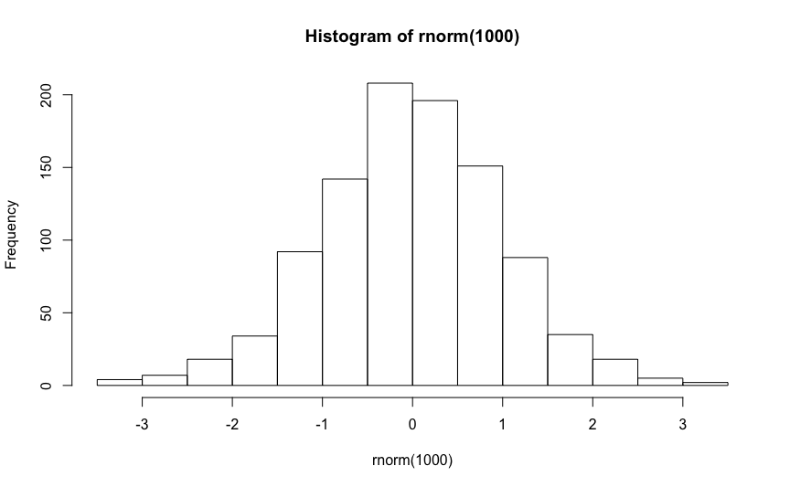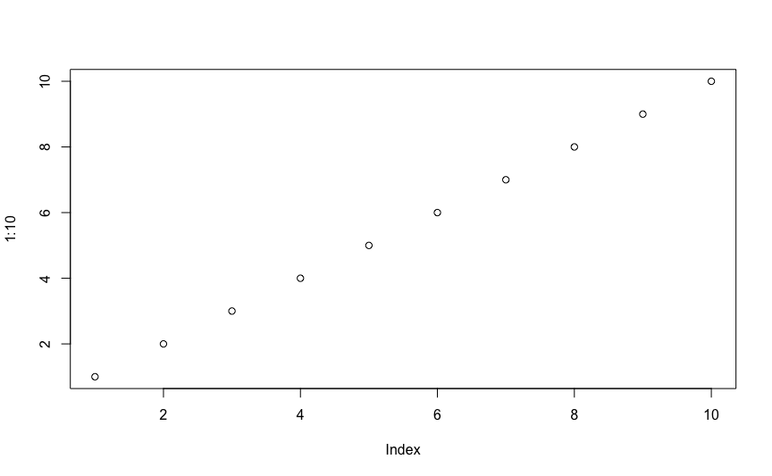

## HTML Report

You can get report with HTML format(this file) by following R command.

data2HTML(sampleData3)