**Introduction**

If you are a data scientist or researcher, you will certainly be interested in reproducible research. R package `rrtable` makes it possible to make reports with HTML, LaTex, MS word or MS Powerpoint formats from a table of R codes.

**Package Installation**

|  |  |
| --- | --- |
|  | if(!require(devtools)){ install.packages("devtools") } |
|  | devtools::install_github("cardiomoon/rrtable") |

**Package Loading**

|  |  |
| --- | --- |
|  | require(rrtable) |

**Sample Data**

|  |  |
| --- | --- |
|  | str(sampleData3) |
|  | 'data.frame': 24 obs. of 5 variables: |
|  | $ type : chr "title" "subtitle" "author" "text" ... |
|  | $ title : chr "" "" "" "Introduction" ... |
|  | $ text : chr "R package `rrtable`" "Reproducible Research with a Table of R cod |
|  | es" "Keon-Woong Moon" "If you are a data scientist or researcher, you will cert |
|  | ainly be interested in reproducible research. R package"| __truncated__ ... |
|  | $ code : chr "" "" "" "" ... |
|  | $ option: chr "" "" "" "" ... |
|  |  |

**Paragraph**

| **type** | **title** | **text** | **code** | **option** |
| --- | --- | --- | --- | --- |
| title |  | R package `rrtable` |  |  |
| subtitle |  | Reproducible Research with a Table of R codes |  |  |
| author |  | Keon-Woong Moon |  |  |
| text | Introduction | If you are a data scientist or researcher, you will certainly be interested in reproducible research. R package `rrtable` makes it possible to make reports with HTML, LaTex, MS word or MS Powerpoint formats from a table of R codes. |  |  |
| header2 | Package Installation | You can install R package `rrtable` with the following command. | if(!require(devtools)){ install.packages("devtools") } devtools::install_github("cardiomoon/rrtable") | echo=TRUE, eval=FALSE |
| header2 | Package Loading | You can load the `rrtable` package with the following R command. | require(rrtable) | echo=TRUE |
| header2 | Sample Data | Sample data sampleData3 is included in rrtable package. You can see the sampleData3 by folllowing R command. | str(sampleData3) | echo=TRUE, eval=TRUE |
| Data | Paragraph | You can make a paragraph with this data | sampleData3 | landscape=TRUE |
| mytable | mytable object | You can add mytable object with the following R code. | mytable(Dx~.,data=acs) |  |
| plot | Plot | You can insert a plot into your document. | plot(Sepal.Width~Sepal.Length,data=iris) |  |
| ggplot | ggplot | You can insert a ggplot into a document | ggplot(iris,aes(x=Sepal.Length,y=Sepal.Width,color=Species))+ geom_point() |  |
| Rcode | R code | You can insert the result of R code. For example, you can insert the result of regression analysis. | fit=lm(mpg~wt*hp,data=mtcars) summary(fit) |  |
| 2ggplots | Two ggplots | You can insert two parallel ggplots with the following code. | ggplot(iris,aes(Sepal.Length,Sepal.Width))+geom_point() ggplot(iris,aes(Sepal.Length,Sepal.Width,colour=Species))+ geom_point()+guides(colour=FALSE) |  |
| 2plots | Two plots | You can insert two parallel plots with the following code. | hist(rnorm(1000)) plot(1:10) |  |
| header2 | HTML Report | You can get report with HTML format(this file) by following R command. | data2HTML(sampleData3) | echo=TRUE, eval=FALSE |
| header2 | MS word document | You can get a report with MS word format. | data2docx(sampleData3) | echo=TRUE,eval=FALSE |
|  |  | You can download sample data: [sampleData3.docx](https://github.com/cardiomoon/rrtable/raw/master/inst/doc/sampleData3.docx) - view with [office web viewer](https://view.officeapps.live.com/op/view.aspx?src=https://github.com/cardiomoon/rrtable/raw/master/inst/doc/sampleData3.docx) | data2docx(sampleData2) | echo=TRUE,eval=FALSE |
|  |  | You can download sample data: [sampleData2.docx](https://github.com/cardiomoon/rrtable/raw/master/inst/doc/sampleData2.docx) - view with [office web viewer](https://view.officeapps.live.com/op/view.aspx?src=https://github.com/cardiomoon/rrtable/raw/master/inst/doc/sampleData2.docx) |  |  |
| header2 | MS powerpoint document | You can get a report with MS word format. | data2pptx(sampleData3) | echo=TRUE,eval=FALSE |
|  |  | You can download sample data: [sampleData3.pptx](https://github.com/cardiomoon/rrtable/raw/master/inst/doc/sampleData3.pptx) - view with [office web viewer](https://view.officeapps.live.com/op/view.aspx?src=https://github.com/cardiomoon/rrtable/raw/master/inst/doc/sampleData3.pptx) | data2pptx(sampleData2) | echo=TRUE,eval=FALSE |
|  |  | You can download sample data: [sampleData2.pptx](https://github.com/cardiomoon/rrtable/raw/master/inst/doc/sampleData2.pptx) - view with [office web viewer](https://view.officeapps.live.com/op/view.aspx?src=https://github.com/cardiomoon/rrtable/raw/master/inst/doc/sampleData2.pptx) |  |  |
| header2 | pdf document | You can get a report with pdf format. | data2pdf(sampleData3) | echo=TRUE,eval=FALSE |
|  |  | You can download sample data: [sampleData3.pdf](https://github.com/cardiomoon/rrtable/raw/master/inst/doc/sampleData3.pdf) | data2pdf(sampleData2) | echo=TRUE,eval=FALSE |
|  |  | You can download sample data: [sampleData2.pdf](https://github.com/cardiomoon/rrtable/raw/master/inst/doc/sampleData2.pdf) |  |  |

**mytable object**

| Dx | NSTEMI | STEMI | Unstable.Angina | p |
| --- | --- | --- | --- | --- |
| (N=153) | (N=304) | (N=400) |
| age | 64.3 ± 12.3 | 62.1 ± 12.1 | 63.8 ± 11.0 | 0.073 |
| sex |  | | | 0.012 |
| - Female | 50 (32.7%) | 84 (27.6%) | 153 (38.2%) |
| - Male | 103 (67.3%) | 220 (72.4%) | 247 (61.8%) |
| cardiogenicShock |  | | | < 0.001 |
| - No | 149 (97.4%) | 256 (84.2%) | 400 (100.0%) |
| - Yes | 4 ( 2.6%) | 48 (15.8%) | 0 ( 0.0%) |
| entry |  | | | 0.001 |
| - Femoral | 58 (37.9%) | 133 (43.8%) | 121 (30.2%) |
| - Radial | 95 (62.1%) | 171 (56.2%) | 279 (69.8%) |
| EF | 55.0 ± 9.3 | 52.4 ± 9.5 | 59.2 ± 8.7 | < 0.001 |
| height | 163.3 ± 8.2 | 165.1 ± 8.2 | 161.7 ± 9.7 | < 0.001 |
| weight | 64.3 ± 10.2 | 65.7 ± 11.6 | 64.5 ± 11.6 | 0.361 |
| BMI | 24.1 ± 3.2 | 24.0 ± 3.3 | 24.6 ± 3.4 | 0.064 |
| obesity |  | | | 0.186 |
| - No | 106 (69.3%) | 209 (68.8%) | 252 (63.0%) |
| - Yes | 47 (30.7%) | 95 (31.2%) | 148 (37.0%) |
| TC | 193.7 ± 53.6 | 183.2 ± 43.4 | 183.5 ± 48.3 | 0.057 |
| LDLC | 126.1 ± 44.7 | 116.7 ± 39.5 | 112.9 ± 40.4 | 0.004 |
| HDLC | 38.9 ± 11.9 | 38.5 ± 11.0 | 37.8 ± 10.9 | 0.501 |
| TG | 130.1 ± 88.5 | 106.5 ± 72.0 | 137.4 ± 101.6 | < 0.001 |
| DM |  | | | 0.209 |
| - No | 96 (62.7%) | 208 (68.4%) | 249 (62.2%) |
| - Yes | 57 (37.3%) | 96 (31.6%) | 151 (37.8%) |
| HBP |  | | | 0.002 |
| - No | 62 (40.5%) | 150 (49.3%) | 144 (36.0%) |
| - Yes | 91 (59.5%) | 154 (50.7%) | 256 (64.0%) |
| smoking |  | | | < 0.001 |
| - Ex-smoker | 42 (27.5%) | 66 (21.7%) | 96 (24.0%) |
| - Never | 50 (32.7%) | 97 (31.9%) | 185 (46.2%) |
| - Smoker | 61 (39.9%) | 141 (46.4%) | 119 (29.8%) |

**Plot**



**ggplot**

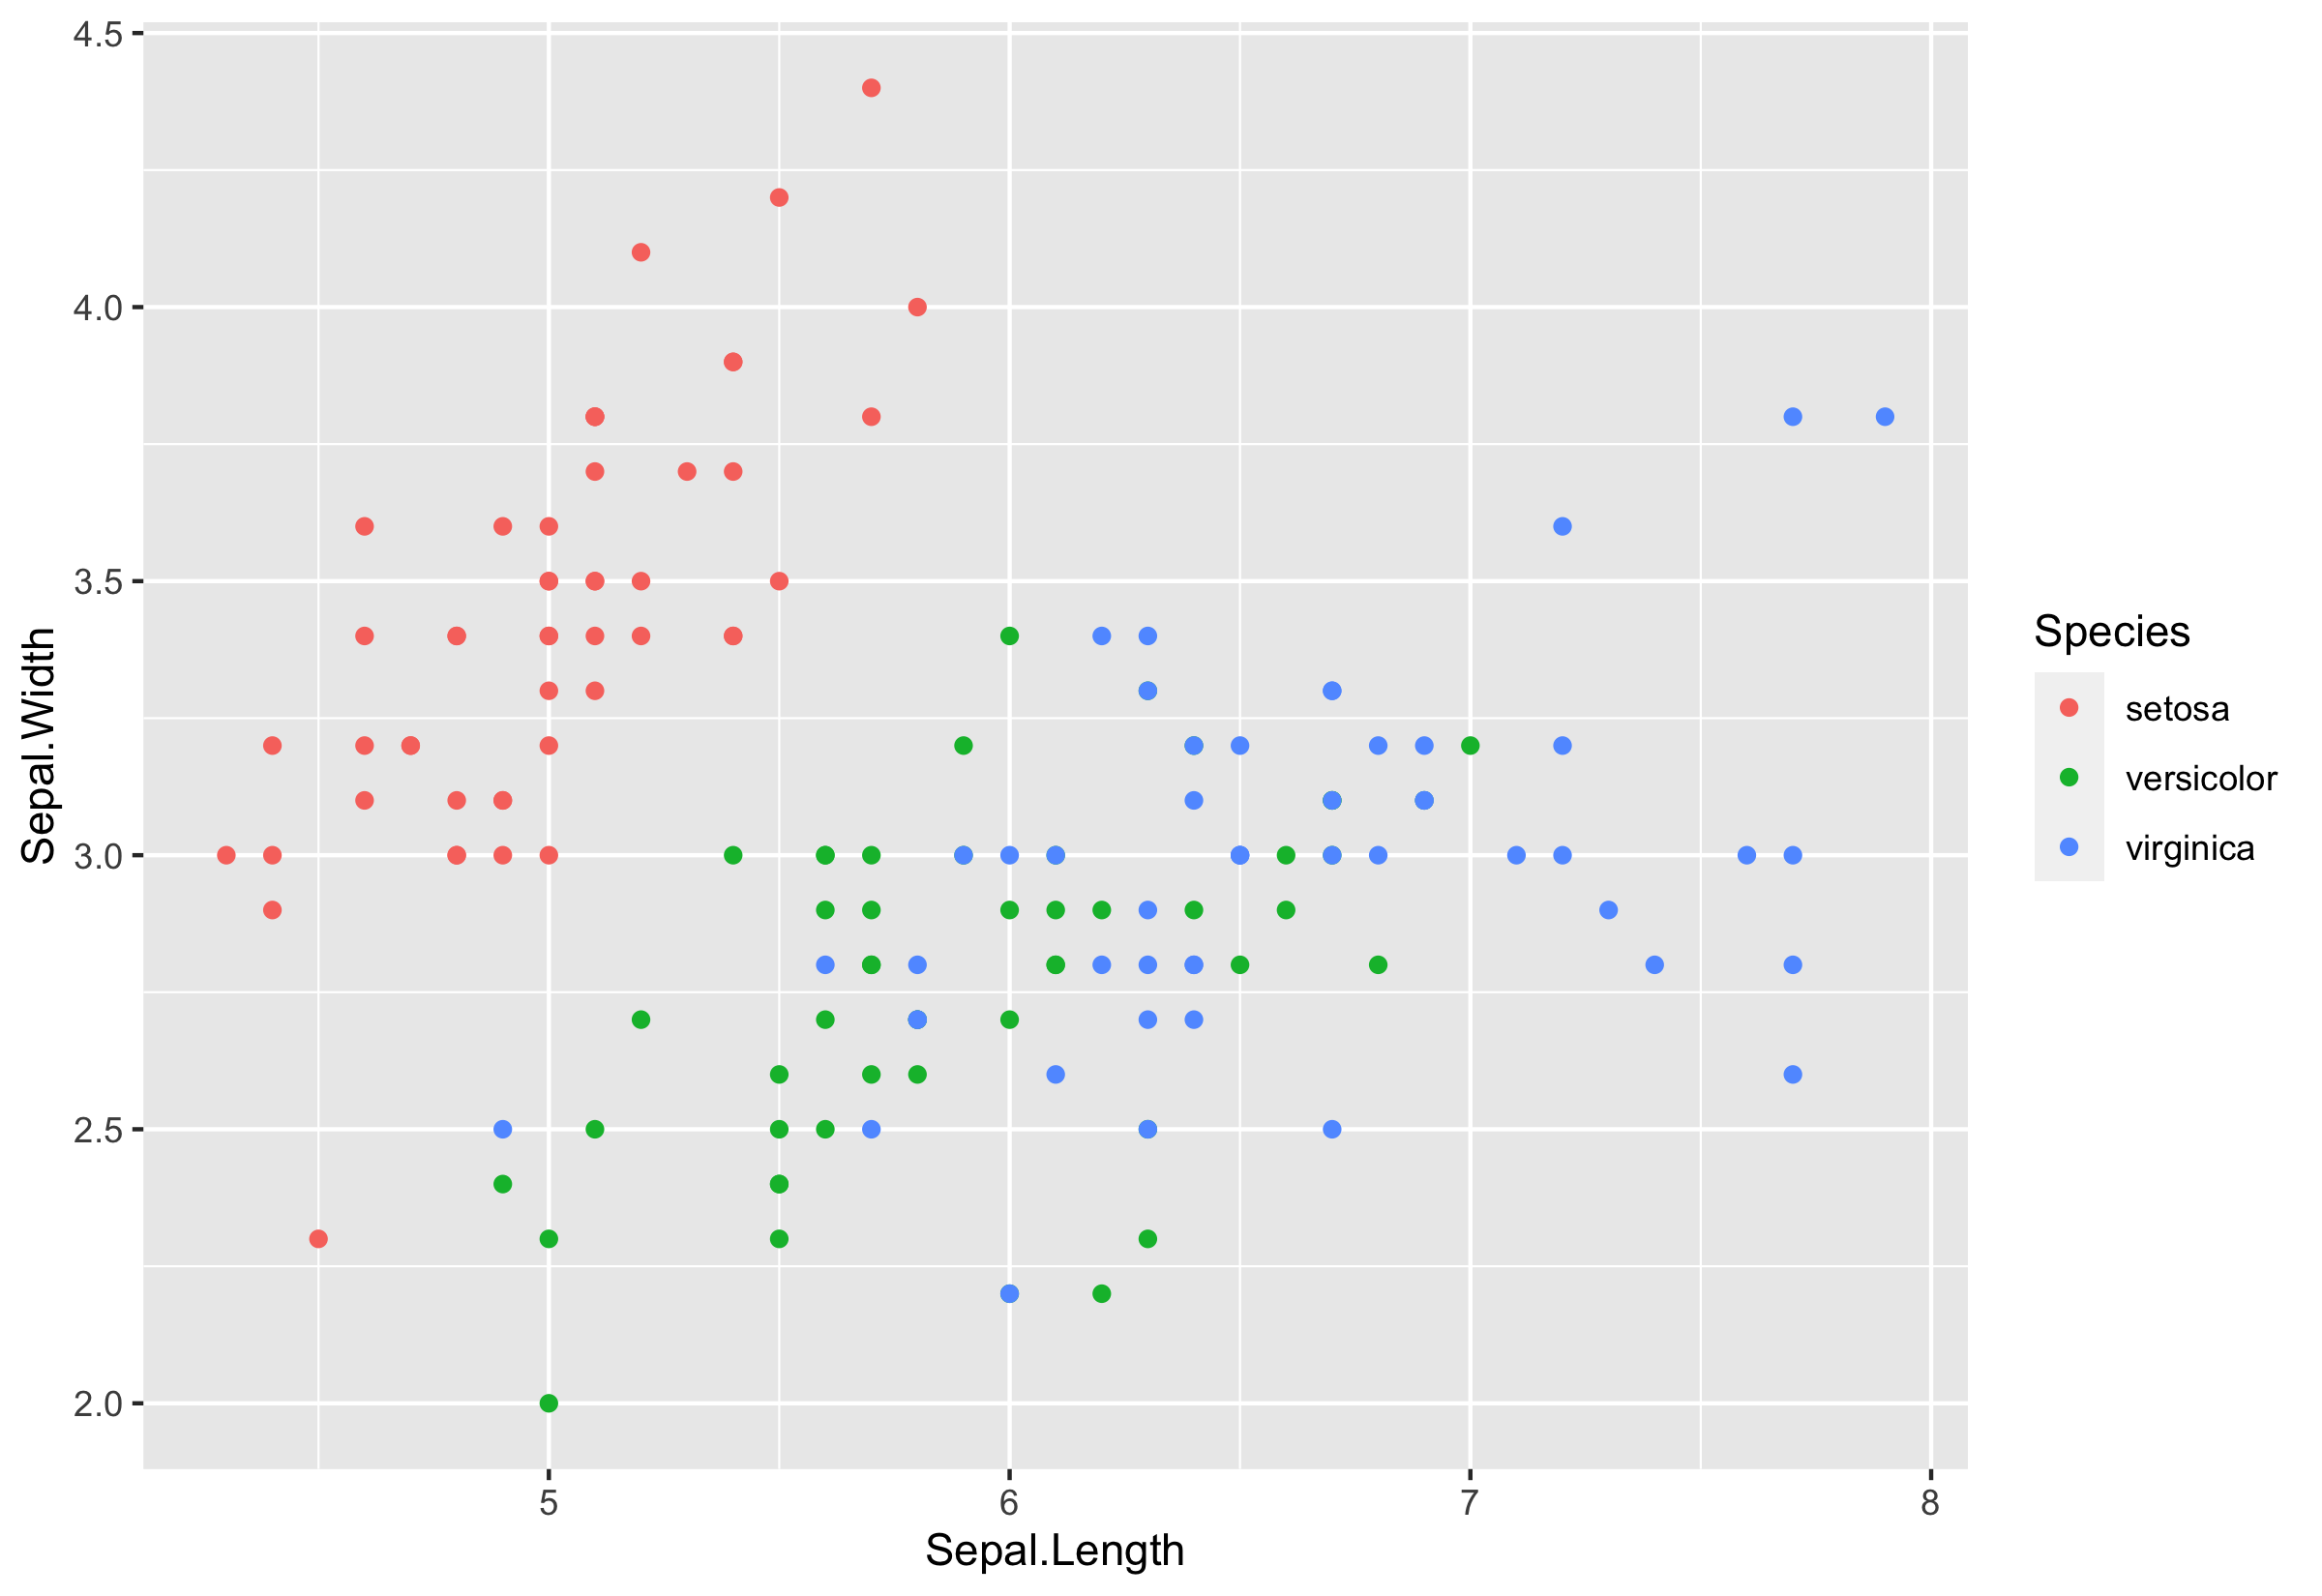

**R code**

|  |  |
| --- | --- |
|  | fit=lm(mpg~wt*hp,data=mtcars) |
|  | summary(fit) |
|  |  |
|  | Call: |
|  | lm(formula = mpg ~ wt * hp, data = mtcars) |
|  |  |
|  | Residuals: |
|  | Min 1Q Median 3Q Max |
|  | -3.0632 -1.6491 -0.7362 1.4211 4.5513 |
|  |  |
|  | Coefficients: |
|  | Estimate Std. Error t value Pr(>|t|) |
|  | (Intercept) 49.80842 3.60516 13.816 5.01e-14 *** |
|  | wt -8.21662 1.26971 -6.471 5.20e-07 *** |
|  | hp -0.12010 0.02470 -4.863 4.04e-05 *** |
|  | wt:hp 0.02785 0.00742 3.753 0.000811 *** |
|  | --- |
|  | Signif. codes: 0 ‘***’ 0.001 ‘**’ 0.01 ‘*’ 0.05 ‘.’ 0.1 ‘ ’ 1 |
|  |  |
|  | Residual standard error: 2.153 on 28 degrees of freedom |
|  | Multiple R-squared: 0.8848, Adjusted R-squared: 0.8724 |
|  | F-statistic: 71.66 on 3 and 28 DF, p-value: 2.981e-13 |
|  |  |
|  |  |

**Two ggplots**

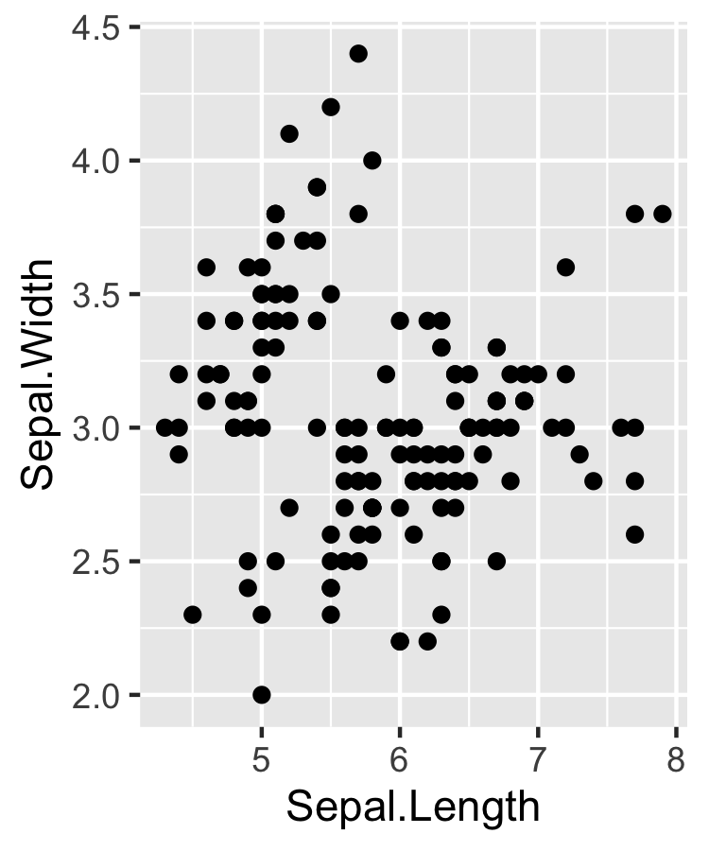

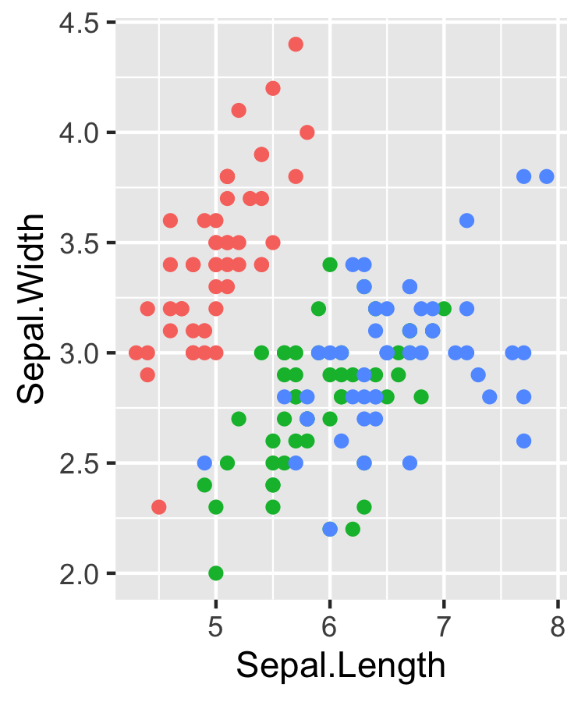

**Two plots**





**HTML Report**

|  |  |
| --- | --- |
|  | data2HTML(sampleData3) |

**MS word document**

|  |  |
| --- | --- |
|  | data2docx(sampleData3) |

You can download sample data: [sampleData3.docx](https%3A//github.com/cardiomoon/rrtable/raw/master/inst/doc/sampleData3.docx) - view with [office web viewer](https%3A//github.com/cardiomoon/rrtable/raw/master/inst/doc/sampleData3.docx)

|  |  |
| --- | --- |
|  | data2docx(sampleData2) |

You can download sample data: [sampleData2.docx](https%3A//github.com/cardiomoon/rrtable/raw/master/inst/doc/sampleData2.docx) - view with [office web viewer](https%3A//github.com/cardiomoon/rrtable/raw/master/inst/doc/sampleData2.docx)

**MS powerpoint document**

|  |  |
| --- | --- |
|  | data2pptx(sampleData3) |

You can download sample data: [sampleData3.pptx](https%3A//github.com/cardiomoon/rrtable/raw/master/inst/doc/sampleData3.pptx) - view with [office web viewer](https%3A//github.com/cardiomoon/rrtable/raw/master/inst/doc/sampleData3.pptx)

|  |  |
| --- | --- |
|  | data2pptx(sampleData2) |

You can download sample data: [sampleData2.pptx](https%3A//github.com/cardiomoon/rrtable/raw/master/inst/doc/sampleData2.pptx) - view with [office web viewer](https%3A//github.com/cardiomoon/rrtable/raw/master/inst/doc/sampleData2.pptx)

**pdf document**

|  |  |
| --- | --- |
|  | data2pdf(sampleData3) |

You can download sample data: [sampleData3.pdf](https%3A//github.com/cardiomoon/rrtable/raw/master/inst/doc/sampleData3.pdf)

|  |  |
| --- | --- |
|  | data2pdf(sampleData2) |

You can download sample data: [sampleData2.pdf](https%3A//github.com/cardiomoon/rrtable/raw/master/inst/doc/sampleData2.pdf)