Presentation

S.1 We are Team HejSan - Sara
- We introduce ourselves
- We have developed a language learning platform that aims at helping users to learn through HRI and AI, though we had some issues that we will cover later

S.2 What we will cover - Sara
- The agenda for today is to go through the journey of developing this application
- We will cover the early phases of brainstorming, understanding the user, the iterations and how we connect this to the design of our application
- We will demonstrate our ideas by jumping back and forth between the slides and the application
- We will also talk about the reality check that we had when trying to implement AI, our future vision and our final reflection

S.3 Can we add a slide about brainstorming and understanding the user? (Maybe “Brainstorming and discovery”) - William
Blocks: Idea generation, Personas, Sketching, Requirement gathering, Feature prioritization, Iterations

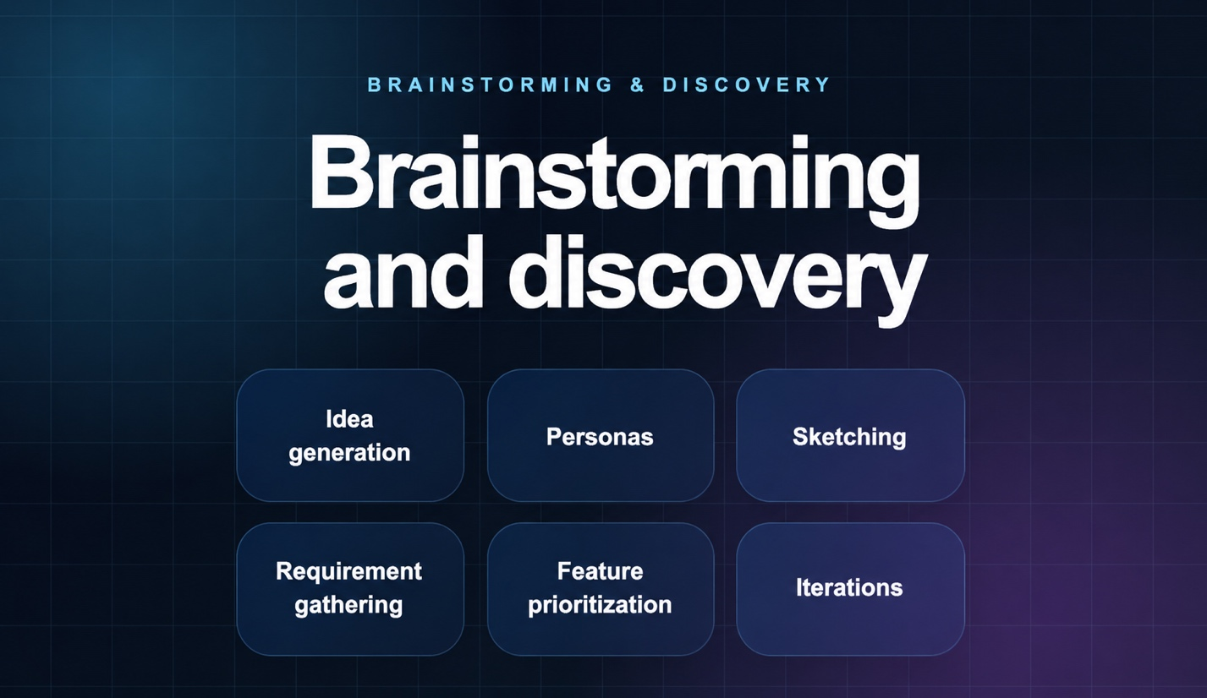

S.4 Language learning should feel interactive - William

- We wanted to amplify elements that can make language learners engaged in learning.
- We had ideas of creating scenario-based learning, for example, what might you want to know if you go to a café, going to the grocery store, or if you are going to travel around the country
- And of course, the core idea of learning language through listening and talking
- We also asked how this could be done by implementing guided learning with robots and AI

S. 5 AI became part of the development process - Cardo

- Using AI to generate practice
- Using AI to act as a teacher and encourage users
- Using robots to embody AI

S. 6 Reality check, what is implemented and what comes next – Cardo

- After implementing the functionality of AI assisted learning, the dark design of these products became apparent as there is too big a cost to use it for this project.

S. 7 Student and teacher experiences in one platform - Sara

- This is where we go into a demo of the application

- Walkthrough of the app, doing a lesson etc.

S. 8 Course concepts became part of the platform - William

- We should demo the app again and show as we talk.

- We have applied UX thinking in multiple aspects of this application.
- From a visual standpoint: A consistent theme in terms of colours, fonts, subtle animations, hover effects, colour contrasts to highlight certain buttons, intuitive navigation

- Accessibility: We have applied a lot of options for personalization by giving the user the possibility of using different settings (desktop and mobile, learning profile, AI interaction style, experience)

- Motivation and engagement: “It’s not about the destination, it’s the journey”. The progress page becomes a way to create motivation by showing that users are getting somewhere and are on a journey. It makes lesson completions feel more rewarding and encourages users to complete more lessons.

- It’s all built on an MVC-inspired architecture -> Cardo

S. 9 Structured and reusable platform architecture- Cardo

- Take it away Cardo

S. 10 Future interactive learning experiences- Cardo

- How we want the AI and robot interaction to work
- Parts of the app are still conceptual, e.g. interaction style, embodiment, colour theme, contact us etc.

S. 11 Thank you, any questions?

