- What is the emissions per capita of Canada?
17.72

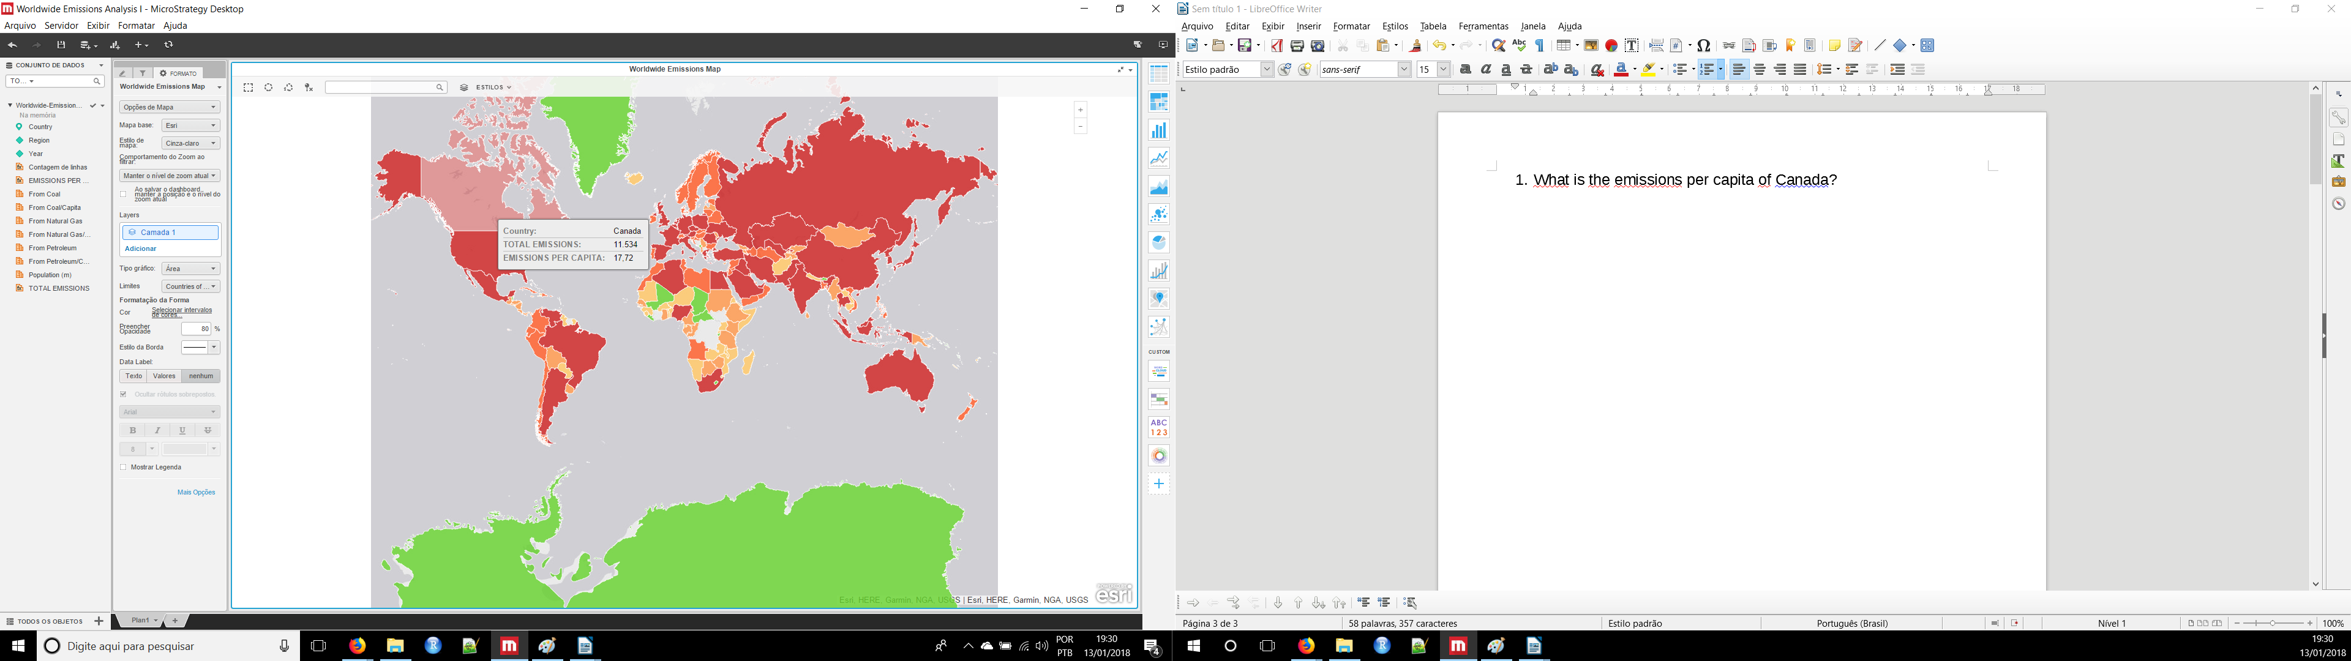

- What is the overall trend in worldwide emissions?
During 1990 to 2007 the trend demonstrated an constant increase than from 2008 to 2010 a decrease trend can be observed as exemplified below.

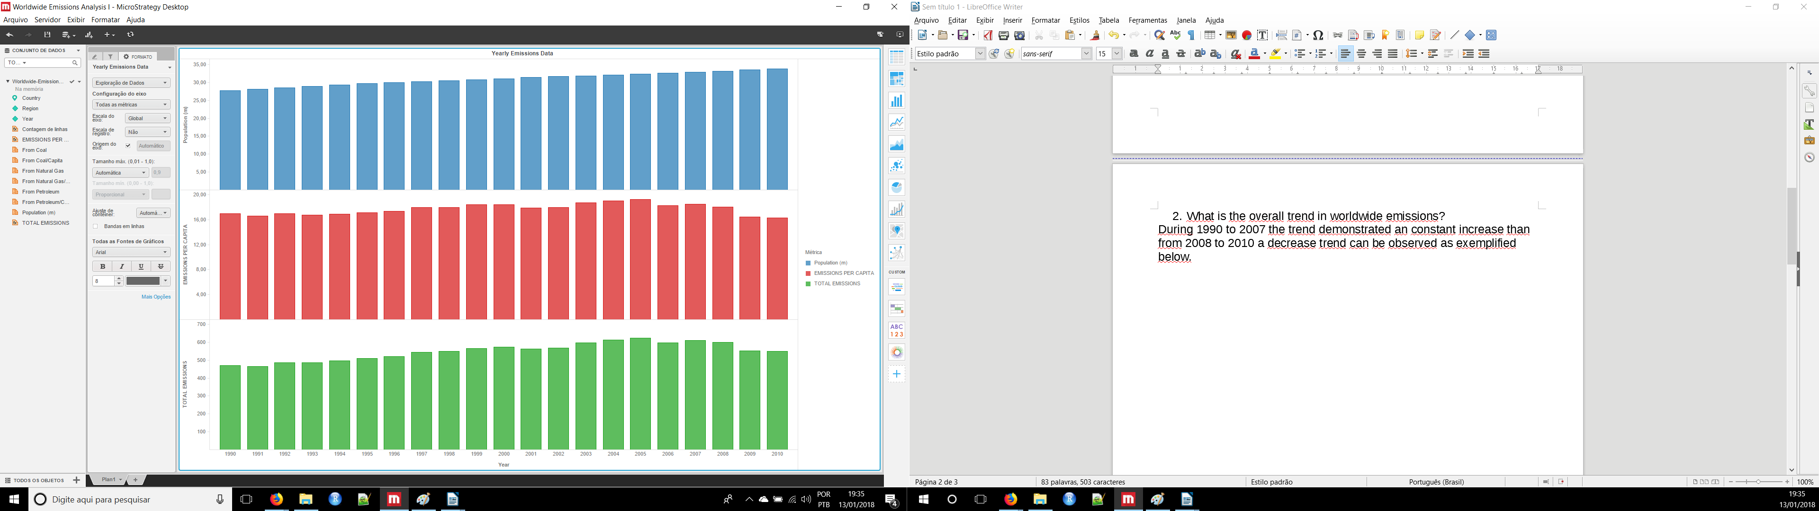

- Notice that overall emissions declined in 2009, the only year in the total number of years surveyed that indicates emissions decreases in all three emissions sources. Why is that? What broader socio-political context might explain this single yearly decrease?

On 2009 due to the economic recession the emisisons were reduced as can be observed on United States and Canada below

