Exploring São Paulo Neighbourhoods Venues

Paulo Cardoso

2019/06/15

# Introduction

The work is a capstone project for the Coursera course IBM Data Science Professional Certificate Specialization. The objective of this first part is to present a description of the problem and also point out with data will be used on the development of de project.

## Problem Statement

* It's possible replicate parts of the analysis performed during the course with São Paulo Data?
* How can performed a grouping the neighborhoods and find out top 10 venues corresponding to that neighborhood in São Paulo, SP - Brazil?

## Problem Description

Grouped by neighborhood exploring the venues around creating a top 10 venues by neighborhood in São Paulo. This kind of analysis can lead to possibility of identification of new opportunities for businesses, identification of the saturation of business segments in the neighborhood and also possibility to better understand the city with its characteristics based on distribution of the venues.

## Target Audience

* Payment industry, this segment could take advantage of an analysis like to that to better position their self on the market, knowing where their product could have a better acceptance.
* Investors thinking on open a new business in town, this kind of person could benefit from this analysis to rule out segment of business in tow due saturation of the kind of business on the neighborhood.
* Social Science researchers curious with the behavior and distribution of venues in the city.

## Success Criteria

The success criteria of the project will be a good presentation of which are the top 10 kind of venue by neighborhood and some recommendation regarding which are the worst business segments to be opened on some neighborhoods.

# Data

On this project was used data originated from three different sources, the first data set gathered was the Brazilian postal code data set, the next one was data retrieved from the geocoder ArcGIS APIs/Python Library and the third and last source Foursquare API data. It’s important to say that the data gathered from the APIs was used to enrich the original postal code data set.

* Postal code: In Brazil is known as CEP, but differently from the data provided on the course a single neighborhood can have several CEPs assigned to it. Link to data: <http://cep.la/CEP-dados-2018-UTF8.zip>
* Geocoder ArcGIS: This API was used to retrieve Latitude and Longitude based on Postal code (CEP). ArcGIS API for Python is a Python library for working with maps and geospatial data, powered by web GIS. It provides simple and efficient tools for sophisticated vector and raster analysis, geocoding, map making, routing and directions, as well as for organizing and managing a GIS with users, groups and information items. Link to documentation: <https://developers.arcgis.com/python/guide/>
* Foursquare: This API was used to retrieve venue information based on Latitude and Longitude. Back in 2009, Foursquare invented the check-in. Today, those 13+ billion check-ins are the foundation of our powerful, proprietary Pilgrim technology that helps make sense of where phones go for the more than 150,000 partners. Link to API documentation: <https://developer.foursquare.com/docs/api>

## Data Cleansing

The original postal code data gathered on <http://cep.la/CEP-dados-2018-UTF8.zip> was loaded into the environment and below is presented its representation. And as can be observed the data has several problems as for example:

* Name of the city separated on more than one column
* State abbreviation combined with second column of the city name
* Neighborhood name and Street name concatenated
* Three empty columns

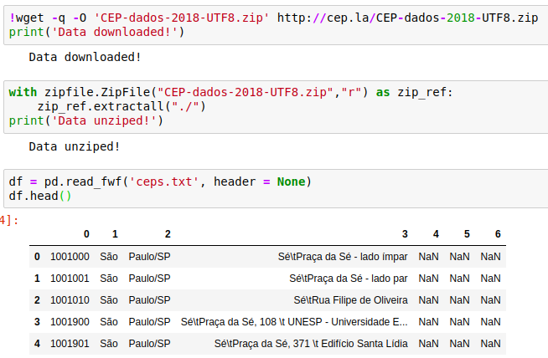

To mitigate this issue and enable analyses continuation a data cleansing must be applied, techniques of string handling, and data frame entanglements were utilized on this cleansing. In order to demonstrate the result of cleansing process below is presented the cleaned data set.

# Methodology

Acquire Postal Code data from Brazilian cities, clean the data, perform data exploration, plot basic statistics to describe the data and present metrics, plot maps to present the data gathered, perform feature engineering, clusterization using K-Means, demonstrate results.

## Data Exploration

The first step of the data exploration was performed the enrichment of the postal code data with geolocation information, on another words latitude and longitude was added to the original cleaned data in order o enrich it. Below is presented the process of data enrichment by the creation of a function, the execution of the function and result data set.

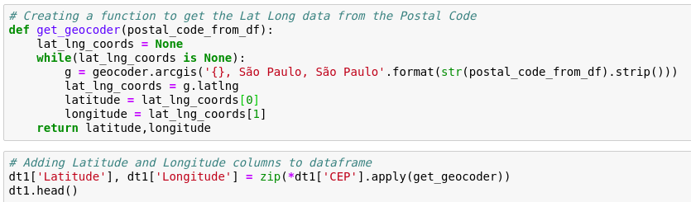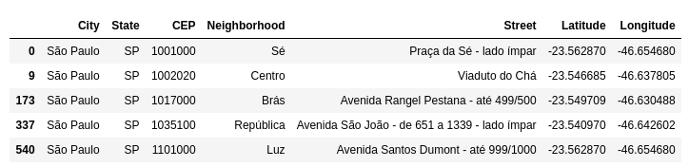

Still on the first step, it was plotted a map pinning all neighborhoods on the city, below the result map can be observed below.

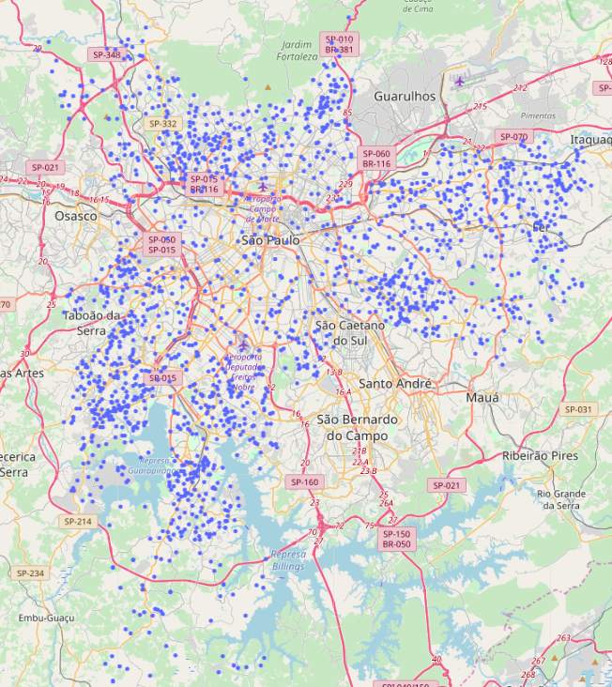

The second step of the data exploration is very similar to the first one, it also aimed into enrich the original data. But this turn the data source utilized was the Foursquare API, to do that, it was created a function responsible for based on a input of the neighborhood name, latitude and longitude performed a API call to retrieve the foursquare data. The result of put all this API response data into a data frame can be observed below.

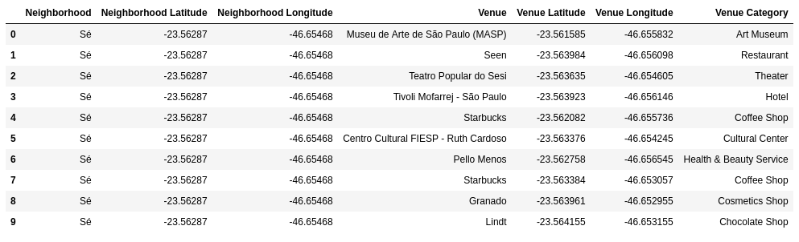

## Data Presentation

In order to better understand the problem several indicators and metrics will be presented to provide a background into the city and project.

* Top 10 Venues Categories
* 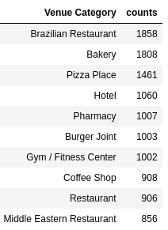Top 10 Venues Categories in the neighborhoods
* 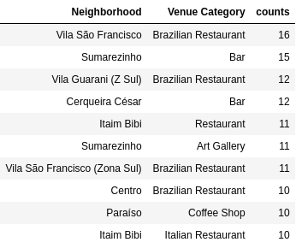Top 3 Venues Categories by neighborhoods (sample)

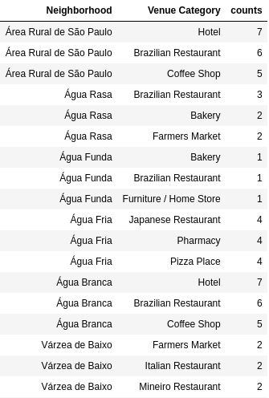

* Top 10 neighborhoods with more venues

*Obs.: Due Foursquare API 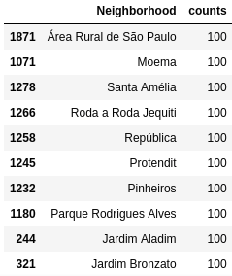restriction, the maximum number of venues by neighborhood is 100

# Results

The result of this project can be understood as the clustering of the neighborhoods based on the similarity of the top 10 venues. To define the ideal amount of clusters several tests were performed with several different number of clusters as for example 3, 4, 5, 6, 7, 8, 9 and 10 clusters.

Below is the plot that represents the distribution of the ten clusters:

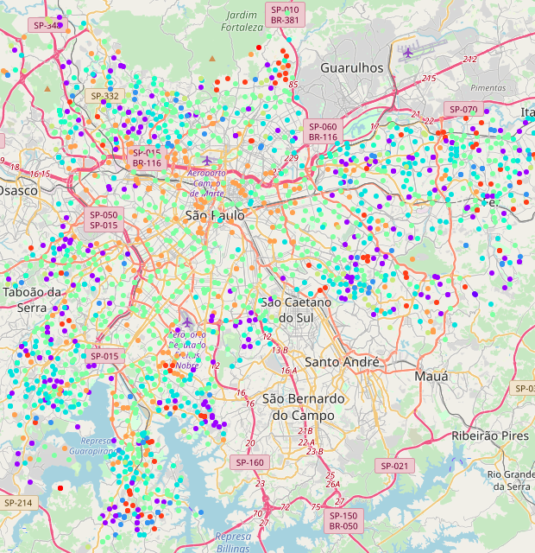

Regarding the Cluster size, below is presented the amount of clusters created in this analysis and also the amount of neighborhoods on each of this clusters.

|  |  |
| --- | --- |
| **Cluster #** | **Amount of Neighborhoods** |
| Cluster 0 | 238 |
| Cluster 1 | 5 |
| Cluster 2 | 83 |
| Cluster 3 | 327 |
| Cluster 4 | 95 |
| Cluster 5 | 681 |
| Cluster 6 | 65 |
| Cluster 7 | 278 |
| Cluster 8 | 96 |
| Cluster 9 | 4 |

# Discussion

As presented on the previous section, the map plot and the frequency of neighborhoods by cluster. Adding to that, when looking at this data and the data of the data exploration it’s possible to extrapolate some recommendations having on mind the target audience mentioned at the beginning of the work.

* Payment industry: could use this data to improve market research and target specific segments to get a better penetration and capillarity in terms os sales. Also, another point it would be knowing the neighborhood distribution on the clusters would be easier to target campaigns to stimulate sales.
* Investors: São Paulo is one of best gastronomical city in the world, several excellent restaurants. I would recommend open a niche restaurant on neighborhoods of cluster 4 because its already a place where the best restaurants are located.
* Social Science researchers: the cluster distribution in the map denote a clear income difference, as rings the clusters are opening letting clear the differences on social class.

# Conclusion

To conclude is important to point out that all problem statements and description were achieved and provided insightful response and recommendations about which would be the best actions depending on certain scenarios. So in a whole this analysis was successful and achieved its objectives.