Carter Dougherty
ME 4180
Final Project
5/13/2026

All scripts used in this assignment along with installation instructions can be found at https://github.com/cardough/ME_4180.

Problem 1
To simulate the arm, a GUI window was constructed using the Python library Pyside6. Within the window, a larger canvas/plot was placed on the left, showing the robot as plotted by the Peter Corke Robotics Toolbox, along with a custom generated line showing the end effector trajectory. The view on the left is animated to show the full robot motion through the movement and can be interacted with to see the robot in 3D. Plots were placed on the right showing the requested joint angles, velocities, accelerations, and torques. The script can be read and run at src\carterd_final_problem_1.py.

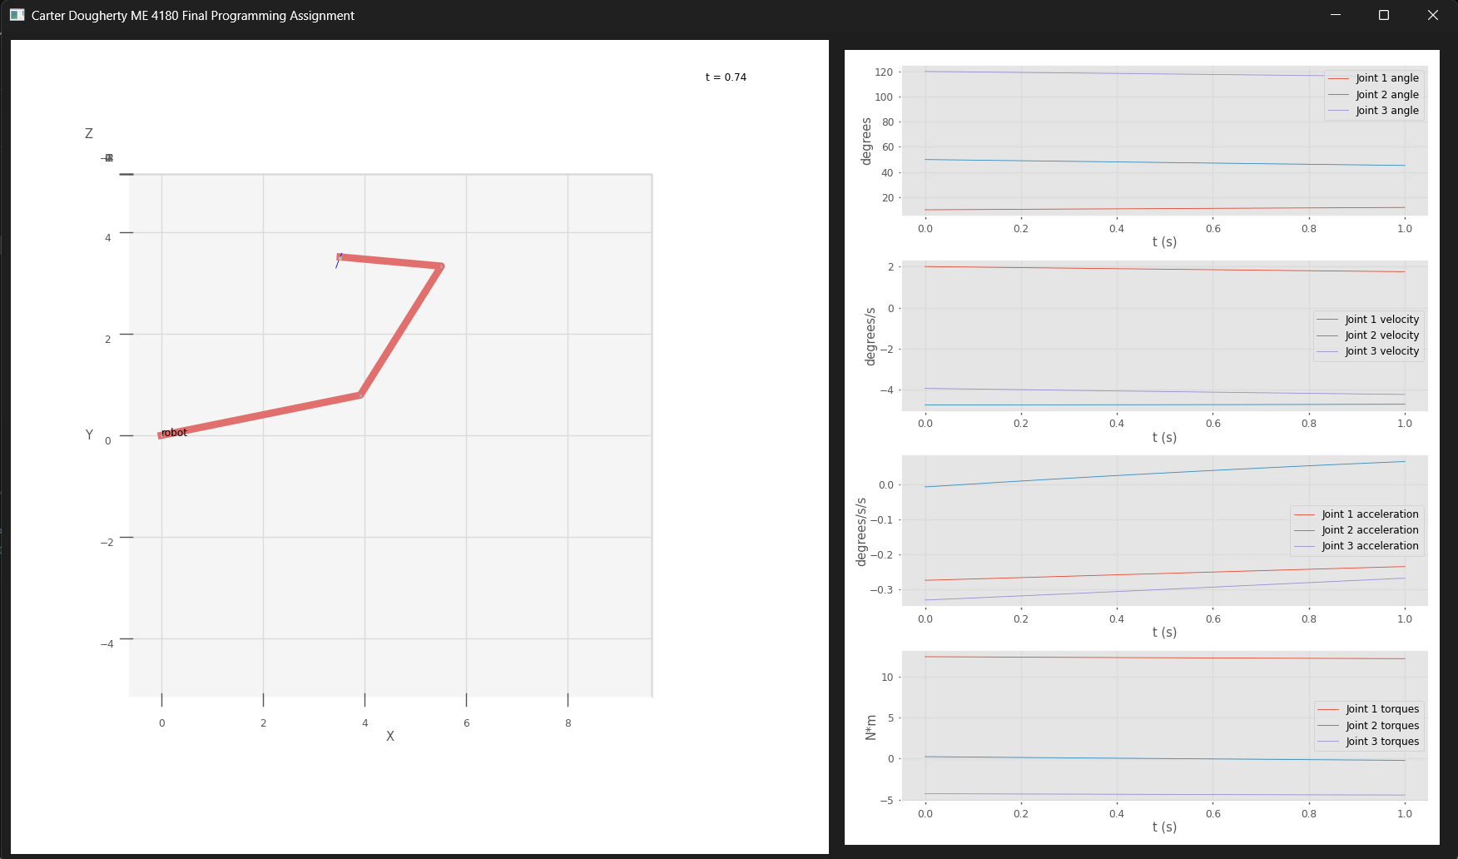
To find the joint positions, the Jacobian was computed using code from previous assignments. The Jacobian was singular, so instead of taking the inverse, the pseudo-inverse was used to form a numerical approximation. Then, the Jacobian was multiplied by the end effector velocities to determine the joint velocities. These were multiplied by the timestep to find the distance traveled per iteration, and these deltas were summed to find the cumulative joint trajectory (angles).
To find joint accelerations, the joint velocities were numerically differentiated with respect to time using a finite difference scheme. It was attempted to find the acceleration analytically, but this proved intractable due to the singular nature of the jacobian.
To find joint torques, the symbolic dynamic equation was determined using the Lagrangian method as found in a previous assignment. The full expression proved to have dozens of terms but was able to be accurately found. Once this expression was known, the joint angles, velocities, and accelerations were substituted in to find the joint torques.
The script for this assignment was packaged into a Windows executable and attached to the Canvas assignment. To run this file, a Windows computer is needed, antivirus may need to be disabled, and the script may need 1-2 minutes to load.

Problem 2
For this problem, Peter Corke’s Python library bdsim was used to generate the block diagram of the system, simulate the response, and generate visualizations. bdsim uses Python text syntax to define transfer function blocks and the wires that connect them together. The following example is the open loop electromechanical system from the problem:
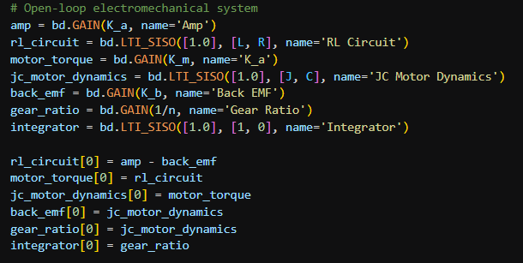
The full system from the problem was implemented in this fashion, using a PID controller with manually defined gains. Scopes were added to the graph to produce graph visualizations of the load angle, load angular velocity, control voltage Va, and back emf. The diagram below shows the system as implemented, and the code itself can be found and run in the script src/carterd_final_problem_2.py.
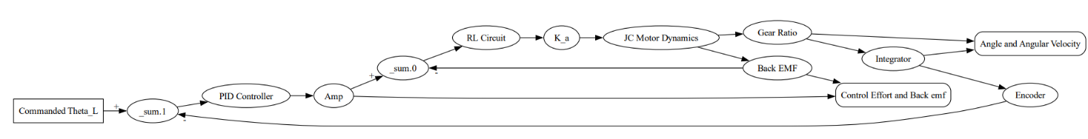
The initial step response of the system is plotted below, with a P gain of 1.0 and no integral or derivative term. It can be observed in the left graph that the system overshoots the set point by at least 10-20 degrees, but settles in about 2 seconds and does not pick up any steady-state error. The lack of steady-state error makes sense since there are no external end-effector forces or gravity. On the right graph, the peak control voltage was over 650 volts, which is likely unrealistic (would damage real hardware).
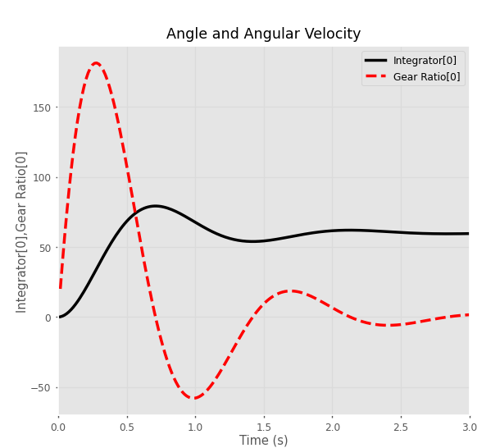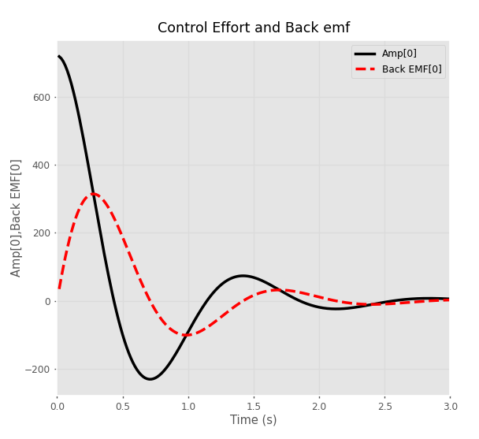

Tuning
The PID gains were tuned starting with the P term; the value was increased gradually until the rise time was around half a second. The integral term was left at zero since the steady-state error was already zero, and the D term was increased until the percent overshoot was visually no more than 5%. After tuning, the P gain was 2.0, the I gain was 0.0, and the D gain was 0.4. On the following graphs, the response can be seen. While this response has quite good performance, it is even less realistic than the untuned response due to the extremely high control voltage (>1400V) and high angular velocity.

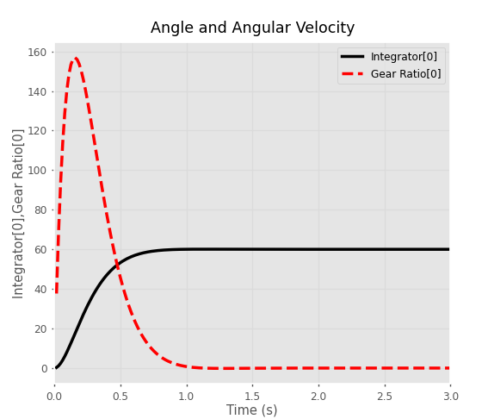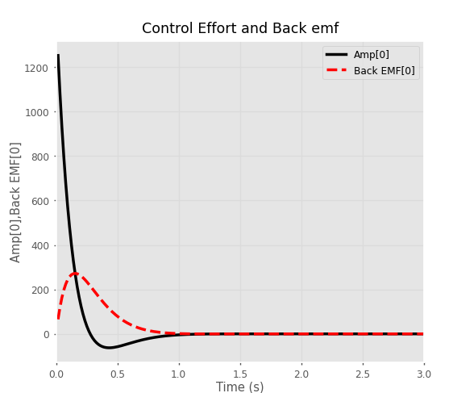

Problem 2.1 – Ramp Input
The step input was changed to a ramp input with the assignment-provided parameters, and the PID gains were redesigned. Generally, the same tuning strategy was used as with the step input, where the proportional gain was tuned first, then the derivative. Again, no integral term was used. In the end, a P gain of 2.0 and a D gain of 0.6 were landed on, which was quite similar to the step input tuning. Through experimentation, it was determined that a smaller P gain led to sluggish behavior. On the other hand, a larger P gain required increasingly large D gains to prevent angle overshoots and spikes in the control effort voltage, which negated the increased responsiveness of the higher P gain. It was found that scaling the gains up uniformly did not change the response. Finally, it can be observed that the control effort voltage stays within reasonable levels (~70V).
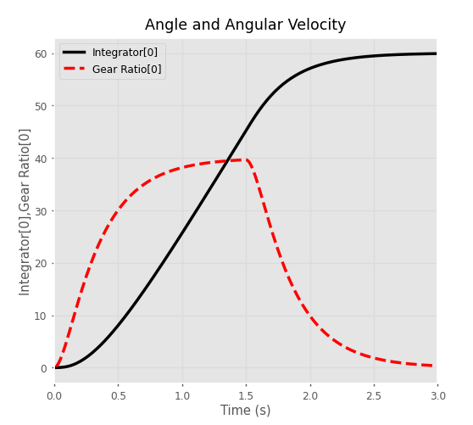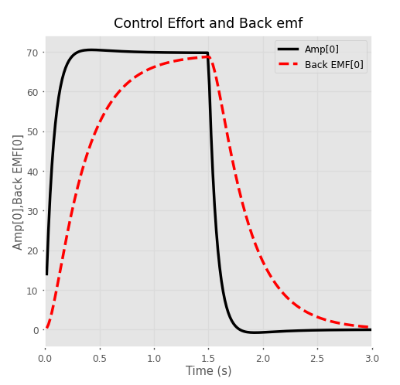
Problem 2.2 – Significance of Inductor
The inductor was assigned an initial value of 0.6 mH for the previous simulation runs. To investigate its significance, various values of L were simulated with the ramp input and tuned gains, and the response was noted.
For a very small L, a value of 0.1 mH was used. Interestingly, this resulted in the system taking much longer to simulate due to the solver choosing a much smaller timestep. However, the resulting graphs were nearly identical to the originals, indicating that the value of the inductor does not have a large impact on the response with its original value.

The value of L was then gradually increased by factors of 10, testing 1 mH, 10 mH, 100 mH, and finally 1 H. At 100 mH, the response started showing oscillations in the control voltage signal (shown below). At 1 H, the response was even more unstable and failed to reach the angle setpoint. This makes sense, since the large inductor would create a resonance within the motor’s back emf feedback with a similar frequency to the control input, and a significant amplification factor. With the inductor at its original value, this resonance was insignificant due to the mismatch in frequencies. In conclusion, the value of the inductor is not particularly significant; it would need to be at least 100 times larger to matter for the inputs we are concerned with.
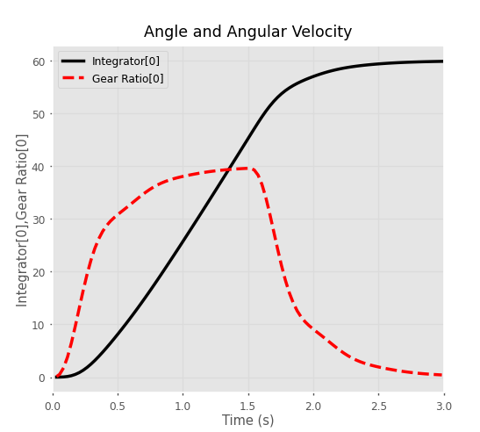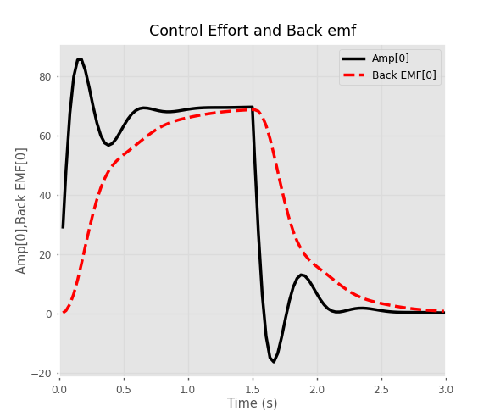

Problem 2.3 – Load Inertia and Damping
The load inertia and damping were scaled up uniformly to investigate how far they could climb. Since the load values are divided by n^2 to reflect them to the motor shaft, it was predicted that a very large scale-factor would be needed before they became significant. Therefore, a scale factor of 10 was used initially, then 100, 1000, and 10,000.
At a scale factor of 100, it is already visible that the control effort voltage overshoots its steady-state value:
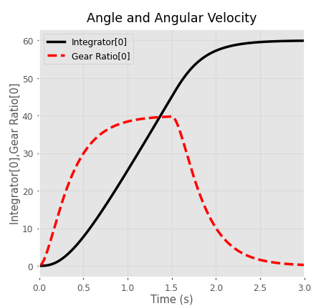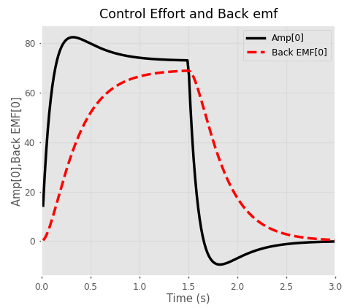

At 1000, the voltage overshoots even more and the actual angle starts to overshoot as the controller is no longer able to completely account for the inertia of the load:
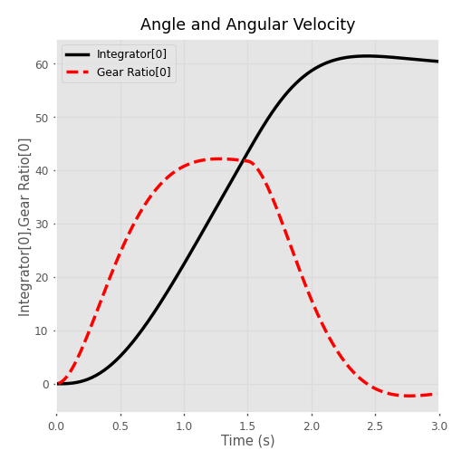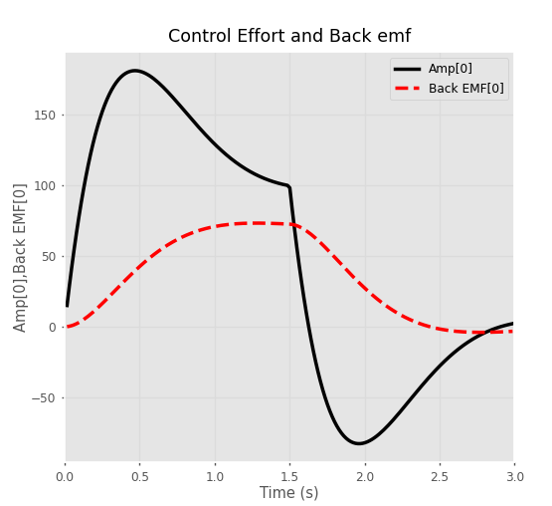
At 10,000, the load inertia is now entirely too large for the controller to start or stop in an appropriate amount of time, and the voltage spikes to over 600 volts as the error balloons. ~12 degrees of overshoot are observed and on these time scales, the input starts behaving more like a step than a ramp:
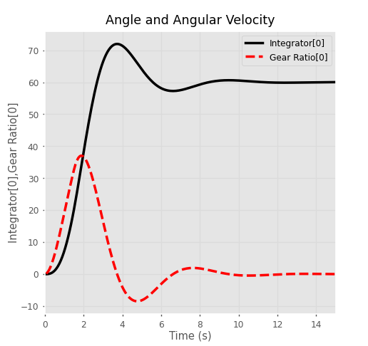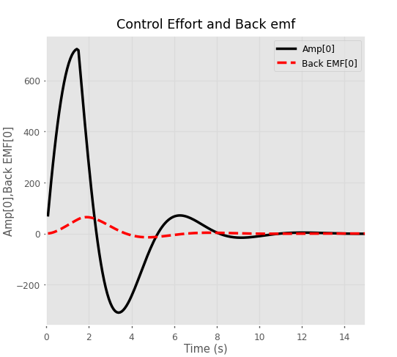

At 100,000, the system takes over 9 seconds to rise and 20 seconds to settle, but the high damping coefficient actually reduces the overshoot compared to the previous case. The max angular velocity reached by the system is much lower than the previous, but stability is not a large concern. If the system could be designed to handle the weight and over 1300V of peak armature voltage, the same controller could safely be used on a load with 100,000 times the inertia and damping:
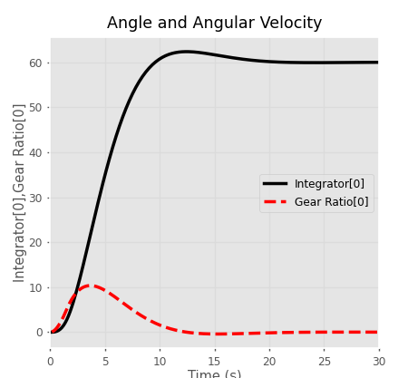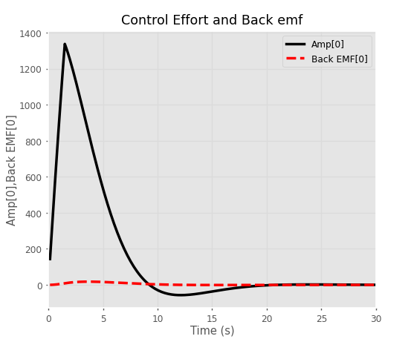
Of course, the trajectory design for this load would be extremely different due to the limited speed; a 10 second rise time would likely be unacceptable in practice.
In conclusion, the largest load that was tested without significant disruption of the operation was 1000 times the initial, and this modification still resulted in much higher armature voltage. At higher loads, the response took much longer than initially, the max speed was reduced, more overshoot was introduced, and the armature voltage reached much higher peak values.

