

Heutrix organisational structure
  - Founder responsibilities and operating areas
Proposed for founder review | 16 September 2026
Heutrix should operate through four complementary founder functions, with Janith coordinating the business and Rochelle coordinating client delivery. Each business area has one accountable lead, supported by the other founders where their expertise is needed.
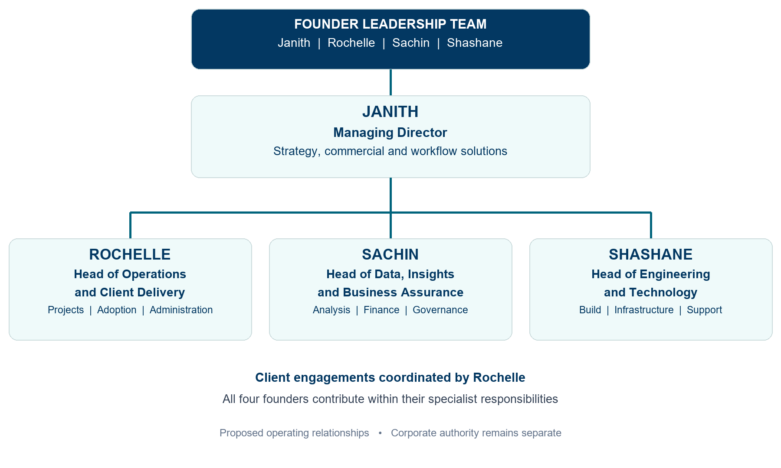

Contents
01 Organisation overview and reporting relationships
02 Founder roles and responsibilities
03 Business areas and folder contents
04 Delivery responsibilities and decision making
The structure is a recommendation. It does not appoint officers, change signing authority or assign permanent folder owners. Existing confirmed responsibilities remain in effect until an agreed update is recorded.

Founder roles and responsibilities

Janith Managing Director — Strategy, Commercial and Workflow Solutions
Documented strengths: Workflow implementation and experience helping build a disability support business.
Set business priorities and offer direction; lead fit calls, sales and partnerships; translate client needs into workflow designs; coordinate decisions across functions.
Accountable outcome: Clear scope, a qualified pipeline, viable commercial commitments and aligned founder priorities.

Rochelle Head of Operations and Client Delivery
Documented strengths: Project delivery and disability-provider administration and operations.
Plan engagements and capacity; coordinate clients and milestones; maintain delivery methods; lead staff training and adoption; organise administration, invoicing and handover.
Accountable outcome: Predictable delivery, clear client communication, complete handovers and timely administrative follow-through.

Sachin Head of Data, Insights and Business Assurance
Documented strengths: Data and analytics.
Lead diagnostic analysis and outcome measurement; maintain financial models and management reporting; coordinate data governance and risk records; support campaign measurement.
Accountable outcome: Reliable evidence, visible project economics and documented handling and review arrangements.

Shashane Head of Engineering and Technology
Documented strengths: Backend engineering and infrastructure.
Design and build integrations and automation; maintain infrastructure and the website; manage technical access controls, testing, release readiness and support; retain confirmed enquiry cover.
Accountable outcome: Maintainable solutions, controlled releases, reliable infrastructure and responsive technical support.
Finance and governance ownership means coordinating the work and obtaining appropriate specialist input. The documented founder summaries do not establish accounting, legal or privacy qualifications.

Business areas and folder contents
The folders remain the operating library. Proposed leads maintain their area and involve affected founders when changes alter scope, cost, delivery, public claims or information handling.
Area | Proposed lead | Contents and responsibilities
00 Control | Janith | Priorities, decisions, launch status, dependencies, risks and shared coordination.
01 Company | Janith | Company records, founder roles, approved systems and insurance records. Rochelle supports administration.
02 Market and offers | Janith | Target markets, positioning, service definitions, scope boundaries and private pricing policy.
03 Sales | Janith | Enquiries, qualification, fit calls, proposals, pipeline, follow-up and delivery handover.
04 Delivery | Rochelle | Delivery methods, project planning, workflow design, testing, training, acceptance and closeout.
05 Legal privacy and risk | Sachin | Review coordination, data-handling standards, risk and incident records. Directors and advisers retain their respective authority.
06 Marketing | Janith | Brand, website content, campaigns, resources and case studies. Sachin supports publishing and measurement.
07 Finance | Sachin | Budgets, forecasts, costing, margins and reporting. Rochelle coordinates invoicing and payment follow-up.
08 Client project template | Rochelle | Reusable engagement structure, project records, deliverables and handover templates. Live client records remain outside Git.
Applications and tools | Shashane | Website, automation, integrations, infrastructure, technical documentation and maintenance.

Supporting relationships
Rochelle checks delivery capacity; Sachin checks economics and evidence; Shashane checks technical feasibility. Janith brings these inputs together before a client commitment is made. Marketing claims and sales promises must stay aligned with the agreed offer and delivery capability.

Delivery responsibilities and decision making

How the offers draw on the team
Offer | Specialist contributions
Heutrix Diagnostics | Janith frames the workflow problem; Sachin leads analysis; Rochelle coordinates the engagement; Shashane assesses technical constraints.
Heutrix Workflow Transformation | Rochelle leads delivery; Janith designs the workflow; Shashane implements technology; Sachin measures results.
Heutrix AI Guardrails | Sachin coordinates governance requirements; Shashane implements technical controls; Rochelle leads procedures and adoption; Janith aligns scope with client needs.

One accountable lead for each decision
Decision | Proposed lead | Required input
Qualification and proposed scope or price | Janith | Rochelle on capacity; Sachin on economics; Shashane on feasibility.
Delivery plan and internal closeout | Rochelle | Specialist readiness checks and the client’s agreed acceptance process.
Financial reporting and margin visibility | Sachin | Rochelle on actuals and collections; Janith on commercial priorities.
Technical release readiness | Shashane | Rochelle on delivery readiness; Sachin on data requirements.
Privacy and incident coordination | Sachin | Shashane on technical response; Rochelle on operations; relevant advisers as needed.

Operating rhythm
Weekly founder meeting: review leads, delivery capacity, cash, risks and decisions. Rochelle coordinates project check-ins with the specialists involved. Review financial performance and offer effectiveness monthly. Agree spending limits, escalation thresholds and backups when adopting the structure.

Confirmed responsibilities and adoption
Current records confirm Shashane on enquiries with Rochelle as backup, Janith on fit calls with Rochelle as backup, and Janith on merge coordination. Janith and Sachin are recorded as authorised director signatories; execution arrangements remain document-specific. Other allocations here are proposed.
To adopt: agree titles, capacity, decision boundaries and backups, then date the agreed assignments in the role register. Use Shashane consistently here; confirm the existing Sashane spelling discrepancy before updating the register.
Source basis: founder role register; workspace README; verified facts and dependency registers; current Heutrix brand guide. These records support the founder strengths and business areas; the organisation design is a recommendation.

