Cesar Recinos

CS380-EX6

www.github.com/carecinos/CS380-EX6

**Login ted without a password**

In order to login as ted without providing a password, I ended the condition after requiring name = ‘ted’, then commented out the rest of the line. This bypassed the password by only requiring a name. the username I enter was: **ted’);#** 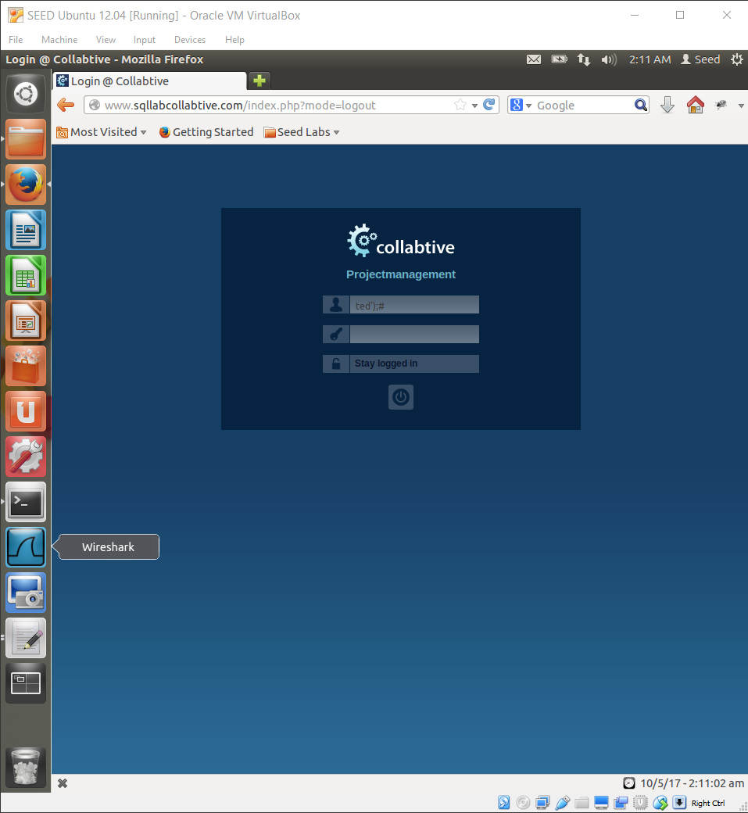

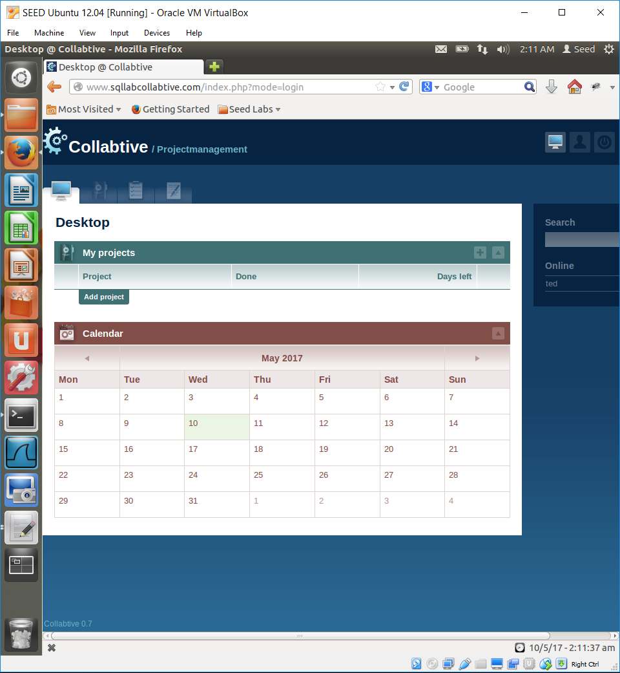

**Login admin without a password**

In order to login as admin without a password, I used the same strategy that was used inn the previous problem. The username I used was as follows: **admin ‘);#**

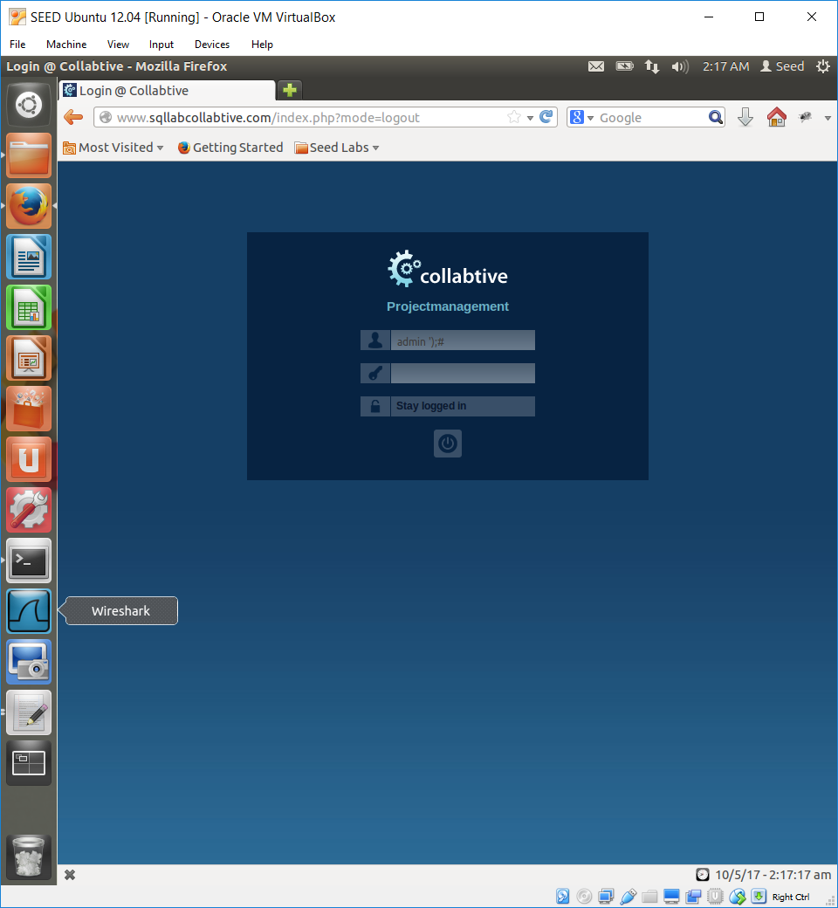

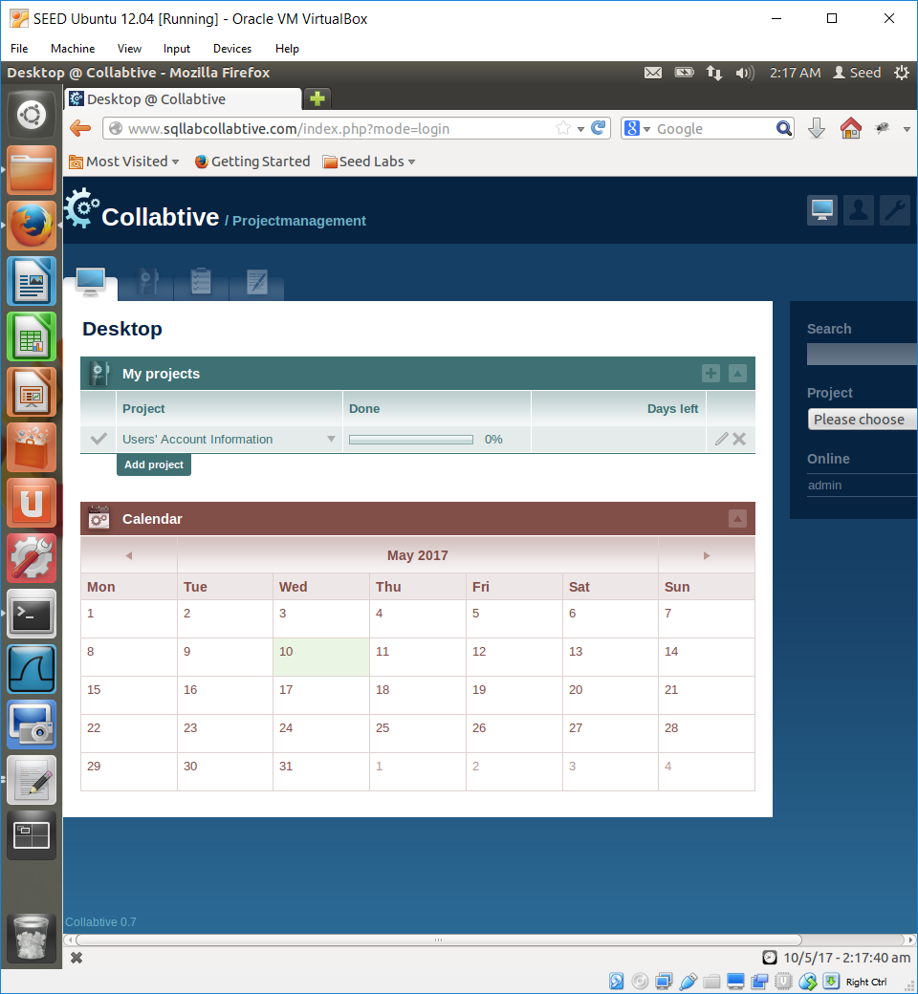

**Login without a username or password**

In order to login without a username, in included an OR condition that is always true, therefore it will always satisfy the login. The username I used is: **‘ or ‘’=’’);#**

This condition is satisfied when **‘’ = ‘’** which is always.

