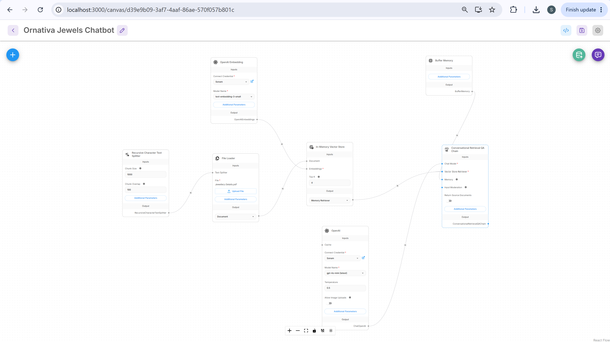
Hi there! How can I help?

List all available diamond items.

Here are the available diamond items from our jewellery catalogue:
- Classic Diamond Ring
  - Material: 18K Gold + Diamond
  - Weight: 5.2 g
  - Price: 135,000
- Diamond Stud Earrings
  - Material: 18K Gold + Diamond
  - Weight: 6.2 g
  - Price: 105,000
- Lotus Pendant
  - Material: 18K Gold + Diamond
  - Weight: 8.0 g
  - Price: 72,000
If you would like more information or assistance with any of these items, feel free to ask!

What is the price of the Pearl Necklace?

The price of the Pearl Necklace is 245,000. If you have any more questions or need assistance with anything else, feel free to ask!

Which products are made of 22K gold?

Here are the products made of 22K gold from our jewellery catalogue:
- Ruby Solitaire Ring
  - Weight: 4.8 g
  - Price: 98,500 (Out of Stock)
- Emerald Choker
  - Weight: 32.0 g
  - Price: 310,000
- Daily Wear Gold Earrings
  - Weight: 7.5 g
  - Price: 55,000
- Gold Chain Bracelet
  - Weight: 12.0 g
  - Price: 87,500
- Om Symbol Pendant
  - Weight: 6.5 g
  - Price: 48,000
Please note that the Ruby Solitaire Ring is currently out of stock. If you need further assistance or details on any of these items, just let me know!

Do you have ruby rings?

We currently have one ruby ring listed in our catalogue:
- Ruby Solitaire Ring
  - Material: 22K Gold + Ruby
  - Weight: 4.8 g
  - Price: 98,500
However, please note that this item is currently out of stock. If you're interested, I can suggest other available rings. Would you like to see those?

What can you recommend as a gift under ₹15,000?

I can only provide information about the jewellery items in our catalogue. Unfortunately, all the available items exceed ₹15,000. The lowest priced item is the Daily Wear Gold Earrings, which are priced at ₹55,000.
If you have a different budget or are looking for specific types of jewellery, please let me know, and I can assist you further!

above 90000

Here are the jewellery items priced above ₹90,000 from our catalogue:
- Classic Diamond Ring
  - Material: 18K Gold + Diamond
  - Weight: 5.2 g
  - Price: 135,000
- Ruby Solitaire Ring
  - Material: 22K Gold + Ruby
  - Weight: 4.8 g
  - Price: 98,500 (Out of Stock)
- Emerald Choker
  - Material: 22K Gold + Emerald
  - Weight: 32.0 g
  - Price: 310,000
- Pearl Necklace
  - Material: 18K Gold + Pearl
  - Weight: 28.5 g
  - Price: 245,000
- Diamond Stud Earrings
  - Material: 18K Gold + Diamond
  - Weight: 6.2 g
  - Price: 105,000
- Lotus Pendant
  - Material: 18K Gold + Diamond
  - Weight: 8.0 g
  - Price: 72,000
If you need more information or assistance with any of these items, feel free to ask!

What products are out of stock

The following products are currently out of stock in our jewellery catalogue:
- Ruby Solitaire Ring
  - Material: 22K Gold + Ruby
  - Weight: 4.8 g
  - Price: 98,500
- Emerald Cuff Bracelet
  - Material: 18K Gold + Emerald
  - Weight: 15.0 g
  - Price: 150,000
If you're interested in any available items or need further assistance, just let me know!

