Please find the problem and the solution illustrated below:

1. You find your Workspace in an **Unhealthy** Status while trying to log in

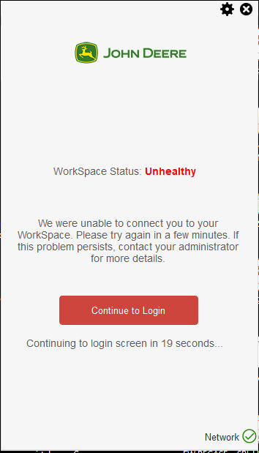

1. Click on the gear box on your Amazon WorkSpace client and click on **My Workspace** where you will get a **Restart Workspace** option. Please click on that to initiate the reboot.

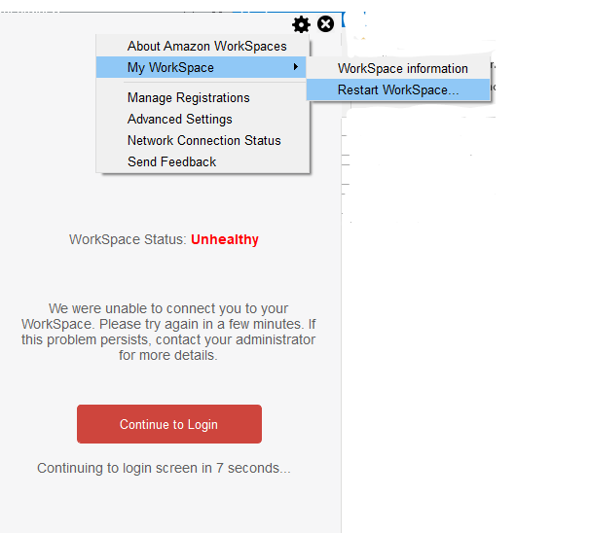

1. Please wait for 15 minutes for the reboot to complete, after which you should be able to connect to your Workspace directly after entering your credentials in the Log in Screen

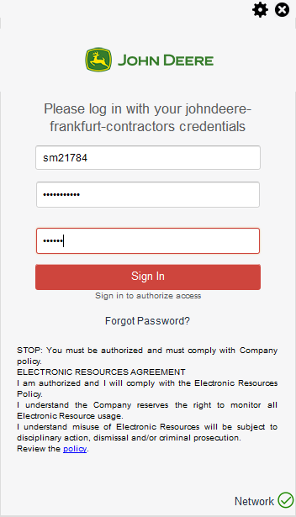

1. In case you still continue to face connectivity issues please raise an incident in Service Now.