**Annexure -3**

**Software Requirements Specification For Minor Project**

**Careerheight$**



|  |  |
| --- | --- |
| **Prepared by: Anjali Mishra Sharmila Kumari** | **Guide: Ms. Shazia Haque Associate Professor** |
| **Department of Information Technology,**  **Poornima College of Engineering**  **<Date created> Session – 2018-19** | |

# Table of Contents

|  |  |
| --- | --- |
| **Table of Contents** | Page No. |
| **1. Introduction** |  |
| **1.1 Purpose** |  |
| **1.2 Feasibility** |  |
| **2. Functional /Nonfunctional Requirements** |  |
| **2.1 Functional Requirement** |  |
| **2.2 Nonfunctional Requirements** |  |
| **2.3 Technical Requirments ( Hardware /Software)** |  |
| **3. System Features** |  |
| **3.1 Module 1** |  |
| **3.1 Module 2** |  |
| **3.1 Module 3** |  |
| **3.1 Module 4** |  |
| **4. Analysis Diagrams** |  |
| * 1. **Use Case Diagram**   2. **Sequence Diagram**   3. **Component diagram**   4. **Data Flow Diagram(Optional)**   5. **ER Diagram**   6. **Activity Diagram**   7. **Project Schedule Diagram** |  |
| **5. Other Requirements** |  |
| **6. Glossary** |  |
| **7. Appendices** |  |
| **8. References** |  |
| **9. Guide’s Comments** |  |

**Revision History**

|  |  |  |  |
| --- | --- | --- | --- |
| **Name** | **Date** | **Reason For Changes** | **Version** |
|  |  |  |  |
|  |  |  |  |
|  |  |  |  |

## Introduction

Viewing available jobs, or applying for the job at the agency/company can be done for which job seekers does not need to go to the agency/company and check the available jobs rather they can do it online. Job seekers check the list of jobs available and apply the job online. Then the agency will show available jobs for the job seeker for his qualifications and then

updates the jobs database.

## Purpose

The **purpose** of designing this project is to give the **job** seekers a platform for finding a right and a satisfactory **job** according to their qualification. It also connects the **job** seekers with the major agencies.

It also provides job portal for Job Seekers to submit their CV and apply for Job posting and Employer can select best Employees from available CV. This is basically a Job Portal where Job Seekers applies for jobs and Employer post jobs and select prospective applicant.

So it enables applicants to search for jobs in a convenient manner and to enable employers to find suitable candidates.

## Feasibility

* + 1. **Operational Feasibility**: Operation of the proposed system depend on its various users. These various user-types mentioned below.
       - Admin
       - Employer
       - Job Seeker

Admin will manage details of employers and employees Admin can restrict unauthorized people or wrong entries. Employees can register the details to the websites.

Employee can upload profile.

* + 1. **Social Feasibility**: Proposed system would be acceptable by the other people*s. Because Online Job portal* is better than ordinary *registration process.*
       - Faster than other older systems
       - Database keeps records
       - Time saving
    2. **Economic Feasibility**: As no papers required so it reduce cost. It would be beneficial because only one time development efforts required. All people are aware of technologies so no special skills required to run the system.

## Functional /Nonfunctional Requirements

* 1. **Functional Requirements**
     1. **Admin**
        + A system for an Admin who can enter the employee details like name, contact number, location, department etc.
        + Admin can manage the account of applicants
        + Admin can manage Recruiters
        + Admin can manage jobs
        + Admin can Add jobs
        + Admin can delete jobs
        + Admin can Edit jobs
        + Admin can view the details of the employees and applicants/job seeker
        + Admin can monitor every activity which is performed by system.
        + Download CV or Application submitted by jobseekers

## Employers

* + - * Can register in the system
      * Can login in the system
      * Can post jobs
      * Can delete jobs
      * Can update jobs
      * Approve jobs for Job seekers
      * Can view the details of registered applicants.
      * Download CV or Application submitted by jobseekers

## Job seekers

* + - * Users has the facility to see available services or vacancies
      * Can login in the system
      * Can upload CV
      * Can search jobs
      * Can apply for jobs
      * Can update profile details
      * According to the profile of applicants available jobs are been suggested to them

## Non-functional Requirements

* + - Secure access of confidential data (employee details) by username and password. This application is secure for every kind of its users, because if any user logout from any session then nobody will be able to access his profile without knowing his confidential password
    - 24x7 availability
    - This application can be accessed from any type of platform
    - The database used here is robust, reliable and fast. So user will have to wait for very short time for the output
    - Reliability
    - Better component designs to get better performance at peak time
    - Flexible service based system
    - Password recovery system is also provided in case of forgetting the password

## Technical Requirments ( Hardware /Software) Operating Environment

Our application could be operated on various platforms which includes – Windows , Linux and MacOs and the data will be stored in Database . All this runs effectively with Internet connectivity.

## Hardware Interfaces

* RAM :2GB
* Processor: Intel Pentium and above version

## Software Interfaces

* + Languages Used to implement : Python 3/PHP
  + Operating System: Windows 7 or above
  + Internet Browser: Mozilla/Google chrome
  + Front End: HTML, CSS, Bootstrap
  + Back End: MySQL
  + Web server: Xampp
  + Tool: Pycharm Professional Edition/Notepad++

## System Features

* 1. **Modules:**

The web application comprises the following major modules:

## Job Seeker Module

This module provides functionalities for job seekers. Applicants can post their resumes with personal and professional details. They can also update the resume as frequently as required.

The applicant can also browse through the present vacancies available. Job Seekers can also get mail alerts when their resumes are selected by employers.

## Employer Module

This module provides functionalities related to Employers. Employer can post vacancy details and update the details as and when necessary. Employers can search through applicant resumes based on their criteria.

## Admin Module

This module provides functionalities related to Admin. Admin manages entire application and maintains the profiles of applicants and employers.

## Analysis Diagrams

* 1. **Use Case Diagram**

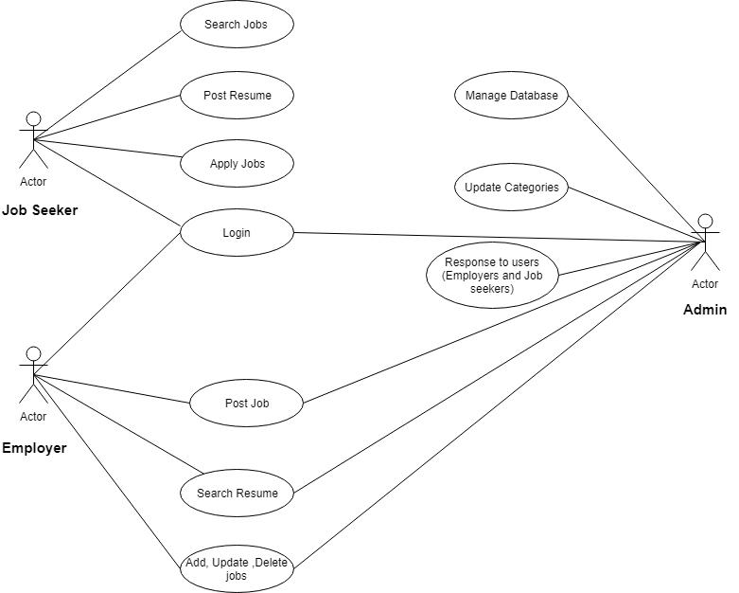

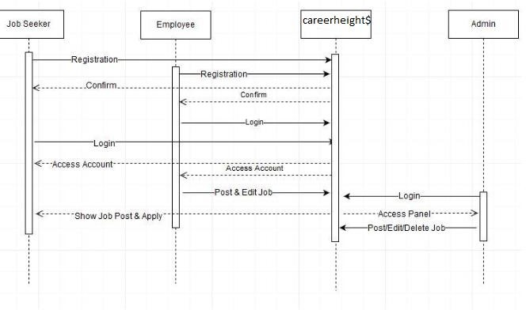**Sequence Diagra**

**Component diagram**

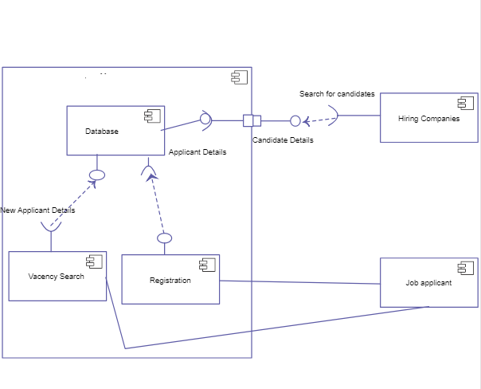

**ER Diagram**

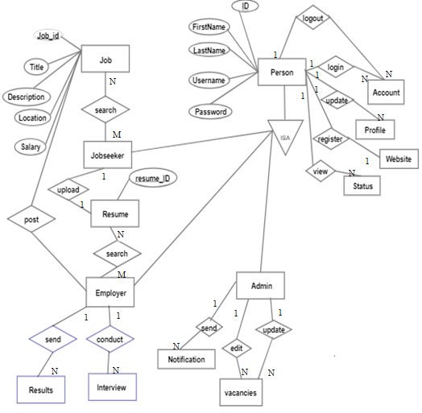



* 1. **Activity Diagram**

Employee Activity Diagram

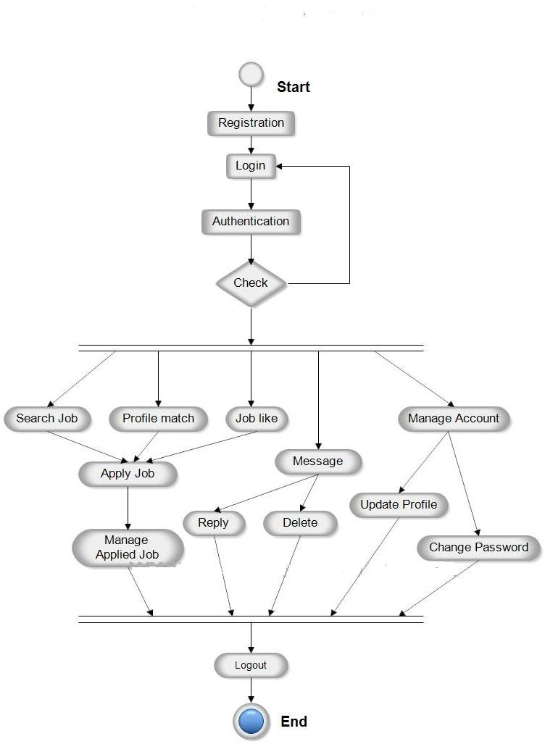

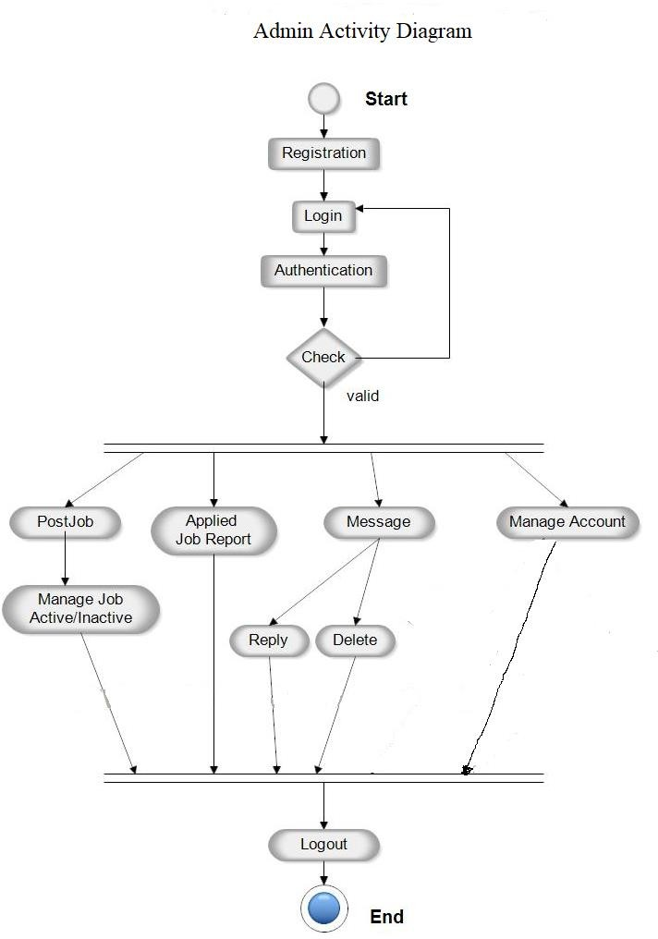

## .6 Flowchart Diagram

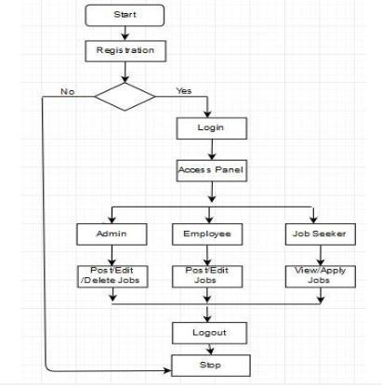

1. **Other Requirements**

* Email will be send to the applicants selected
* Details of all the applicants

## Glossary

CV: Curriculum Vitae

## Appendices

**References**

* + [www.stackoverflow.com](http://www.stackoverflow.com/)
  + [www.psudobyte.blogspot.com](http://www.psudobyte.blogspot.com/)
  + [www.scribd.com](http://www.scribd.com/)

## Guide’s Comments