02

Content

WHAT YOU WILL LEARN

* Typography
* Images
* Tables

Typography

* Headings

Images

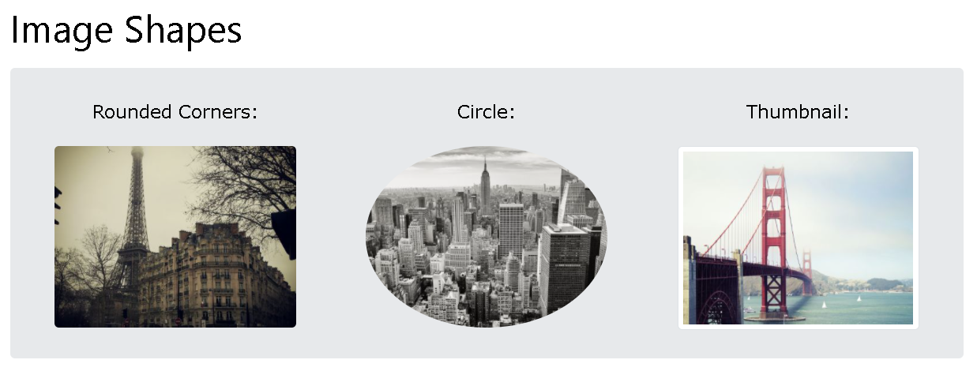

* + The .rounded class adds rounded corners to an image.
  + The .rounded-circle class shapes the image to a circle
  + The .img-thumbnail class shapes the image to a thumbnail (bordered)
  + Float an image to the left with the .float-start class or to the right with .float-end
  + Center an image by adding the utility classes .mx-auto (margin:auto) and .d-block (display:block) to the image
  + Images come in all sizes. So do screens. Responsive images automatically adjust to fit the size of the screen.
  + Create responsive images by adding an .img-fluid class to the <img> tag.
  + The .img-fluid class applies max-width: 100%; and height: auto; to the image

Tables

* + The .table class adds basic styling to a table:
  + The .table-striped class adds zebra-stripes to a table:The .table-bordered class adds borders on all sides of the table and cells:
  + The .table-hover class adds a hover effect (grey background color) on table rows:
  + The .table-dark class adds a black background to the table
  + The .table-borderless class removes borders from the table
  + The .table-responsive class adds a scrollbar to the table when needed (when it is too big horizontally)

