Course Curriculum

Kiran

DevOps with Amazon Web Services

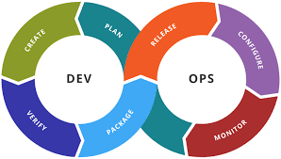

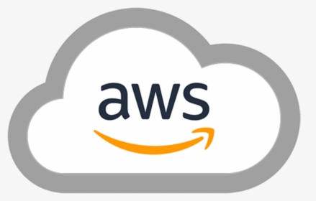

# Topics – Hourly Breakup

|  |  |
| --- | --- |
| **Concept** | **Hours** |
| Course Overview, Setup | 1 |
| IT Architecture Overview. | 1 |
| Networking & DNS | 2 |
| AWS Overview | 1 |
| AWS IAM | 1 |
| AWS – ec2, VPC, Load Balancing | 4 |
| Linux | 2 |
| Source Control – Git & GitHub | 2 |
| Terraform | 3 |
| Ansible | 3 |
| CI-CD | 5 |
| Docker | 3 |
| Kubernetes | 3 |
| Monitoring & AWS Cloudwatch | 2.5 |
| Project - HA Setup | 2.5 |
| **Total** | **36** |

# **Detailed Content**

Day 1

* Introduction to the Course.
* Setup - AWS AccountCreation, Software Installation up.
* IT Architecture Overview.
  + DataCenters, Networks & Virtualization.
  + 3 Tier & n-Tier Architecture.
  + High Availability, Load balancing, DNS
* AWS Overview
  + AWS Global Infrastructure.
  + AWS Services, Accounts, Organizations
  + AWS Physical & Networking Layer.
  + Shared Security Responsibility Model.

Day 2

* Identity & Access Management
  + Access Control Management, RBAC.
  + AWS IAM overview.
  + Understanding Permissions and Policies in AWS.
  + Users, Groups and Roles.
* Networking
  + VPC overview.
  + Choosing the right CIDR & Subnetting.
  + Hands-on with VPC
  + Routing, Gateways - Internet, NAT
  + Security Groups & NACL

Day 3

* Compute
  + EC2 Overview - InstanceTypes, Categories, Pricing.
  + EC2 Creation
  + Auto Scaling, Load Balancing.

Day 4

* Linux
  + File system, administration.
  + Package, Services and Process Management
  + Scripting

Day5

* Version Control
  + Git installation & Configuration
  + commits, Branches, Merging.
* Github, aws Code commit
* Terraform
  + Installation
  + Configuration
  + Apply, Destroy, upgrade.
  + Remote State

Day 6

* Ansible
  + Installation and configuration
  + Inventory
  + Ad-hoc commands
  + Modules, Tasks,
  + Playbooks

Day 7

* CICD
  + Continuous Integration and Continuous Delivery
  + Integration with Source Code repository
  + Installing Jenkins – Multiple Node setup
  + CI-CD pipeline through UI
  + Declarative Pipeline

Day 8

* Containers
  + Overview, Images, containers.
  + Docker – Installation
  + Container Management
  + Image – Creation, tags, reusability.
  + Dockerfile, DockerHub

Day 9

* Container Orchestration - Kubernetes
  + Pods
  + Replicasets
  + Deployments
  + Services, Ingress, Ingress controller
* EKS
  + Creation, Authentication
  + kubectl

Day 10

* Monitoring & Alerting
  + Metrics
  + Logging
  + Major Incident, RCA, MTTR, MTBF
* AWS Cloudwatch
* SNS

Day 11

* AWS - Other key Services
  + Management & Governance Services Overview.
  + Developer Services Overview.
  + Network & Content Delivery Serevices Overview.
  + Security, Identity & Compliance.
* Well Architected Framework

Day 12

* Mini Project - HA Setup with end-to-end automation
* Course wrap, Next steps