AWS Cost Management

Kiran

Table of Contents
1. Cost Management
1.1. Billing Dashboard:
1.2. Cost Explorer
1.3. Cost and Usage Report
1.4. Cost Anomaly Detection
1.5. Budgets
1.6. Budget Actions

Cost Management
The cloud allows you to trade fixed expenses (such as data centers and physical servers) for variable expenses, and only pay for IT as you consume it. And, because of the economies of scale, the variable expenses are much lower than what you would pay to do it yourself.
AWS has a set of solutions to help you with cost management and optimization. This includes services, tools, and resources to organize and track cost and usage data, enhance control through consolidated billing and access permission, enable better planning through budgeting and forecasts, and further lower cost with resources and pricing optimizations. To learn how you can optimize and save costs today, visit cost optimization page .
Summary of Various Cost Management tools and use cases.
Use Cases | Capabilities | Tools
Organize | Construct cost allocation & governance with your own tagging strategy. | Cost Allocation Tags,Cost Categories
Reports | Get detailed view on cloud spend and allocable cost data. | Cost Explorer , Cost & Usage Report
Access | Track consolidated billing of organization. | Consolidated billing , Purchase & Order Management
Control | Establish controls and governance mechanism. | Cost Anomaly Detection
Forecast | Estimate y our resource utilization and billing. | Cost Explorer
Budget | Set up cloud threshold and alert notifications. | Budgets, Budget Actions
Purchase | Create Savings plans in exchange for a usage commitment. | Savings Plans
Rightsize | Optimize your provisioned capacity as per actual demand. | Right Sizing Recommendations, Compute Optimizer

Billing Dashboard:
AWS Billing dasbhoard is the homepage for your Cost Management. This gives you a quick snapshot of your recent monthly spendings and links to other cost managmenet services.
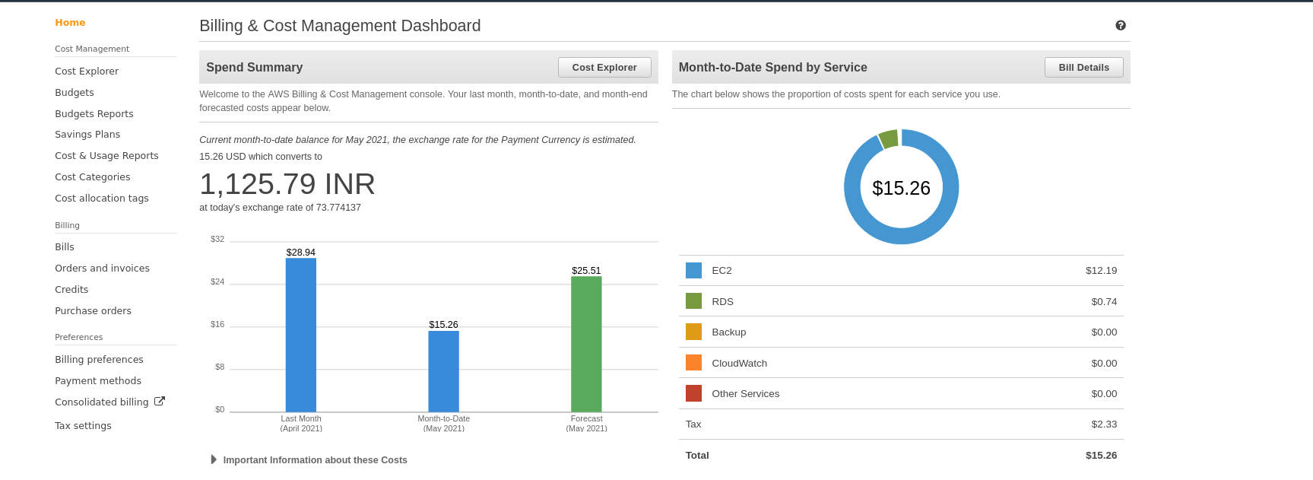
Key Cost Managment Services

Cost Explorer
Cost Explorer is an aws service that lets you easily Visualize, understand, and manage your AWS costs and usage over time. It has an easy-to-use interface with very useful features.
Cost Explorer lets you:
- Use the preconfigured views for common spend scenarios. You can customize any view to fit your use case.
- Shows the monthly spend over last three months, grouped by Linked Accounts. This is only available for paying account in AWS Organizations.
- Shows the daily spend over last 60 days.
You could select a Time line for which you want to see the costs and check the frequency.
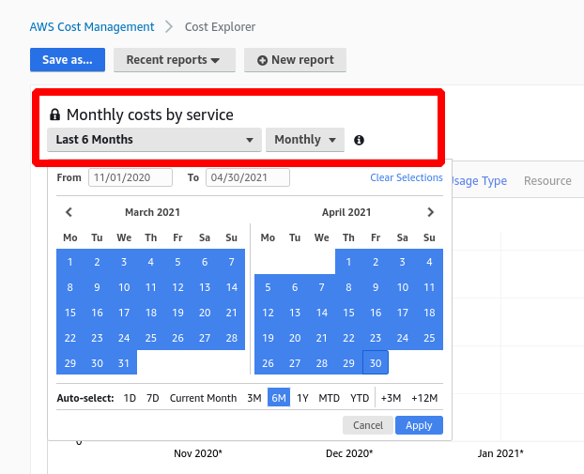
You could see very granular detials and per day usage grouped by location or service or Cost Category or even by Tag.
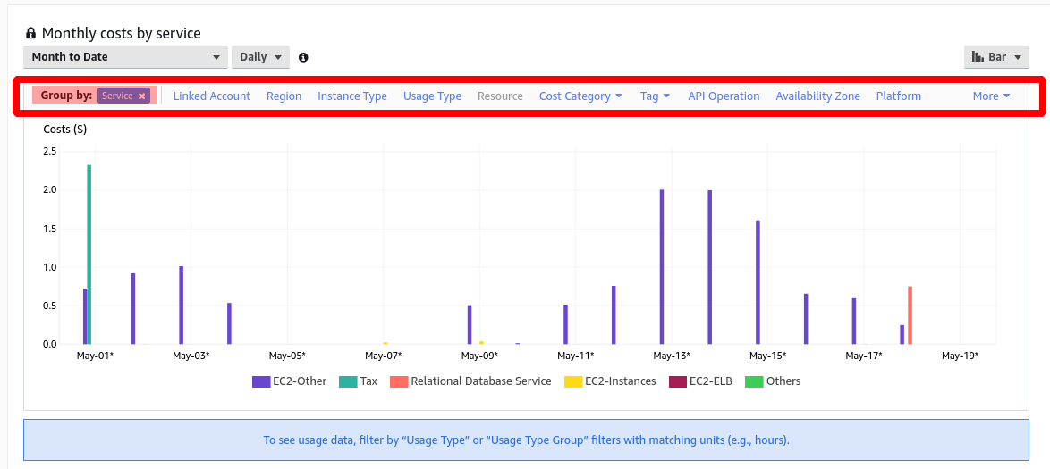

Cost and Usage Report
Cost & Usage Report (CUR) contains the most comprehensive set of AWS cost and usage data available, including additional metadata about AWS services, pricing, Reserved Instances, and Savings Plans.
CUR itemizes usage at the account or Organization level by product code, usage type and operation. These costs can be further organized Usage Report is available at an hourly, daily, or monthly level of granularity.
CUR is available at an hourly, daily, or monthly level of granularit
You can integrate CUR reports with Athena/RedShift/QuickSight to analyse your spending information.

Cost Anomaly Detection
In the World of IT infrastructure, there is always a possibility of incurring costs that are abnormal or not easy to pinpoint.AWS Cost Anomaly Detection uses Machine Learning technologies to identify anomalous spend and root causes, so you can quickly take action.
With three simple steps, you can create your own contexualized monitor and receive alerts when any anomalous spend is detected.
Cost Anamoly Detection saves time on investigating spend anomalies by receiving automated root cause analysis, pin-pointing potential cost drivers, such as usage type (e.g. data transfer cost), specific AWS service, Region, and Member Account(s).

Budgets
Budgets allows you to set custom budgets to track your cost and usage from the simplest to the most complex use cases.
Budgets alert you by email or SNS notification when actual or forecasted cost and usage exceed your budget threshold, or when your actual Reserved Instances and Savings Plans' utilization or coverage drops below your desired threshold.
Budgets integrates with multiple other AWS services, such as AWS Cost Explorer, so you can easily view and analyze your cost and usage drivers, AWS Chatbot, so you can receive Budget alerts in your designated Slack channel or Amazon Chime room, and AWS Service Catalog, so you can track cost on your approved AWS portfolios and products.

Budget Actions
Budget Actions lets you configure specific actions to respond to cost and usage status in your accounts, so that if your cost or usage exceeds or is forecasted to exceed your threshold, actions can be executed automatically or with your approval to reduce unintentional over-spending.

Savings Plans
Savings Plans is a flexible pricing model offering lower prices compared to On-Demand pricing, in exchange for a specific usage commitment (measured in $/hour) for a one or three-year period.
AWS offers three types of Savings Plans:
- Compute Savings Plans: Compute Savings Plans apply to usage across Amazon EC2, AWS Lambda, and AWS Fargate.
- EC2 Instance Savings: Plans apply to EC2 usage.
- Amazon SageMaker Savings Plans: Aply to Amazon SageMaker sage.
You can easily sign up a 1- or 3-year term Savings Plans in AWS Cost Explorer and manage your plans by taking advantage of recommendations, performance reporting, and budget alerts.
