Course Curriculum

Kiran

DevOps with Amazon Web Services

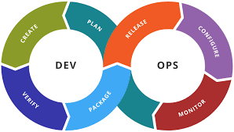

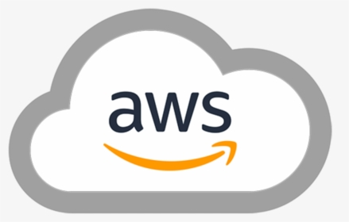

Topics – Hourly Breakup

Concept | Hours
Course Overview, Setup | 1
IT Architecture Overview. | 1
Networking & DNS | 2
AWS Overview | 1
AWS IAM | 1
AWS – ec2, VPC, Load Balancing | 4
Linux | 2
Source Control – Git & GitHub | 2
Terraform | 3
Ansible | 3
CI-CD | 5
Docker | 3
Kubernetes | 3
Monitoring & AWS Cloudwatch | 2.5
Project - HA Setup | 2.5
Total | 36

Detailed Content

Day 1
- Introduction to the Course.
- Setup - AWS AccountCreation, Software Installation up.
- IT Architecture Overview.
  - DataCenters, Networks & Virtualization.
  - 3 Tier & n-Tier Architecture.
  - High Availability, Load balancing, DNS
- AWS Overview
  - AWS Global Infrastructure.
  - AWS Services, Accounts, Organizations
  - AWS Physical & Networking Layer.
  - Shared Security Responsibility Model.

Day 2
- Identity & Access Management
  - Access Control Management, RBAC.
  - AWS IAM overview.
  - Understanding Permissions and Policies in AWS.
  - Users, Groups and Roles.
- Networking
  - VPC overview.
  - Choosing the right CIDR & Subnetting.
  - Hands-on with VPC
  - Routing, Gateways - Internet, NAT
  - Security Groups & NACL

Day 3
- Compute
  - EC2 Overview - InstanceTypes, Categories, Pricing.
  - EC2 Creation
  - Auto Scaling, Load Balancing.

Day 4
- Linux
  - File system, administration.
  - Package, Services and Process Management
  - Scripting

Day5
- Version Control
  - Git installation & Configuration
  - commits, Branches, Merging.
- Github, aws Code commit
- Terraform
  - Installation
  - Configuration
  - Apply, Destroy, upgrade.
  - Remote State

Day 6
- Ansible
  - Installation and configuration
  - Inventory
  - Ad-hoc commands
  - Modules, Tasks,
  - Playbooks

Day 7
- CICD
  - Continuous Integration and Continuous Delivery
  - Integration with Source Code repository
  - Installing Jenkins – Multiple Node setup
  - CI-CD pipeline through UI
  - Declarative Pipeline

Day 8

- Containers
  - Overview, Images, containers.
  - Docker – Installation
  - Container Management
  - Image – Creation, tags, reusability.
  - Dockerfile, DockerHub

Day 9
- Container Orchestration - Kubernetes
  - Pods
  - Replicasets
  - Deployments
  - Services, Ingress, Ingress controller
- EKS
  - Creation, Authentication
  - kubectl

Day 10
- Monitoring & Alerting
  - Metrics
  - Logging
  - Major Incident, RCA, MTTR, MTBF
- AWS Cloudwatch
- SNS

Day 11
- AWS - Other key Services
  - Management & Governance Services Overview.
  - Developer Services Overview.
  - Network & Content Delivery Serevices Overview.
  - Security, Identity & Compliance.
- Well Architected Framework

Day 12
- Mini Project - HA Setup with end-to-end automation
- Course wrap, Next steps

