AWS CloudWatch

Kiran

Table of Contents
Cloudwatch
Dashboards
Metrics
Logs
Alarms
SSM Installation

Cloudwatch
CloudWatch is aws's native service to monitor resources and applictions and alert the responsible parties when a service or application is not working as expected.
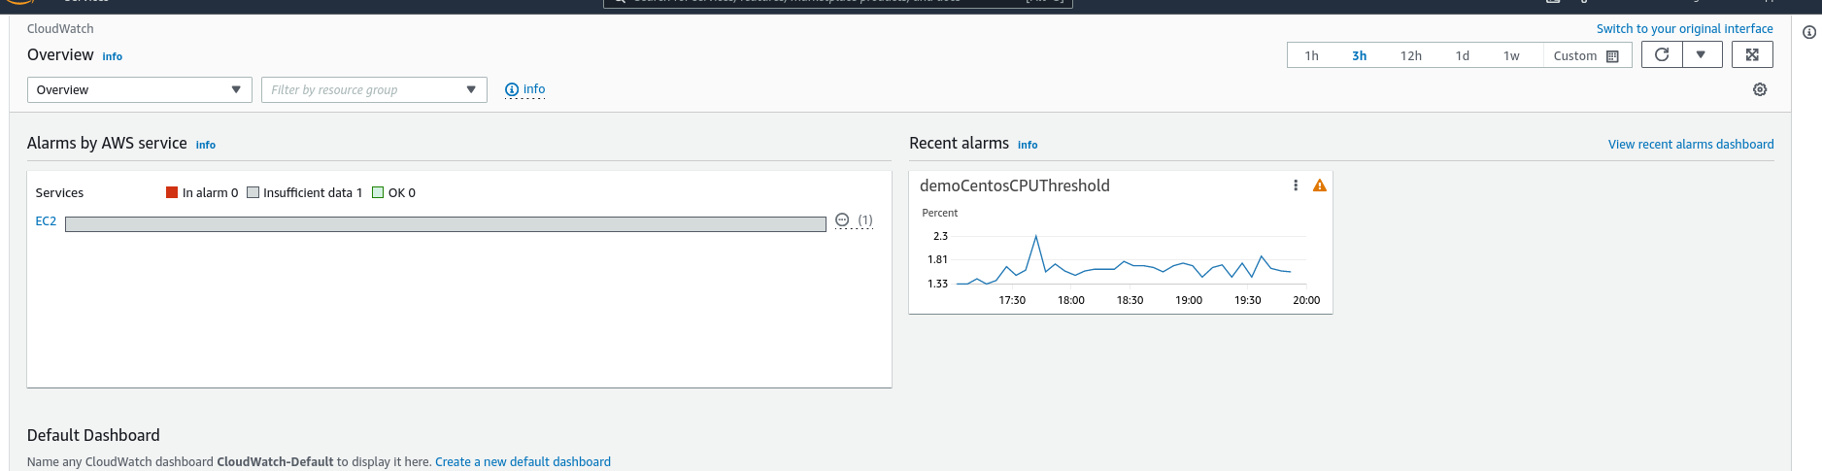

Dashboards
Cloudwatch lets you create dashboards. Each dashboard can be configured to display multiple graphs in the form of widgets, displaying various metrics.
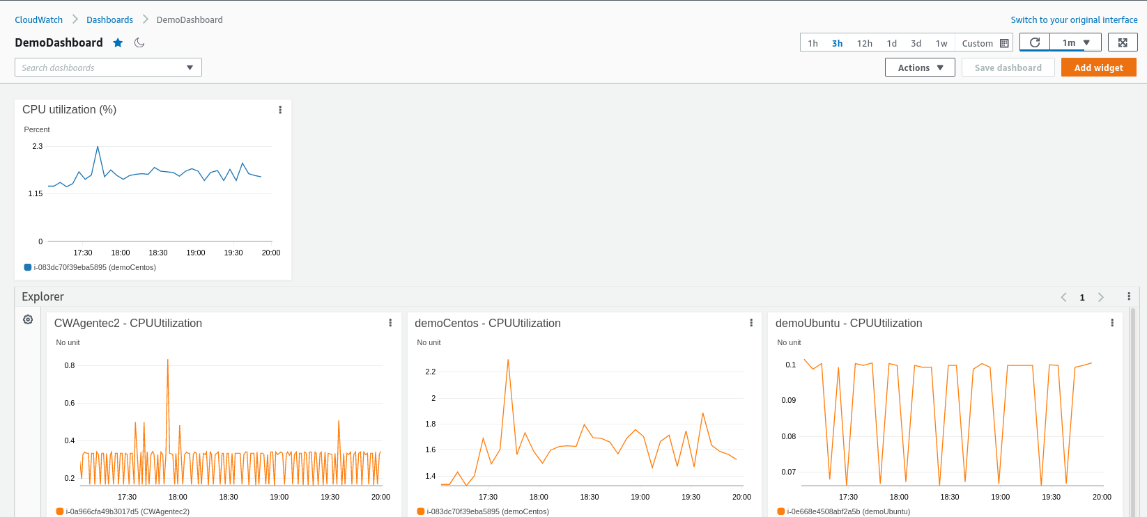

Metrics
CloudWatch lets you monitor metrics such as CPU Utilization, Network In and Network Out and disk write and read statistics.
There are 2 types of metrices
- Built-in metrics: Metrics displayed by Cloudwatch by default.
- Custom Metrics: Needs Cloudwatch Agent installed on ec2 instances.

Logs
CloudWatch lets you stream logs from various services such as ec2, lambda, S3 and various other services. It also offers a feature to filter your logs for entries matching a certain patterns - example error codes or terms such as Access denied etc.

Alarms
CloudWatch lets you set Alarms when a particular Metric breaches a set threshold. For example, you could configure an Alarm to send an email whenever CPU Utilization of a certain instance breaches a set threshold (ex: 75%)
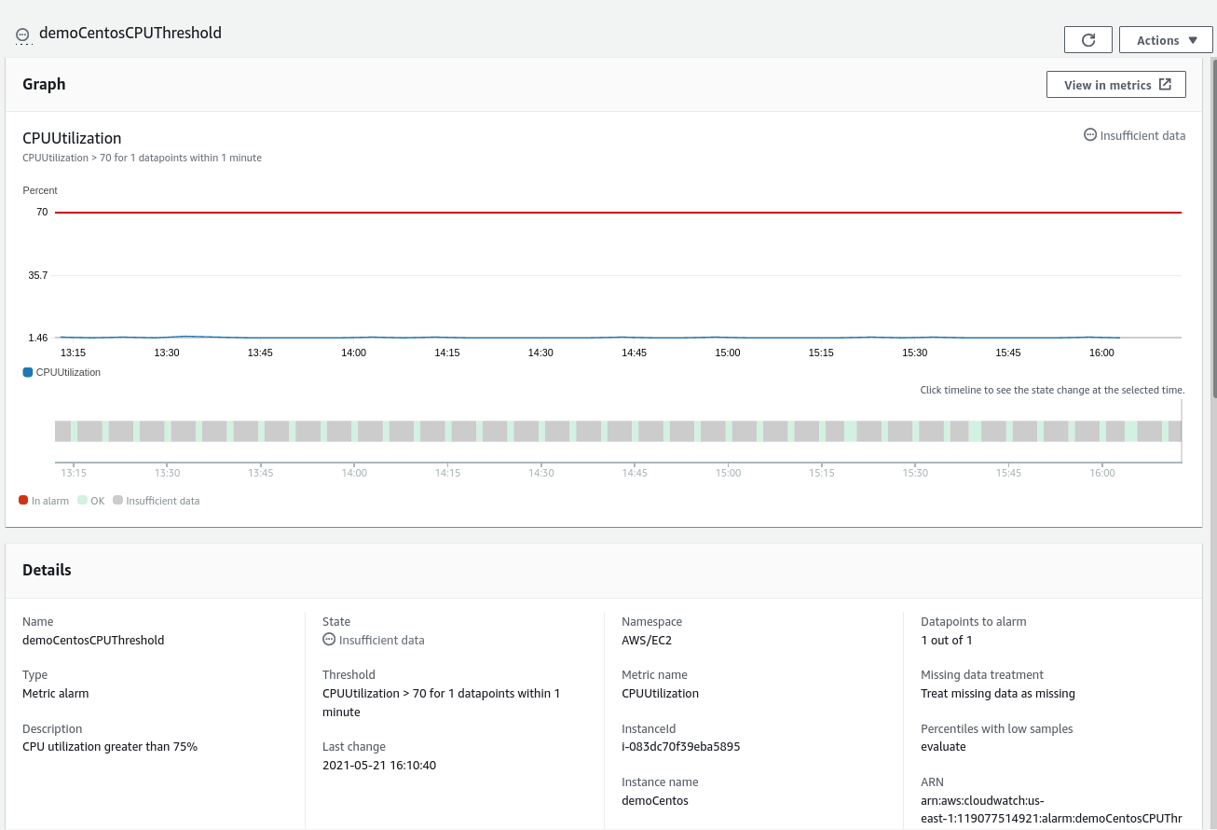

CloudWatch Agent
ClouWatch by default monitors a certain set of metrics. If you'd like to monitor custom metrics such as RAM utilization and disk space, you'd need to install CloudWatch Agent on the ec2 instances you'd wish to monitor.
Follow the below steps to Install CloudWatchAgent on ec2 instance.
- Create an IAM Role with the following Permissions:
  - AmazonEC2RoleSSM
  - CloudWatchAgentAdminPoicy
  - CloudWatchAgentServerPolicy
- Download the appropriate CloudWatchAgent for your ec2 instance from CloudWatch Agents Page onto your ec2 instance.
- Install from CLI
- For Centos run the below command
sudo rpm -U ./amazon-cloudwatch-agent.rpm
- For Ubuntu run the below command
sudo dpkg -i -E ./amazon-cloudwatch-agent.deb
- For Windows run the below command
msiexec /i amazon-cloudwatch-agent.msi
- On Linux Machines run the below commands to configure CloudWatch
sudo /opt/aws/amazon-cloudwatch-agent/bin/amazon-cloudwatch-agent-config-wizard
sudo /opt/aws/amazon-cloudwatch-agent/bin/start-amazon-cloudwatch-agent

SSM Installation
Amazon Systems Manager (SSM) is an automation tool that helps you manage the ec2 Instances from a central location. This can let you configure CloudWatch Agents and also save the configuration in Parameter Store for reusability.
- Centos based systems (Redhat, Centos, Fedora)
## Install AWS SSM Agent (Replace <region> with the region where your ec2 instance is hosted)

sudo yum install -y https://s3.<region>.amazonaws.com/amazon-ssm-<region>/latest/linux_amd64/amazon-ssm-agent.rpm

## Start and enable SSM agent
sudo systemctl enable amazon-ssm-agent
sudo systemctl start amazon-ssm-agent
sudo systemctl status amazon-ssm-agent

- Ubuntu
# Install AWS SSM Agent (Replace <region> with the region where your ec2 instance is hosted)

sudo yum install -y https://s3.us-east-1.amazonaws.com/amazon-ssm-us-east-1/latest/linux_amd64/amazon-ssm-agent.rpm

## Start and enable SSM agent
sudo systemctl enable amazon-ssm-agent
sudo systemctl start amazon-ssm-agent
sudo systemctl status amazon-ssm-agent

Install SSM on Ubuntu
## ------
## Ubuntu
## ------

## Install SSM agent
sudo snap install amazon-ssm-agent --classic

## Start and enable SSM agent
sudo systemctl enable snap.amazon-ssm-agent.amazon-ssm-agent.service
sudo systemctl start snap.amazon-ssm-agent.amazon-ssm-agent.service
sudo systemctl status snap.amazon-ssm-agent.amazon-ssm-agent.service

