Elastic File System (EFS)

Kiran

Table of Contents
1. Elastic File System
1.1. Overview of Network File System(NFS)
1.2. Overview of EFS
1.3. EFS Pricing
1.4. Creating EFS File System
1.5. Create Security Group to Mount EFS on ec2 instances.
1.6. Mounting the EFS on Linux ec2 instances.

Elastic File System

Overview of Network File System(NFS)
Network File System (NFS) is a distributed file system protocol originally developed by Sun Microsystems (Sun) in 1984, allowing a user on a client computer to access files over a computer network much like local storage is accessed.

Overview of EFS
Amazon Elastic File System (Amazon EFS) provides a simple, serverless, set-and-forget elastic file system for use with AWS Cloud services and on-premises resources. It is built to scale on demand to petabytes without disrupting applications, growing and shrinking automatically as you add and remove files, eliminating the need to provision and manage capacity to accommodate growth. Amazon EFS has a simple web services interface that allows you to create and configure file systems quickly and easily. The service manages all the file storage infrastructure for you, meaning that you can avoid the complexity of deploying, patching, and maintaining complex file system configurations.
Amazon EFS supports the Network File System version 4 (NFSv4.1 and NFSv4.0) protocol, so the applications and tools that you use today work seamlessly with Amazon EFS.
Multiple compute instances, including Amazon EC2, Amazon ECS, and AWS Lambda, can access an Amazon EFS file system at the same time, providing a common data source for workloads and applications running on more than one compute instance or server.
With Amazon EFS, you pay only for the storage used by your file system and there is no minimum fee or setup cost. Amazon EFS offers a range of storage classes designed for different use cases.
Standard storage classes: EFS Standard and EFS Standard-Infrequent Access (Standard-IA), which offer multi-AZ resilience and the highest levels of durability and availability.
EFS Standard Storage Class
This is designed for active file system workloads, and you pay only for the amount of file system storage you use per month. Data is stored regionally within and across multiple Availability Zones (AZs).
EFS Standard-Infrequent Access Storage Class
This is cost-optimized for files accessed less frequently. Data stored on the EFS Standard-IA storage class costs less than EFS Standard storage class, and you will pay a fee each time you read from or write to a file. Data is stored regionally within and across multiple Availability Zones (AZs).
One Zone storage classes: EFS One Zone and EFS One Zone-Infrequent Access (EFS One Zone-IA), which offer customers the choice of additional savings by choosing to save their data in a single AZ'
One Zone Storage Class
The EFS One Zone storage class is designed for active file system workloads, and you pay only for the amount of file system storage you use per month. Data is stored within a single Availability Zone. Standard data transfer fees apply for inter-AZ or inter-region access to file systems
One Zone-Infrequent Access Storage Class: The EFS One Zone-Infrequent Access storage class (EFS One Zone-IA) is cost-optimized for files accessed less frequently. Data stored on the EFS One Zone-IA storage class costs less than the One Zone storage class, and you will pay a fee each time you read from or write to a file. Data is stored within a single Availability Zone. Standard data transfer fees apply for inter-AZ or inter-region access to file systems.
Read more on EFS Storage Classes

EFS Pricing
AWS charges you only for the amount of EFS storage you use. There is no minimum fee and there are no set-up charges.
Read more on EFS Pricing

Creating EFS File System
As EFS is a fully managed file system, it's very easy to create and use EFS File Share.
A File Share is a unit of EFS which can be bounded on any number of compute instances.
OB Follow the below steps to create EFS File Share:
- Go to Services –> Click On EFS
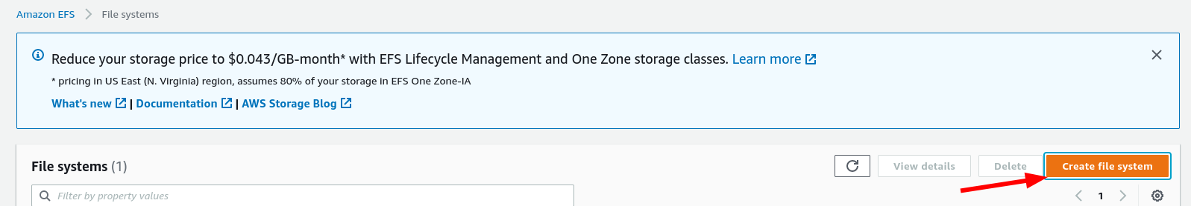
- Click on Create Create file System and add the below details a. Name of the File Share (optional).
b. Specify the VPC - the VPC where your ec2 instances that will consume the EFS file share reside.
c. Choose Regional or One Zone - If your compute instances are spread across multiple AZs choose Regional.
d. Click on Create.
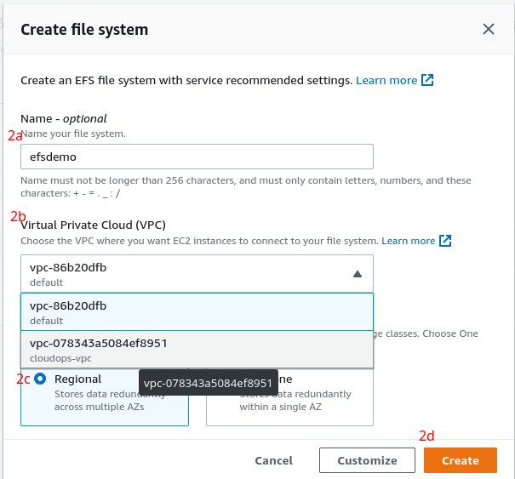
- Now your EFS is created and you should see it under your File Shares
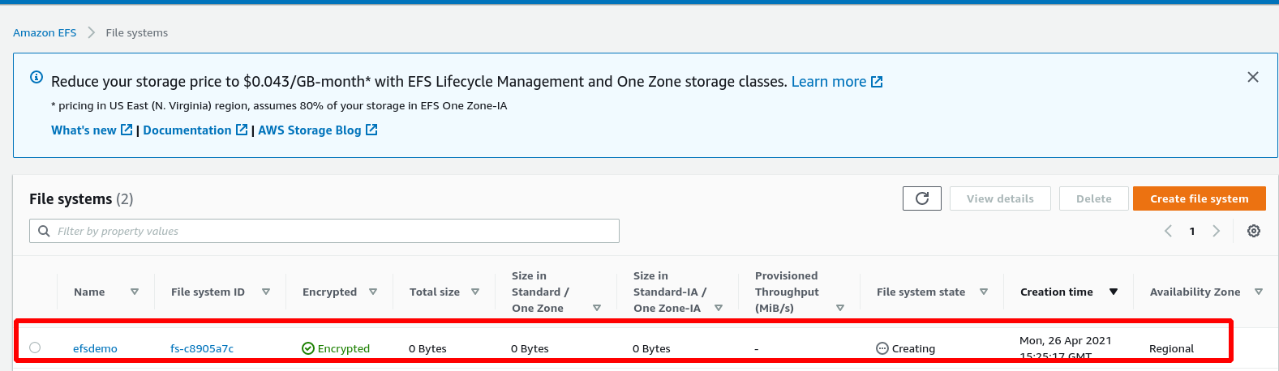
- Click on the File share and click on Network. You will see the Mount points for each Availability Zone where you have subnets.
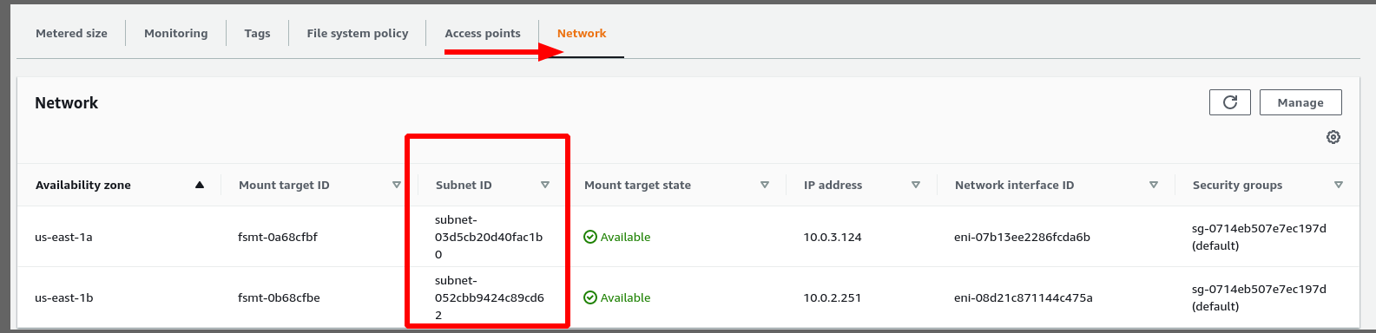
- By default Private Subnets are selected for each Availability Zone. You may click on Manage and update the delete the existing Mountpoints and add the desired subnet.
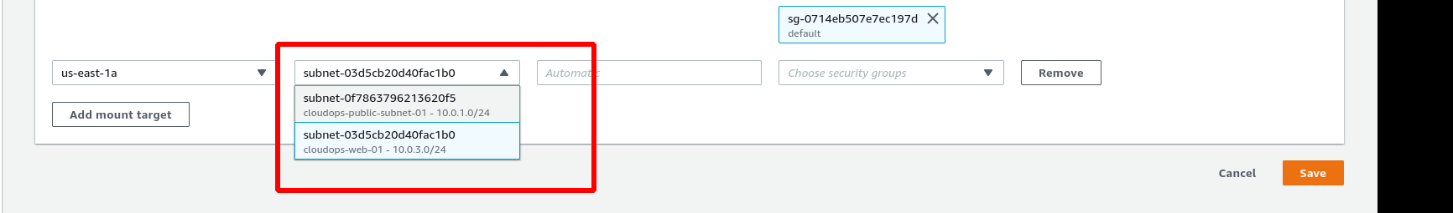

Create Security Group to Mount EFS on ec2 instances.
To mount EFS file share on ec2 instances, create a security group that allows traffic on NFS port i.e., 2049 from ec2 instances.
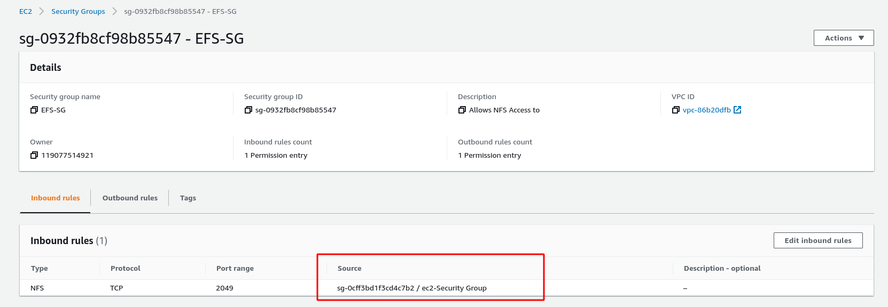
In the above picture the Source should be the Security Group of the EC2 security group

Mounting the EFS on Linux ec2 instances.
Once your Mount points show as available, click on Attach
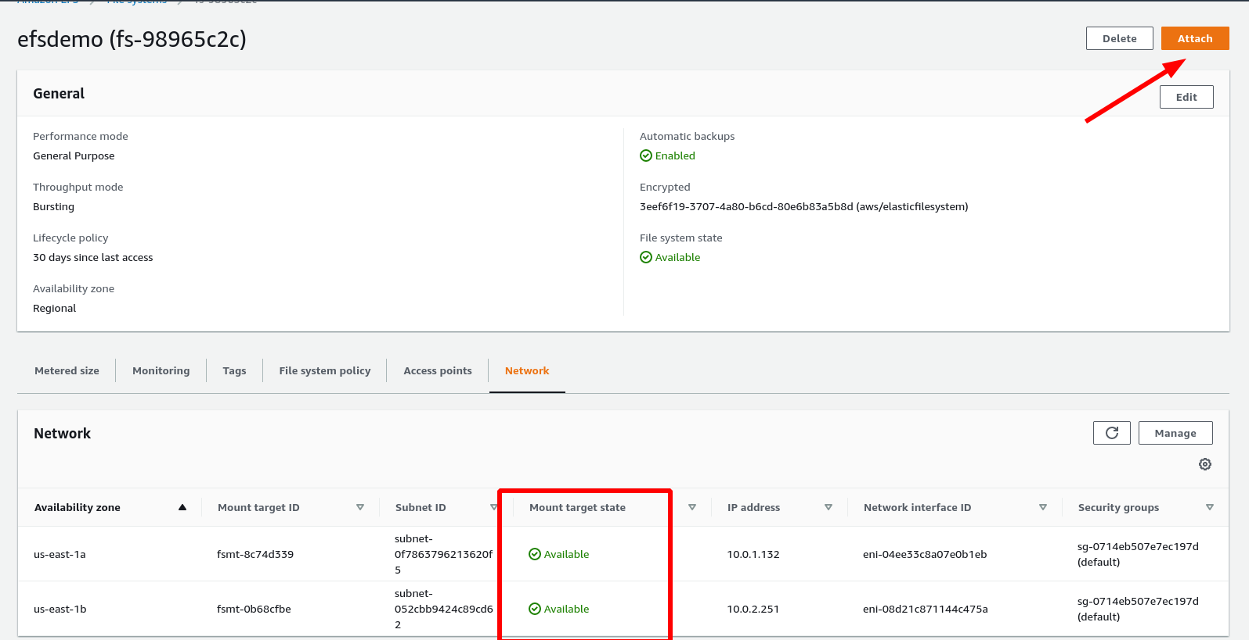
Copy the Command and execute it inside the Linux instance after modifying the parameters (such as Mount point)
Create a Mount point if required.
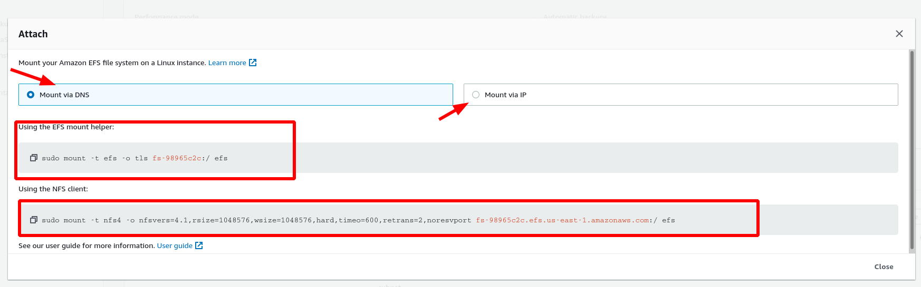
Note: EFS can be used only with Linux ec2 instances and cannot be used with Windows ec2 instnaces. Use FSx for Windows ec2 instnaces.

EFS Access Points
Amazon EFS access points are application-specific entry points into an EFS file system that make it easier to manage application access to shared datasets. Access points can enforce a user identity, including the user's POSIX groups, for all file system requests that are made through the access point. Access points can also enforce a different root directory for the file system so that clients can only access data in the specified directory or its subdirectories.
You can use IAM policies to enforce that specific applications use a specific access point.
By combining IAM policies with access points, you can easily provide secure access to specific datasets for your applications.

