RDS

Kiran

Table of Contents
1. Relational Database Service (RDS)
1.0.1. Amazon Aurora
1.1. Instance Types
1.2. Storage types
1.2.1. General Purpose SSD
1.2.2. Provisioned IOPS
1.3. High Availability
1.3.1. Multi-AZ Configuration
1.4. Read Scalability
1.5. Backups
1.5.1. Storage Level snapshots
1.5.2. Automated Backups
1.6. Disaster Recovery
1.7. Create an RDS Instance

Relational Database Service (RDS)
Amazon RDS is managed database sevice offered by AWS - where users can create a Database Instance and start using it without having to set up a cluster of servers and install the required SQL Database software.
RDS makes it easy to set up, operate, and scale a relational database in the cloud. It provides cost-efficient and resizable capacity while automating time-consuming administration tasks such as hardware provisioning, database setup, patching and backups. It frees you to focus on your applications so you can give them the fast performance, high availability, security and compatibility they need.
Amazon RDS is available on several database instance types - optimized for memory, performance or I/O.
AWS provides you with six familiar database engines:
- Amazon Aurora.
- PostgreSQL.
- MySQL
- MariaDB
- Oracle Database
- MS SQL Server.
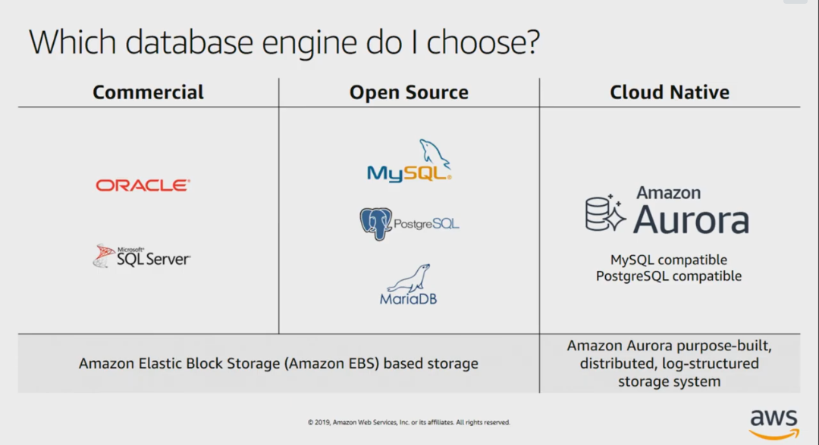

Amazon Aurora
Amazon Aurora is a MySQL and PostgreSQL-compatible relational database built for the cloud, that combines the performance and availability of traditional enterprise databases with the simplicity and cost-effectiveness of open source databases.
Amazon Aurora is up to five times faster than standard MySQL databases and three times faster than standard PostgreSQL databases. It provides the security, availability, and reliability of commercial databases at 1/10th the cost. Amazon Aurora is fully managed by Amazon Relational Database Service (RDS), which automates time-consuming administration tasks like hardware provisioning, database setup, patching, and backups.
You can use the AWS Database Migration Service to easily migrate or replicate your existing databases to Amazon RDS.

Instance Types
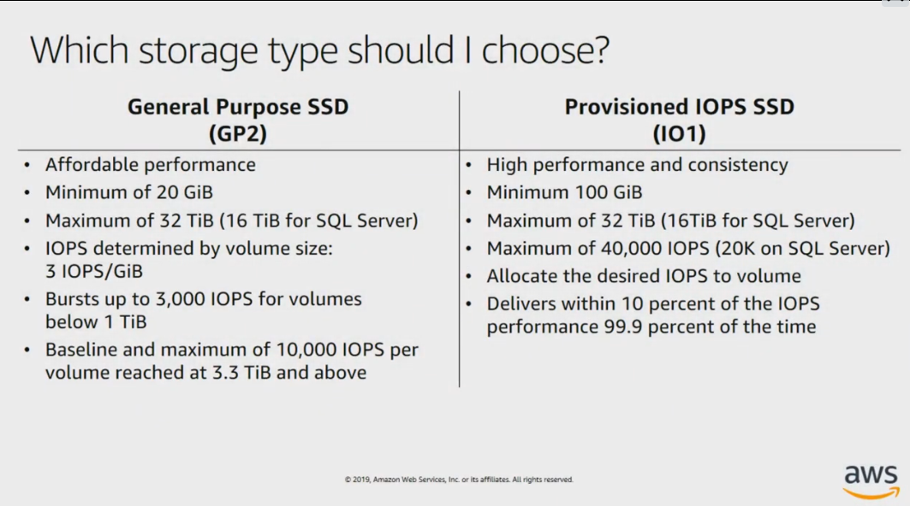

Storage types

General Purpose SSD
- Affordable Performance
- Minimum of 20GB and Maximum of 32 TiB (16 TiB for SQL Server)
- IOPS determined by volume size - 3 IOPS/GiB
- Bursts up to 3,000 IOPS coumes belwow 1 TiB
- Baseline and maximum of 10,000 IOPS per volume reached at 3.3 TiB and over

Provisioned IOPS
- High Performance and Consistency.
- Minimum of 100 GiB and Maximum of 32 TiB (16 TiB for SQL Server).
- Maximum of 40,000 IOPS (20K on SQL Server).
- Allocate the desired IOPS to volumes.

High Availability

Multi-AZ Configuration
There are 2 Database instances. Primary and secondary/Standby in 2 different AZs.
Each DB instance manages a set of Amazon EBS volumes with a full copy of the data. Data is synchronously (real-time) replicated from primary to standby instance.
In case of failure of the primary DB, RDS automatically initiates the failover to the Standby instance.
The standby instance now becomes the primary instance. A new DB instance is created in the other AZ and data starts replicating to that instance.
This set up only detects DB infrastructure issues but not any DB engine problems.

Read Scalability
RDS provides read replication to decrease load on the source Database with additional read capacity.
The replication is asynchronous.
You can create up to 5 replicas per source database.

Backups

Storage Level snapshots
Manual snapshots taken at EBS levels.

Automated Backups
Provides a point-in-time restore options. Transaction logs are stored every five minutes. Can restore up to 35 days agouu – kkkk
NN00tt@@55ttrruunngg00nnee
ccdd DDeess
ll
vviimm aazznnootteess..mmdd
https://www.youtube.com/watch?v=TdCc4reQYbU .

Disaster Recovery
Use Automated Backups and Manual snapshots
Use cross region read replica as a standby database for recovery in case of disaster in the region where your source db is located.
Read replicas can be configured for Multi-AZ to reduce recovery time.

Create an RDS Instance
