**A.1 Access**

**A.1.1 Enrollment**

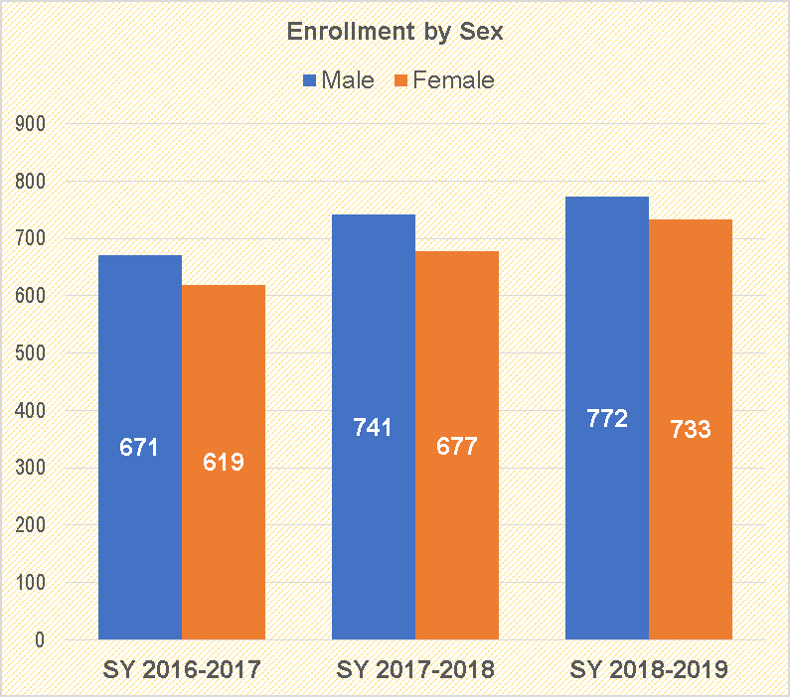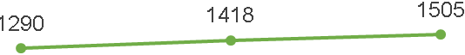

From SY 2017-2018 the number of male enrollees increased from 741 to 772, and the number o f female enrollees increased from 677 to 733. This can be attributed to:

*Balik-aral

**A.1.2 Cohort- Survival Rate**

This graph of Cohort- Survival rate reveals its fluctuation. It began from a high value 93.51% to a lower value of 72.64% in 2017-2018. Though it increased up to 94.09% in 2018-2019. There was a accession of 21.45% (need additional info :reason why it was increased from .

**A.1.3 Number of Completers**

For the SY 2018-2019, there were 215 out of 221 number of completers (Grade 10). There were 103 males with a percentage of 96.26% and 112 females with a percentage of 98.25%. There were 4 enrollees were not able to be recognized as completers. The most pressing cause is Child labor.

**A.1.4 Number of Rate of Dropouts and Cause**

The dropout rate of the school for S.Y. 2018-2019 is 0.07 percent or (1 out of 1505) as compared to the dropout rate of S.Y. 2017-2018 which is 0 percent or (0 out of 1418). The most pressing cause is Individual- Related Factors

**A.1.5 No. of SARDO saved**

As shown in the chart, there were 8 SARDOs saved from Grade 7. 50% of which were females and 50% were males. There are 16 Grade 8 who were SARDO saved. 50% were males and 50% were females. For Grade 9, there were 4 students and all of them are male. Lastly, for Grade 10, which has the least of SARDO saved for the SY 2018- 2019, there was only 1 student saved from SARDO which is a female student.

There were 29 SARDO’s out of 1141 enrollees for SY 2018-2019. Thus, 2.54% of the total enrollment become SARDO. Distance to school is the main reason for this problem.

**A.1.6 No. of Learners with 100% of Attendance**

For Grade 7, there were 343 learners with 100% attendance with a percentage of 94.23%. This only implies that there were only few students who were not able to attain the 100% attendance since the start of classes until the last day. On the other hand, 92.79% of the students in the Grade 8 with 100% attendance for the SY 2018-2019. 233 out of 247 students in Grade 9 were able to attain the 100% attendance which is 94.33% of the enrollees. For Grade 10, there were 95.48 % of learners with 100% attendance.

For Grade 11, there were 81.16 % of learners with 100% attendance and for Grade 12, there were 83.85% of learners with 100% attendance for the SY 2018-2019.

19% from the population of Grade 11 who were not able to attain the 100% attendance. The most pressing reasons is that students from far-flung barangays suffered from the fare rate of “Habal-habal” drivers.

**A.1.7 No. of Learners with incidence of Tardiness**

For grade 7, there were 31 students out of 365 students or 8.49% learners with incidence of tardiness. For Grade 8, 19.33% learners with incidence of tardiness out of 305 students. 56 students out of 269 were identified with incidence of tardiness which is 20.82% of the population in Grade 9. For Grade 10, out of 248 students there were 51 learners with incidence of tardiness with a percentage of 20.57%. The main cause for this is distance to school.

**A.1.8 No. of Learners with incidence of Habitual Absenteeism**

5.77% of the students in Grade 7 have the incidence of habitual absenteeism. Most were males and there are only 6 females. For Grade 8, there were 22 identified learners with incidence of habitual absenteeism out of 305 students with a percentage of 7.21%. There were 14 males and only 2.62% were females. 14 students with incidence of habitual absenteeism out of 247 students in Grade 9 with a percentage of 5.67%. For Grade 10, 10 students were identified out of 221 students who were officially enrolled with a percentage of 4.52%. The main cause for this is the geographical location from home to school.

**A.1.9 Health and Nutritional Status**

In the current school year, 14.77 percent (114 of 772) of the male learners fall outside normal health status while 7.91 percent (58 of 733) of the female learners fall outside normal health status