BeModelAssignment
Name | BeModelAssignment
Title | BeModelAssignment
Canonical URL | https://www.ehealth.fgov.be/standards/fhir/drp/StructureDefinition/BeModelAssignment
Version | 1.1.1
Status | active
Parent model | Base
Publisher | eHealth Platform

Logical model with the information for the assignment to a referral prescription of a care provider.

Class diagram
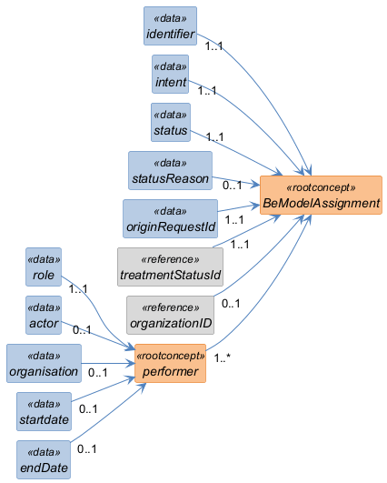

Structure
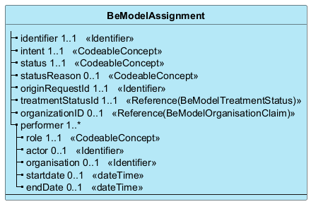

Elements
Element | Card. | Type | Value set | Description
identifier | 1..1 | Identifier |  | Business identifier. Absent during creation by client software, otherwise always present.
intent | 1..1 | CodeableConcept |  | Defaults to 'Order', since in this case it is always linked to a referral prescription.
status | 1..1 | CodeableConcept |  | Status of the task
statusReason | 0..1 | CodeableConcept |  | Provides details on the status of the task
originRequestId | 1..1 | Identifier |  | Reference to the associated referral prescription
treatmentStatusId | 1..1 | Reference(BeModelTreatmentStatus) |  | Reference to the 'TreatmentStatus', the treatment tracking associated with the prescription
organizationID | 0..1 | Reference(BeModelOrganisationClaim) |  | Reference to the organization Task
performer | 1..* |  |  | Information about the intended performer of the task
role | 1..1 | CodeableConcept |  | Role of the provider assigned to provide the requested service
actor | 0..1 | Identifier |  | NISS of the provider assigned to provide the requested service
organisation | 0..1 | Identifier |  | Organization assigned to provide the requested service (e.g. WGK, ...). In this case, it is the organization that is responsible for assigning the correct provider
startdate | 0..1 | dateTime |  | Start date of the prescription execution (encoded by the healthcare provider who performs the treatment)
endDate | 0..1 | dateTime |  | End date of the prescription execution (encoded by the healthcare provider who performs the treatment)

