BeClinicalObservation Model
Name | BeModelClinicalObservation
Title | BeClinicalObservation Model
Canonical URL | https://www.ehealth.fgov.be/standards/fhir/core-clinical/StructureDefinition/BeModelClinicalObservation
Version | 1.3.0
Status | active
Parent model | Base
Publisher | eHealth Platform

Clinical Observation logical model

Class diagram
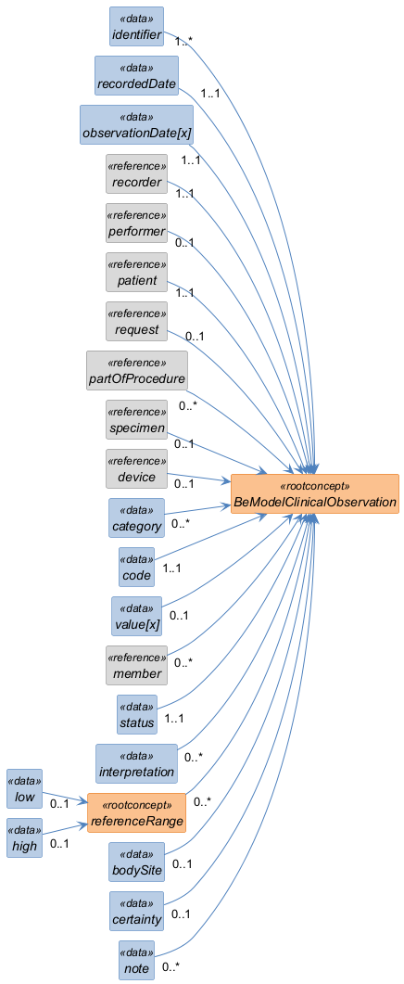

Structure
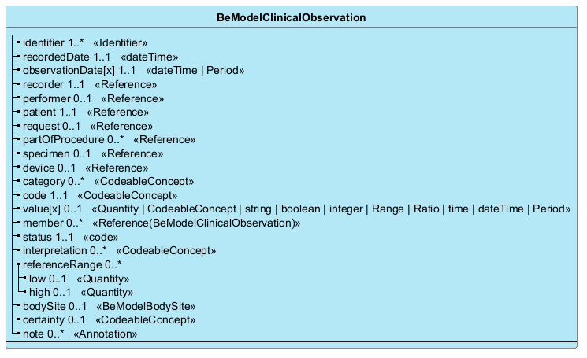

Elements
Element | Card. | Type | Value set | Description
identifier | 1..* | Identifier |  | Unique identifier for the observation
recordedDate | 1..1 | dateTime |  | Date when the observation was recorded
observationDate[x] | 1..1 | dateTime | Period |  | Date or period of the observation
recorder | 1..1 | Reference |  | Person, organisation or device that recorded the observation
performer | 0..1 | Reference |  | The professional that performed the observation
patient | 1..1 | Reference |  | The patient that this observation is about
request | 0..1 | Reference |  | The request that this observation is fulfilling
partOfProcedure | 0..* | Reference |  | Part of referenced procedure
specimen | 0..1 | Reference |  | The specimen that was used when this observation was made
device | 0..1 | Reference |  | The device used to generate the observation data
category | 0..* | CodeableConcept |  | A code that classifies the general type of observation being made
code | 1..1 | CodeableConcept |  | Describes what was observed. Sometimes this is called the observation 'name'
value[x] | 0..1 | Quantity | CodeableConcept | string | boolean | integer | Range | Ratio | time | dateTime | Period |  | The value of the observation - typically a code, an amount or a date
member | 0..* | Reference(BeModelClinicalObservation) |  | Other observations that are part of this observation
status | 1..1 | code |  | The status of the result value.
interpretation | 0..* | CodeableConcept |  | A categorical assessment of an observation value
referenceRange | 0..* |  |  | Guidance on how to interpret the value by comparison to a normal or recommended range
low | 0..1 | Quantity |  | Low Range, if relevant
high | 0..1 | Quantity |  | High Range, if relevant
bodySite | 0..1 | BeModelBodySite |  | The site on the subject's body where the observation was made (i.e. the target site)
certainty | 0..1 | CodeableConcept |  | A subjective assessment of the quality of the observation
note | 0..* | Annotation |  | Comments about the observation or the results

