Dosaging (model)
Name | BeModelDosagingInformation
Title | Dosaging (model)
Canonical URL | https://www.ehealth.fgov.be/standards/fhir/medication/StructureDefinition/BeModelDosagingInformation
Version | 1.1.1
Status | active
Parent model | Base
Publisher | eHealth Platform

Structured Dosage data model.

Class diagram
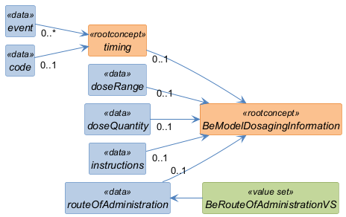

Structure
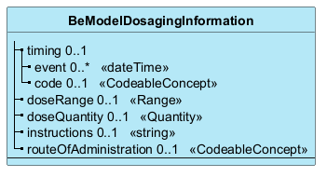

Elements
Element | Card. | Type | Value set | Description
timing | 0..1 |  |  | When medication should be administered (period, time of day, frequency, etc)
event | 0..* | dateTime |  | Exact date and/or time of the administration
code | 0..1 | CodeableConcept |  | Timing abbreviation (AM - morning, Q4H - once in every 4 hours, BID - twice a day, etc)
doseRange | 0..1 | Range |  | Amount of medication per one dose (e.g '1 tablet', '2-3 tablets', '20ml')
doseQuantity | 0..1 | Quantity |  | Amount of medication per one dose (e.g '1 tablet', '2-3 tablets', '20ml')
instructions | 0..1 | string |  | Free text instructions for the patient, e.g 'take with food', 'do not take with alcohol', etc
routeOfAdministration | 0..1 | CodeableConcept | BeRouteOfAdministrationVS | Route of administration

