BeModelEAgreement
Name | BeModelEAgreement
Title | BeModelEAgreement
Canonical URL | https://www.ehealth.fgov.be/standards/fhir/mycarenet/StructureDefinition/be-model-eagreement
Version | 2.2.0
Status | active
Parent model | Element
Publisher | eHealth Platform

Class diagram
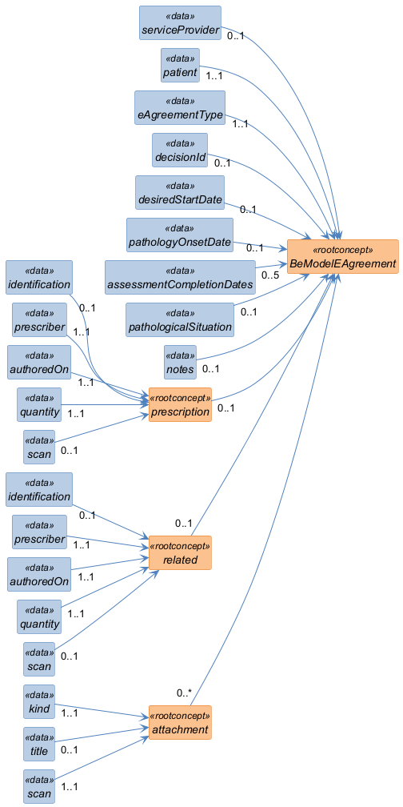

Structure
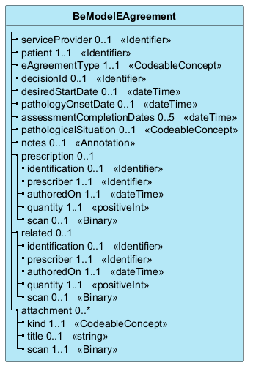

Elements
Element | Card. | Type | Value set | Description
serviceProvider | 0..1 | Identifier |  | NIHDI number of the service provider making the request
patient | 1..1 | Identifier |  | Patient identification
eAgreementType | 1..1 | CodeableConcept |  | Identification of the type of agreement (ex: Fb). A general type "physiotherapist" is applicable for the consultation
decisionId | 0..1 | Identifier |  | Identifier of the decision communicated by the insurer organization (included in the consultation flow)
desiredStartDate | 0..1 | dateTime |  | Desired agreement start date, corresponding to the processing start date (dd/mm/yyyy)
pathologyOnsetDate | 0..1 | dateTime |  | Estimated date of onset of pathology (dd/mm/yyyy)
assessmentCompletionDates | 0..5 | dateTime |  | Date(s) of completion of the assessment (1 to 5 for an ask and 1 for an extend) to be communicated in case of a treatment request
pathologicalSituation | 0..1 | CodeableConcept |  | Coding of the pathological situation referring to existing notification/request forms (e.g.: Fb-51)
notes | 0..1 | Annotation |  | Free text for any additional information
prescription | 0..1 |  |  | Data of the prescription concerned by the request
identification | 0..1 | Identifier |  | UHMEP identifier of the referral prescription
prescriber | 1..1 | Identifier |  | NIHDI number of the prescriber
authoredOn | 1..1 | dateTime |  | Prescription date
quantity | 1..1 | positiveInt |  | Number of sessions prescribed
scan | 0..1 | Binary |  | Electronic copy of the prescription
related | 0..1 |  |  | Prescription of a previous pathology
identification | 0..1 | Identifier |  | UHMEP identifier of the referral prescription
prescriber | 1..1 | Identifier |  | NIHDI number of the prescriber
authoredOn | 1..1 | dateTime |  | Prescription date
quantity | 1..1 | positiveInt |  | Number of sessions prescribed
scan | 0..1 | Binary |  | Electronic copy of the prescription
attachment | 0..* |  |  | Other possible appendix
kind | 1..1 | CodeableConcept |  | Type of content (medical report, …)
title | 0..1 | string |  | Free text allowing a more precise description of the subject of the appendix (recommended)
scan | 1..1 | Binary |  | Electronic copy

