BeModelNursingPrescription
Name | BeModelNursingPrescription
Title | BeModelNursingPrescription
Canonical URL | https://www.ehealth.fgov.be/standards/fhir/drp/StructureDefinition/BeModelNursingPrescription
Version | 1.1.1
Status | active
Parent model | BeModelReferralPrescription
Publisher | eHealth Platform

Data model for the nursing prescription referral.

Class diagram
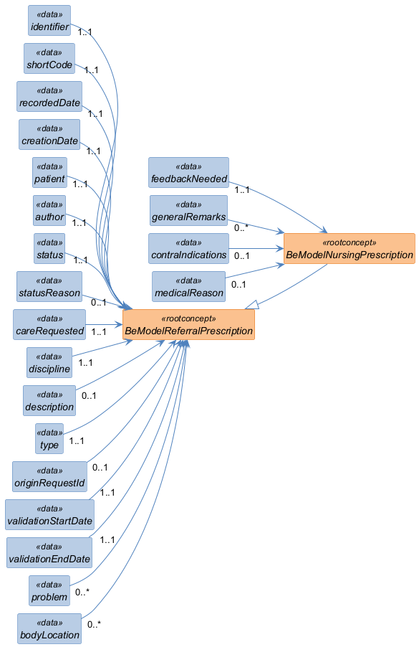

Structure
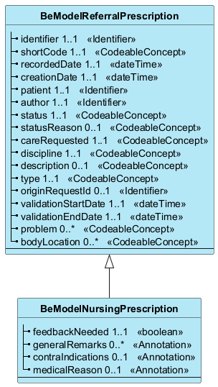

Elements
Element | Card. | Type | Value set | Description
feedbackNeeded | 1..1 | boolean |  | Follow-up indicator (boolean) specifying whether a feedback is expected from the doctor on this treatment.
generalRemarks | 0..* | Annotation |  | General remarks concerning the treatment or request.
contraIndications | 0..1 | Annotation |  | Medical contraindications (e.g. 'Latex allergy'). 103306004 : 'Contraindication to (x)"  Medical contraindications (e.g. 'Latex allergy'). 103306004 : 'Contraindication to (x)'
medicalReason | 0..1 | Annotation |  | Medical reasons for the prescription (e.g. 'Infected wound requiring follow-up'). 410666004 : "Reason For (x)"  Medical reasons for the prescription (e.g. 'Infected wound requiring follow-up'). 410666004 : 'Reason For (x)'

Inherited from BeModelReferralPrescription
Element | Card. | Type | Value set | Description
identifier | 1..1 | Identifier |  | Business identifier of the request
shortCode | 1..1 | CodeableConcept |  | Business code allowing the healthcare professional to find a prescription associated with a patient
recordedDate | 1..1 | dateTime |  | Date of recording of the information by the Recorder.
creationDate | 1..1 | dateTime |  | Date of creation of the referral prescription  Date of creation of the referral prescription. This date will not change throughout the process. This date corresponds to the first recordedDate recorded for this referral prescription.
patient | 1..1 | Identifier |  | Identification of the patient. The unique identifier must be: NISS, National Registry Number or Bis Patient  Is the unique identifier of the patient. The unique identifier must be: NISS, National Registry Number or Bis Patient
author | 1..1 | Identifier |  | The person who encodes the prescription (e.g. a doctor, nurse, midwife or dentist) and takes responsibility for their content. The unique identifier must be: NISS, National Registry Number or Bis Requester  Is the unique identifier of the person who encodes the prescription (e.g. a doctor, nurse, midwife or dentist) and takes responsibility for their content. The unique identifier must be: NISS, National Registry Number or Bis Requester
status | 1..1 | CodeableConcept |  | Is the status of the referral prescription (e.g. planned, complete, stopped, suspended, in progress, ….)  Is the status of the referral prescription (e.g. planned, complete, stopped, suspended, in progress, ...)
statusReason | 0..1 | CodeableConcept |  | Gives the reason for the status of the referral prescription (treatment has been changed, patient is allergic, patient refuses, …)  Gives the reason for the status of the referral prescription (treatment has been changed, patient is allergic, patient refuses, ...)
careRequested | 1..1 | CodeableConcept |  | Type of care requested (e.g. 'Compression therapy', 'Sample collection', CT Scan).  Type of care requested (e.g. 'Compression therapy', 'Sample collection', 'CT Scan').
discipline | 1..1 | CodeableConcept |  | Category of the requested care (nursing, radiology, ...)
description | 0..1 | CodeableConcept |  | Additional details on the requested care
type | 1..1 | CodeableConcept |  | Type of the request or prescription ('Prescription' or 'Proposal').
originRequestId | 0..1 | Identifier |  | Reference to the ID of the original request (useful when the request is an extension of another one).
validationStartDate | 1..1 | dateTime |  | Start date of the prescription validity (encoded by the prescriber).
validationEndDate | 1..1 | dateTime |  | End date of the prescription validity (encoded by the prescriber)
problem | 0..* | CodeableConcept |  | Medical problem or clinical context related to this request (for example: 'Open wound', 'Broken leg').
bodyLocation | 0..* | CodeableConcept |  | Anatomical location where the treatment should be applied (for example: 'Left arm').

