BeModelOrganisationClaim
Name | BeModelOrganisationClaim
Title | BeModelOrganisationClaim
Canonical URL | https://www.ehealth.fgov.be/standards/fhir/drp/StructureDefinition/BeModelOrganisationClaim
Version | 1.1.1
Status | active
Parent model | Base
Publisher | eHealth Platform

Information of a claim of an organisation to have the prescription fulfilled.

Class diagram
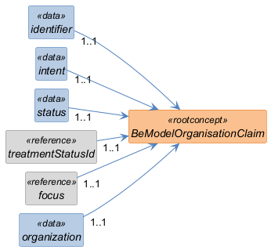

Structure
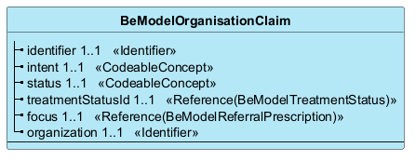

Elements
Element | Card. | Type | Value set | Description
identifier | 1..1 | Identifier |  | Business identifier  Business Identifier. Absent during creation by client software, otherwise always present.
intent | 1..1 | CodeableConcept |  | Defaults to 'Order'
status | 1..1 | CodeableConcept |  | Status of the task
treatmentStatusId | 1..1 | Reference(BeModelTreatmentStatus) |  | Reference to the TreatmentStatus related to the prescription
focus | 1..1 | Reference(BeModelReferralPrescription) |  | Reference to what the task acts on
organization | 1..1 | Identifier |  | Reference to the organization that will assign the providers to the prescription.

