BeModelPatientDocument
Name | BeModelPatientDocument
Title | BeModelPatientDocument
Canonical URL | https://www.ehealth.fgov.be/standards/fhir/core/StructureDefinition/BeModelPatientDocument
Version | 2.2.0
Status | active
Parent model | Base
Publisher | eHealth Platform

Data about a patient related document

Class diagram
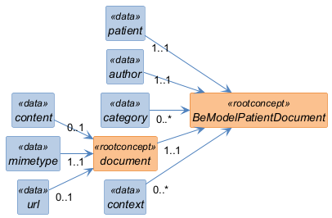

Structure
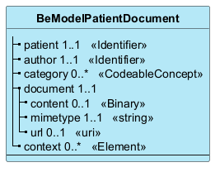

Elements
Element | Card. | Type | Value set | Description
patient | 1..1 | Identifier |  | The subject of the document
author | 1..1 | Identifier |  | The author of the document, either Practitioner or Organization
category | 0..* | CodeableConcept |  | A number of classifiers for the document, each code refines the previous one
document | 1..1 |  |  | Document information
content | 0..1 | Binary |  | The content of the document as such
mimetype | 1..1 | string |  | The technical type of the document
url | 0..1 | uri |  | If the document is not in the content, the reference to the document
context | 0..* | Element |  | Any related resources or elements that provide context for the document, such as institution, encounter,...

