BeModelVaccination
Name | BeModelVaccination
Title | BeModelVaccination
Canonical URL | https://www.ehealth.fgov.be/standards/fhir/vaccination/StructureDefinition/be-model-vaccination
Version | 1.1.3
Status | active
Parent model | Element
Publisher | eHealth Platform

Logical Model for vaccination

Class diagram
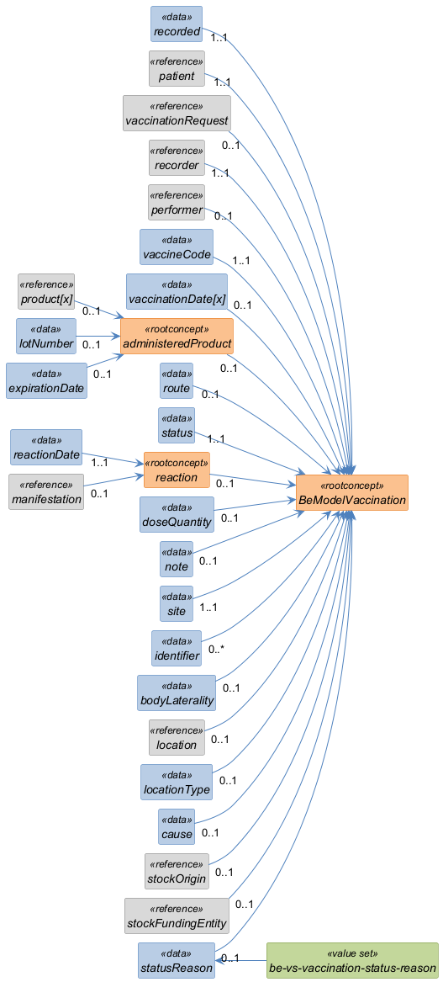

Structure
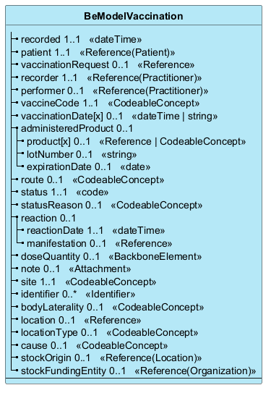

Elements
Element | Card. | Type | Value set | Description
recorded | 1..1 | dateTime |  | The date and time when the administration of the vaccine was recorded  The date and time when the administration of the vaccine was recorded - typically used when the vaccine event is recorded a posteriori.
patient | 1..1 | Reference(Patient) |  | The patient that received vaccination.  The patient that has received the vaccination.
vaccinationRequest | 0..1 | Reference |  | The patient-specific order or recommendation for the vaccination  The patient-specific order or recommendation for the vaccination, for example a prescription or a request for vaccination for a patient by a physician, for example for optional vaccines.
recorder | 1..1 | Reference(Practitioner) |  | The professional that recorded the administration of the vaccine  The professional that recorded the administration of the vaccine.
performer | 0..1 | Reference(Practitioner) |  | The professional that administered the medication  The professional that administered the medication. Use code "unknown" if not known.
vaccineCode | 1..1 | CodeableConcept |  | The vaccine code, typically identified by the diseas(s) it covers. For example MMR, HPV, Tetanus, DTPa  The vaccine code - a type of vaccine, typically identified by the disease(s) it covers. For example MMR, HPV, Tetanus, DTPa. This should be a coded value.
vaccinationDate[x] | 0..1 | dateTime | string |  | The date and time when the vaccination has been administered  The date and/or time when the vaccine administration has been administered or presumed to be administered
administeredProduct | 0..1 |  |  | The details of the product that was administered.  The details of the product that was administered
product[x] | 0..1 | Reference | CodeableConcept |  | The actual product that was administered. This should be a product code or a reference to an actual Medication resource  The actual product that was administered. This can be just text (not desired), or a code (e.g. 1696392 = Neisvac C Dos 0,5ml) or a reference to an actual Medication product (e.g. http://server/Medication/1696392)
lotNumber | 0..1 | string |  | The lot number
expirationDate | 0..1 | date |  | The expiration date of the product.
route | 0..1 | CodeableConcept |  | The route of administration.  The route of administration for the vaccine. This can be free text (not desired) or a code
status | 1..1 | code |  | The status of this vaccination record entry  The status of the vaccination record entry - whether it is active, entered in error, etc.
statusReason | 0..1 | CodeableConcept | be-vs-vaccination-status-reason | The reason for the status e.g. 'not completed because...'  Supporting reason for status information.
reaction | 0..1 |  |  | Reaction to the immunization - cfr. AllergyIntolerance
reactionDate | 1..1 | dateTime |  | date of the reaction
manifestation | 0..1 | Reference |  | reference to the observation of the reaction
doseQuantity | 0..1 | BackboneElement |  | The number or quantity of product(s) that was administered - e.g. 1/2 dose  The number or quantity of product(s) that was administered - e.g. 1/2 dose, etc.
note | 0..1 | Attachment |  | Additional notes for the vaccination.  Additional notes for the vaccination
site | 1..1 | CodeableConcept |  | The body site where the vaccination entered the body
identifier | 0..* | Identifier |  | The business identifier(s) for the vaccination entry  The business identifier(s) for the vaccination entry - This is an optional attribute, used for example to track an entry throughout its lifecycle, or across vaults.
bodyLaterality | 0..1 | CodeableConcept |  | The side of the body (for sites that occur on both sides of the body)
location | 0..1 | Reference |  | The location where the immunization is performed.  a resource (Location) if one exists e.g. 'Location/kind-en-gezin-092375' which could be defining 'Kind en Gezin Gent Koepoortkaai'
locationType | 0..1 | CodeableConcept |  | The location where the immunization administration was performed. This can be a text (e.g. 'at the physician's office' or a code e.g. '00078' meaning 'patient's home'
cause | 0..1 | CodeableConcept |  | Is the vaccination due to pre or post exposition prophylaxis?
stockOrigin | 0..1 | Reference(Location) |  | The stock position where the product is originating from. This can be a specific location like a shelf, a warehouse, a building...
stockFundingEntity | 0..1 | Reference(Organization) |  | The entity that is funding the provision of the vaccines

