eBirth Report logical model
Name | BeModeleBirthReport
Title | eBirth Report logical model
Canonical URL | https://www.ehealth.fgov.be/standards/fhir/perinatal/BeModeleBirthReport
Version | 0.1.0
Status | draft
Parent model | Base
Publisher | RIZIV/INAMI

Logical model for eBirth Report

Class diagram
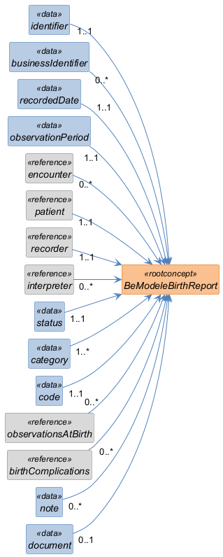

Structure
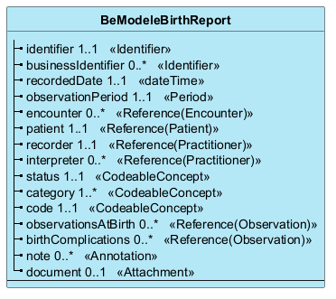

Elements
Element | Card. | Type | Value set | Description
identifier | 1..1 | Identifier |  | Unique identifier for the eBirth report
businessIdentifier | 0..* | Identifier |  | Business identifier for the eBirth report
recordedDate | 1..1 | dateTime |  | Date and time when the eBirth report was recorded or last update.
observationPeriod | 1..1 | Period |  | Period during which the eBirth report is valid or applicable.
encounter | 0..* | Reference(Encounter) |  | Transfer to another service?????????? What is this???? Why many??
patient | 1..1 | Reference(Patient) |  | The patient associated with the eBirth report.
recorder | 1..1 | Reference(Practitioner) |  | The practitioner who recorded the eBirth report.
interpreter | 0..* | Reference(Practitioner) |  | The practitioner who interpreted the eBirth report.
status | 1..1 | CodeableConcept |  | The status of the eBirth report, e.g., 'final', 'amended', 'cancelled'.
category | 1..* | CodeableConcept |  | The category of the eBirth report.
code | 1..1 | CodeableConcept |  | The code of the eBirth report.
observationsAtBirth | 0..* | Reference(Observation) |  | Observations made at the time of birth.
birthComplications | 0..* | Reference(Observation) |  | Observations related to complications during birth.
note | 0..* | Annotation |  | Notes or comments related to the eBirth report.
document | 0..1 | Attachment |  | PDF representation of the report

