PSS Response
Name | PSSResponse
Title | PSS Response
Canonical URL | https://www.ehealth.fgov.be/standards/fhir/pss/StructureDefinition/PSSResponse
Version | 1.1.0
Status | active
Parent model | Base
Publisher | eHealth Platform

Response containing the results from the PSS.

Class diagram
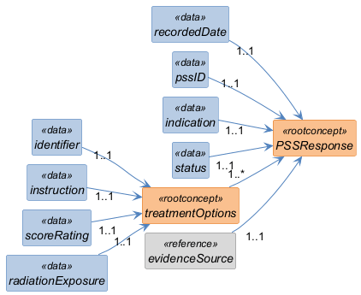

Structure
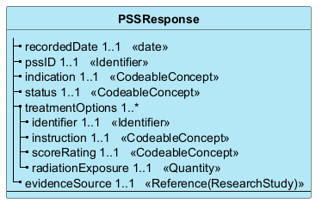

Elements
Element | Card. | Type | Value set | Description
recordedDate | 1..1 | date |  | Date on which the information was recorded
pssID | 1..1 | Identifier |  | Identifier of the exchange session
indication | 1..1 | CodeableConcept |  | Condition that triggered the PSS response
status | 1..1 | CodeableConcept |  | Status of the response
treatmentOptions | 1..* |  |  | List of search results provided by PSS
identifier | 1..1 | Identifier |  | Identifier of the result
instruction | 1..1 | CodeableConcept |  | Code of the examination
scoreRating | 1..1 | CodeableConcept |  | Code (e.g. color code) associated with the score (Red, Orange, Green)
radiationExposure | 1..1 | Quantity |  | Radiation exposure associated with the response
evidenceSource | 1..1 | Reference(ResearchStudy) |  | Link to a source (study, publication, etc.) for the PSS

