Pregnancy Status Model
Name | PregnancyStatusDataSet
Title | Pregnancy Status Model
Canonical URL | https://www.ehealth.fgov.be/standards/fhir/pregnancy-status/StructureDefinition/PregnancyStatusDataSet
Version | 1.0.0
Status | active
Parent model | Base
Publisher | eHealth Platform

Logical model for the pregnancy-status data.
This is the minimal data set for the pregnancy status (consumed, for example, via
Vitalink FHIR / MAGDA / VUTG / mijnburgerprofiel.be / mijngezondheid.be /
caregivers).

Class diagram
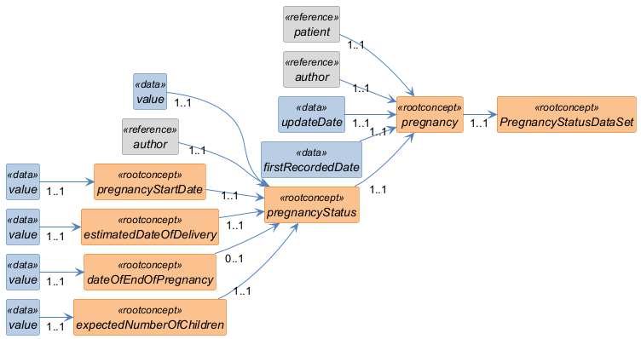

Structure
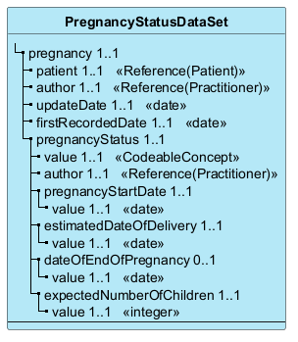

Elements
Element | Card. | Type | Value set | Description
pregnancy | 1..1 |  |  | Pregnancy Episode
patient | 1..1 | Reference(Patient) |  | Patient (pregnant woman)  The patient who is pregnant. The reference may identify the patient by pseudonymised SSIN, depending on the implementation.
author | 1..1 | Reference(Practitioner) |  | The healthcare professional who takes responsibility for the recording of the pregnancy information
updateDate | 1..1 | date |  | Last update date  The last date on which the pregnant woman was observed by her gynaecologist or midwife during the pregnancy.
firstRecordedDate | 1..1 | date |  | Recorded date of pregnancy  The date the pregnancy was first registered in the system. This is not the date the pregnancy was observed, but the date it was entered in the system for the first time.
pregnancyStatus | 1..1 |  |  | Pregnancy status (observation)  Observation conveying the current pregnancy status of the woman at the date of observation (e.g. pregnant, not pregnant). Bound to SNOMED CT, EHDS Patient Summary aligned.
value | 1..1 | CodeableConcept |  | The actual value  Coded pregnancy status (e.g. pregnant, not pregnant).
author | 1..1 | Reference(Practitioner) |  | Practitioner who recorded the pregnancy status
pregnancyStartDate | 1..1 |  |  | Date the pregnancy started  The date the pregnancy began, usually estimated as the first day of the last menstrual period (LMP) or from an early ultrasound.
value | 1..1 | date |  | The actual value
estimatedDateOfDelivery | 1..1 |  |  | Estimated date of delivery  The date the practitioner expects the delivery, usually etimated from the ultrasound. It normally does not change after the initial etimation; the actual delivery date is typically within ±2 weeks.
value | 1..1 | date |  | The actual value
dateOfEndOfPregnancy | 0..1 |  |  | Date of end of pregnancy  The actual end date of the pregnancy.
value | 1..1 | date |  | The actual value
expectedNumberOfChildren | 1..1 |  |  | Expected number of children  The number of births the practitioner expects in the delivery, usually estimated from the ultrasound.
value | 1..1 | integer |  | The actual value

