BeModelAnnex81
Name | BeModelAnnex81
Title | BeModelAnnex81
Canonical URL | https://www.ehealth.fgov.be/standards/fhir/drp/StructureDefinition/BeModelAnnex81
Version | 1.1.1
Status | active
Parent model | Base
Publisher | eHealth Platform

Logical model describing the model for the Annex81 proposal and approval

Class diagram
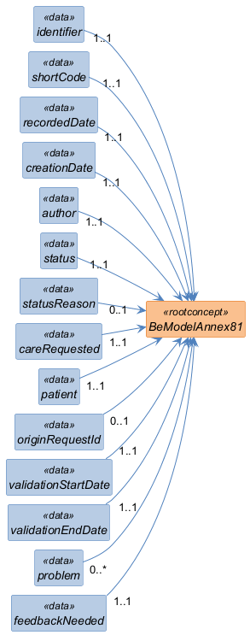

Structure
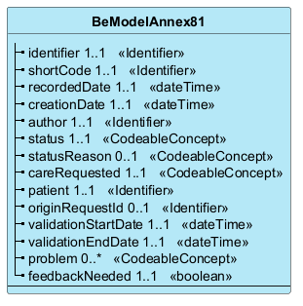

Elements
Element | Card. | Type | Value set | Description
identifier | 1..1 | Identifier |  | Business identifier of the Annex81 proposal / approval
shortCode | 1..1 | Identifier |  | Business short identifier allowing the healthcare professional to find a prescription associated with a patient  'Business' code allowing the healthcare professional to find a prescription associated with a patient
recordedDate | 1..1 | dateTime |  | Date of encoding of the information by the Recorder.
creationDate | 1..1 | dateTime |  | Creation date of the referral prescription. This date will not change throughout the process. This date corresponds to the first recordedDate recorded for this referral prescription.
author | 1..1 | Identifier |  | The person who encodes the prescription (e.g. a doctor, nurse, midwife or dentist) and takes responsibility for their content. The unique identifier must be the National Register Number (NISS) or bis number.  Is the unique identifier of the person who encodes the prescription (e.g. a doctor, nurse, midwife or dentist) and takes responsibility for their content. The unique identifier must be the National Register Number (NISS) or bis number.
status | 1..1 | CodeableConcept |  | Is the status of the referral prescription (e.g. planned, complete, stopped, suspended, in progress, ….)
statusReason | 0..1 | CodeableConcept |  | Gives the reason for the status of the referral prescription (treatment has been changed, patient is allergic, patient refuses, …)
careRequested | 1..1 | CodeableConcept |  | Type of care requested (list of acts that each profession can do (not nomenclature code)) (snomed-ct code (procedure))
patient | 1..1 | Identifier |  | The patient's identification. The unique identifier must be the National Patient Registry Number (NISS) or the patient bis  Is the patient's unique identifier. The unique identifier must be the National Patient Registry Number (NISS) or the patient bis
originRequestId | 0..1 | Identifier |  | Reference to the original prescription on which the prescription is based (prescriptionId), care plan, follow-up path, …. referenceId. Reference to the CarePlan that addresses this prescription.
validationStartDate | 1..1 | dateTime |  | Start date of the prescription validity (encoded by the prescriber).
validationEndDate | 1..1 | dateTime |  | End date of the prescription validity (encoded by the prescriber)
problem | 0..* | CodeableConcept |  | Reason for the request. The problem (code or reference) that is the main reason for this prescription (example: problem justifying the patient's inability to manage his medications).
feedbackNeeded | 1..1 | boolean |  | Boolean - true if the prescriber requests feedback. If he wants to add other care providers, this will be mentioned in free text in the note. Here by default "True"  Boolean – true if the prescriber requests feedback. If he wants to add other care providers, this will be mentioned in free text in the note. Here by default "True"

