BeModelCarePlan
Name | BeModelCarePlan
Title | BeModelCarePlan
Canonical URL | https://www.ehealth.fgov.be/standards/fhir/patient-care/StructureDefinition/BeModelCarePlan
Version | 1.1.0
Status | active
Parent model | Base
Publisher | eHealth Platform

Logical model for Care Plan.

Class diagram
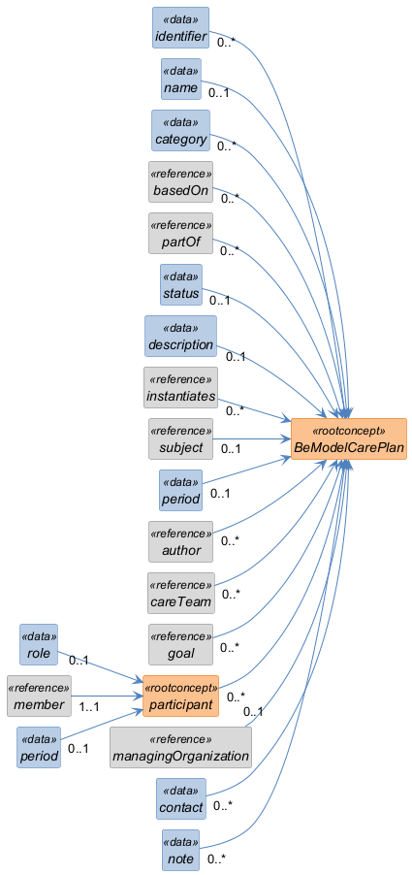

Structure
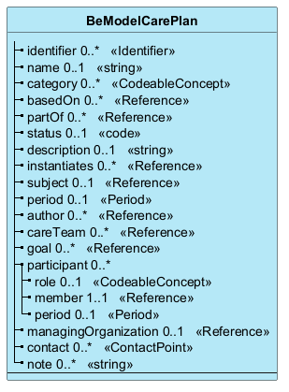

Elements
Element | Card. | Type | Value set | Description
identifier | 0..* | Identifier |  | Identifiers assigned to this care plan
name | 0..1 | string |  | Human-readable name for the care plan
category | 0..* | CodeableConcept |  | Type of plan
basedOn | 0..* | Reference |  | Care plans that this care plan is based on
partOf | 0..* | Reference |  | Care plans that this care plan is part of
status | 0..1 | code |  | status of the care plan
description | 0..1 | string |  | Description of the care plan
instantiates | 0..* | Reference |  | Protocol or definition that is instantiated by this care plan
subject | 0..1 | Reference |  | Who care plan is for
period | 0..1 | Period |  | Time period plan covers
author | 0..* | Reference |  | Who is responsible for plan
careTeam | 0..* | Reference |  | Care team assigned to the care plan
goal | 0..* | Reference |  | Expressed goals that this care plan is intended to achieve
participant | 0..* |  |  | Who is involved in the care plan
role | 0..1 | CodeableConcept |  | Type of involvement
member | 1..1 | Reference |  | Who is involved
period | 0..1 | Period |  | Time period of involvement
managingOrganization | 0..1 | Reference |  | Organization responsible for the care plan
contact | 0..* | ContactPoint |  | Contact details for the care plan
note | 0..* | string |  | Comments about the care plan

