BeModelCareTeam
Name | BeModelCareTeam
Title | BeModelCareTeam
Canonical URL | https://www.ehealth.fgov.be/standards/fhir/patient-care/StructureDefinition/BeModelCareTeam
Version | 1.1.0
Status | active
Parent model | Base
Publisher | eHealth Platform

Logical model for Care Teams.

Class diagram
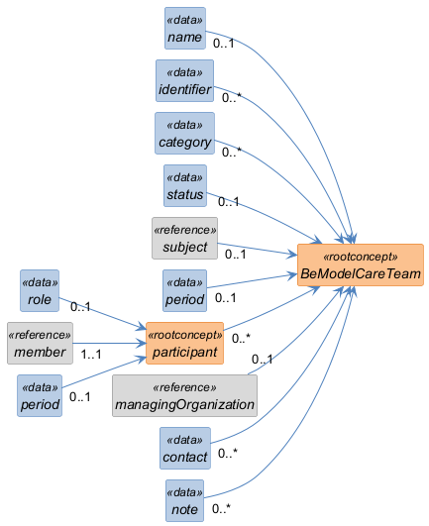

Structure
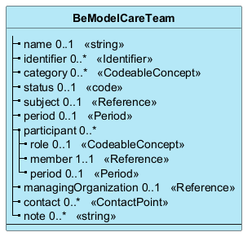

Elements
Element | Card. | Type | Value set | Description
name | 0..1 | string |  | Name of the care team
identifier | 0..* | Identifier |  | Business identifiers of the care team
category | 0..* | CodeableConcept |  | Type of team
status | 0..1 | code |  | Status of the care team
subject | 0..1 | Reference |  | the subject of care for the care team
period | 0..1 | Period |  | Time period of the care team
participant | 0..* |  |  | Members of the care team
role | 0..1 | CodeableConcept |  | Role of the team member
member | 1..1 | Reference |  | Who is involved
period | 0..1 | Period |  | Time period of the membership
managingOrganization | 0..1 | Reference |  | Organization responsible for the care team
contact | 0..* | ContactPoint |  | Contact details for the care team
note | 0..* | string |  | Additional notes

