BeDocument model
Name | BeModelDocument
Title | BeDocument model
Canonical URL | https://www.ehealth.fgov.be/standards/fhir/patient-dossier/StructureDefinition/BeModelDocument
Version | 1.0.0
Status | active
Parent model | Base
Publisher | eHealth Platform

Generic logical model for a FHIR document structuring and containing caresets.

Class diagram
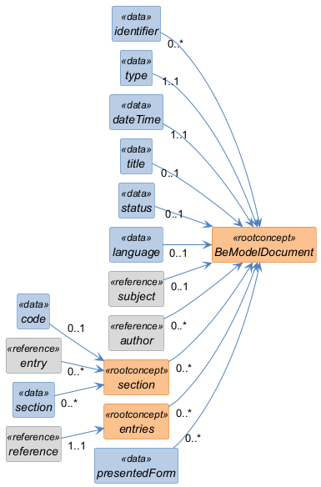

Structure
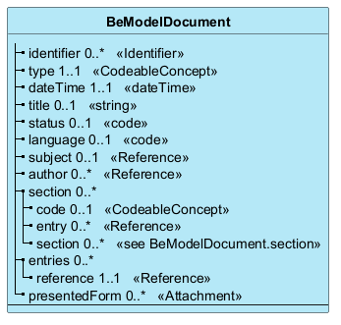

Elements
Element | Card. | Type | Value set | Description
identifier | 0..* | Identifier |  | Document identifier
type | 1..1 | CodeableConcept |  | Document type
dateTime | 1..1 | dateTime |  | Document date/time
title | 0..1 | string |  | Title
status | 0..1 | code |  | Status
language | 0..1 | code |  | Language
subject | 0..1 | Reference |  | Subject
author | 0..* | Reference |  | Author(s)
section | 0..* |  |  | Document content sections
code | 0..1 | CodeableConcept |  | Section classification
entry | 0..* | Reference |  | Referenced resources  FHIR references to CareSets, e.g. CarePlan/1, Observation/2
section | 0..* | see BeModelDocument.section |  | Child sections
entries | 0..* |  |  | Entries (CareSets) in the document
reference | 1..1 | Reference |  | FHIR reference (e.g., CarePlan/1, Observation/2)
presentedForm | 0..* | Attachment |  | A narrative easy-to-read representation of the full data set, e.g. PDF-version of a document

