BeModelPatientWill
Name | BeModelPatientWill
Title | BeModelPatientWill
Canonical URL | https://www.ehealth.fgov.be/standards/fhir/patientwill/StructureDefinition/BeModelPatientWill
Version | 1.0.0
Status | active
Parent model | Base
Publisher | eHealth Platform

Logical model of the patient will

Class diagram
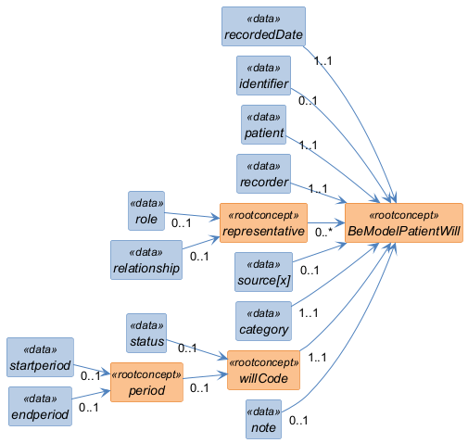

Structure
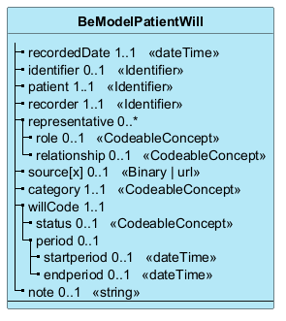

Elements
Element | Card. | Type | Value set | Description
recordedDate | 1..1 | dateTime |  | Date of encoding of the information
identifier | 0..1 | Identifier |  | Unique identifier
patient | 1..1 | Identifier |  | Is the patient's unique identifier. The unique identifier must be the patient's national patient registry number (NISS) or BIS number.
recorder | 1..1 | Identifier |  | Is the unique identifier of either the healthcare professional responsible for the encrypted content, or the patient encoding his or her own wishes, or a representative of the patient encoding the patient's wishes. The unique identifier must be the National Register Number (NISS) or BIS number.
representative | 0..* |  |  | The representative is the person who acts on behalf of the applicant (patient) when he is no longer able to express his wishes. For example: the confidant is the person who guides the patient through his steps and assists him during medical appointments. He guarantees the follow-up of the wishes of the patient when he can no longer express his wishes clearly.
role | 0..1 | CodeableConcept |  | Role of the representative (e.g. confidant, administrator, guardian...)
relationship | 0..1 | CodeableConcept |  | Type of relationship of the representative with the patient (e.g. father, mother, son, neighbour...)
source[x] | 0..1 | Binary | url |  | Enables you to attach a document
category | 1..1 | CodeableConcept |  | Type of patient wishes.
willCode | 1..1 |  |  | patient's wishes  The patient's wishes (euthanasia, no vaccination, no intubation...)
status | 0..1 | CodeableConcept |  | Indicates the status of the patient's will (draft, proposes, active, ...)
period | 0..1 |  |  | Validity of the will
startperiod | 0..1 | dateTime |  | Date the will comes into effect
endperiod | 0..1 | dateTime |  | Date the will expires
note | 0..1 | string |  | Comments

