Logical model for population screening plan
Name | BeModelPopulationScreeningPlan
Title | Logical model for population screening plan
Canonical URL | https://www.ehealth.fgov.be/standards/fhir/public-health/StructureDefinition/BeModelPopulationScreeningPlan
Version | 1.0.3
Status | active
Parent model | Element
Publisher | eHealth Platform

Logical model for recurrent population based screening. This model represents a screening plan for a patient for a given cancer type.

Class diagram
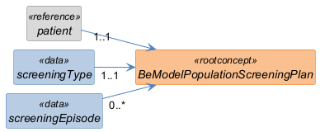

Structure
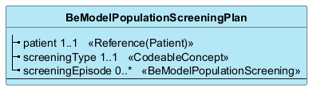

Elements
Element | Card. | Type | Value set | Description
patient | 1..1 | Reference(Patient) |  | The patient for the screening
screeningType | 1..1 | CodeableConcept |  | The related screening  The related screening, for example breast cancer, colon cancer or cervicalcancer.
screeningEpisode | 0..* | BeModelPopulationScreening |  | Each screening event - actual screening or missed scheduled screening

