BeProcedure Model
Name | BeModelProcedure
Title | BeProcedure Model
Canonical URL | https://www.ehealth.fgov.be/standards/fhir/core-clinical/StructureDefinition/BeModelProcedure
Version | 1.3.0
Status | active
Parent model | Base
Publisher | eHealth Platform

Procedure logical model

Class diagram
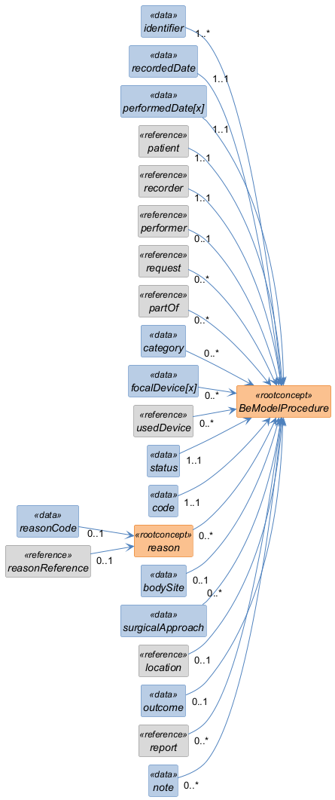

Structure
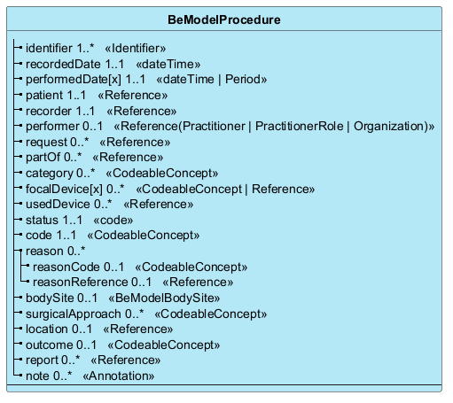

Elements
Element | Card. | Type | Value set | Description
identifier | 1..* | Identifier |  | Unique identifier for the procedure
recordedDate | 1..1 | dateTime |  | Date of the last modification/recording of the procedure
performedDate[x] | 1..1 | dateTime | Period |  | Date or period when the procedure was actually performed  Date or period when the procedure was actually performed. For example: the date of an operation or the period during which a treatment was carried out
patient | 1..1 | Reference |  | The patient that is the subject of the procedure.  The patient that is the subject of the procedure. This includes the patient's Social Security Identification Number (NISS), generally corresponding to the national registry number. In some cases, another unique identification code may be authorized, such as the BIS number
recorder | 1..1 | Reference |  | Person, organization or device that recorded the procedure.  Person, organization or device that recorded the procedure. For a healthcare provider, this is the Social Security Identification Number (NISS). For an organization, the Crossroads Bank for Social Security (BCSS) number is used. For a medical device, use the unique device identification number
performer | 0..1 | Reference(Practitioner | PractitionerRole | Organization) |  | Person who performed the procedure.  Person who performed the procedure. For a healthcare provider, this is the Social Security Identification Number (NISS). For an organization, the BCSS number is used. For a medical device, use the unique device identification number
request | 0..* | Reference |  | CarePlan and/or Referral Prescription that is at the origin of the procedure. For example: a physiotherapy session performed on prescription from the general practitioner
partOf | 0..* | Reference |  | Part of the event being referenced: procedure, observation (symptoms) or problem (disease). For example: Blood draw (procedure) is part of the diagnostic observation (Observation)
category | 0..* | CodeableConcept |  | Type or nature of the procedure. For example: surgical, psychiatric or chiropractic procedures
focalDevice[x] | 0..* | CodeableConcept | Reference |  | Implanted or manipulated device
usedDevice | 0..* | Reference |  | Devices or materials used temporarily during the procedure. For example: surgical robot, intraoperative imaging, neuronavigation. This also includes substances such as gels. Standard small instruments such as scalpels and syringes are not recorded
status | 1..1 | code |  | Procedure status (not-done, stopped, completed, entered-in-error). Note: 'not-done' is out of scope as it implies planning. Business Rule: 'completed' by default
code | 1..1 | CodeableConcept |  | Identification of the procedure (SNOMED-CT Procedure concept)
reason | 0..* |  |  | Reason why the procedure is performed. For example: amputation after an accident, broken leg
reasonCode | 0..1 | CodeableConcept |  | Coded reason why the procedure is performed
reasonReference | 0..1 | Reference |  | Reference to the condition, observation or procedure that is the reason
bodySite | 0..1 | BeModelBodySite |  | The site on the patient's body where the procedure was performed
surgicalApproach | 0..* | CodeableConcept |  | Indicates by which anatomical route or according to which technique the procedure was performed. For example: laparoscopic, endoscopic, percutaneous
location | 0..1 | Reference |  | Reference to the location where the procedure was performed. Example: Healthcare provider's office, Patient's home, Hospital, Outpatient, other
outcome | 0..1 | CodeableConcept |  | Result of the procedure execution. Example: Partial success, Success, Unsuccessful
report | 0..* | Reference |  | Any report resulting from the procedure. To be discussed (In version 1: attached document (pdf, URL, jpg, etc.). In the future possibly reference to a DiagnosticReport or other)
note | 0..* | Annotation |  | Additional information about the procedure

