BeModelEAgreementResponse
Name | BeModelEAgreementResponse
Title | BeModelEAgreementResponse
Canonical URL | https://www.ehealth.fgov.be/standards/fhir/mycarenet/StructureDefinition/be-model-eagreement-response
Version | 2.2.0
Status | active
Parent model | Element
Publisher | eHealth Platform

Class diagram
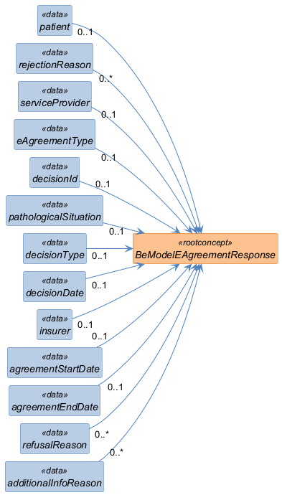

Structure
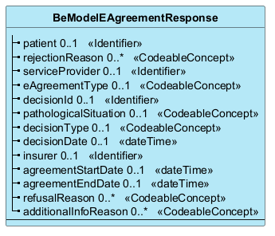

Elements
Element | Card. | Type | Value set | Description
patient | 0..1 | Identifier |  | Patient identification
rejectionReason | 0..* | CodeableConcept |  | Reason for rejection
serviceProvider | 0..1 | Identifier |  | NIHDI number of the service provider/institution responsible for the request
eAgreementType | 0..1 | CodeableConcept |  | Identification of the type of agreement (ex: Fb)
decisionId | 0..1 | Identifier |  | Identifier of the decision communicated by the insurer organization
pathologicalSituation | 0..1 | CodeableConcept |  | Codification of the pathological situation referring to existing notification/request forms (eg: Fb-51)
decisionType | 0..1 | CodeableConcept |  | Current decision of the request (ex: 'in process')
decisionDate | 0..1 | dateTime |  | Latest decision date (including if in process or request for info)
insurer | 0..1 | Identifier |  | Insurer organization responsible for the message (3 positions)
agreementStartDate | 0..1 | dateTime |  | Agreement start date (dd/mm/yyyy)
agreementEndDate | 0..1 | dateTime |  | Agreement end date (dd/mm/yyyy)
refusalReason | 0..* | CodeableConcept |  | Reason for refusal (code with optional additional description)
additionalInfoReason | 0..* | CodeableConcept |  | Reason for the request of additional information

