Problem Logical Model
Name | BeModelProblem
Title | Problem Logical Model
Canonical URL | https://www.ehealth.fgov.be/standards/fhir/core-clinical/StructureDefinition/BeModelProblem
Version | 1.3.0
Status | active
Parent model | Base
Publisher | eHealth Platform

Logical model for Problem

Class diagram
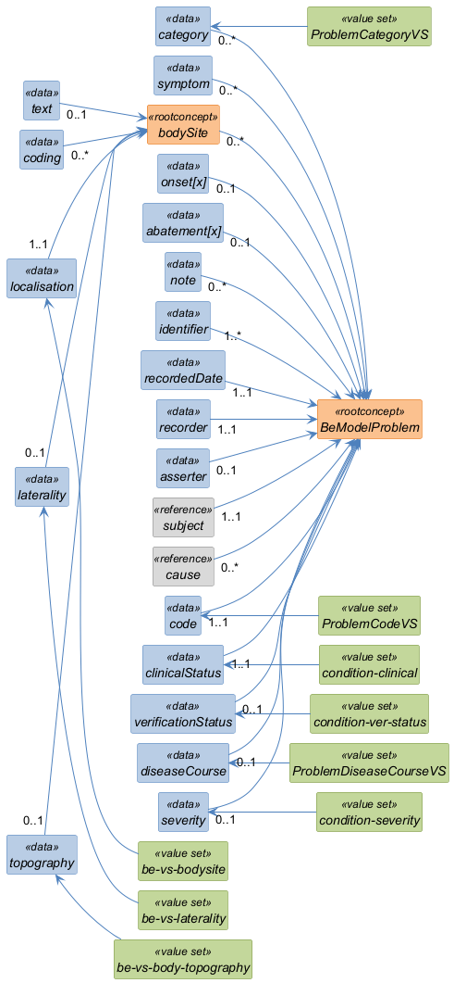

Structure
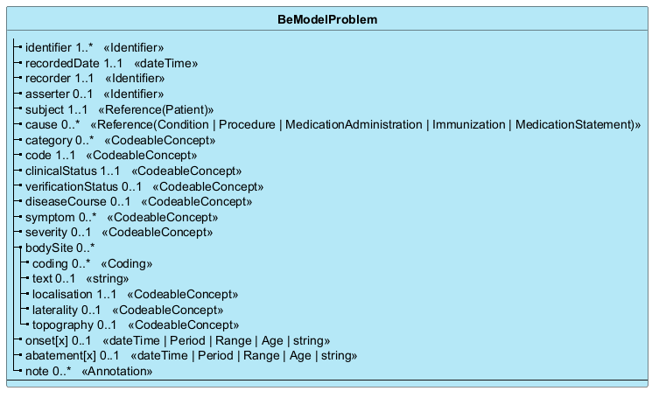

Elements
Element | Card. | Type | Value set | Description
identifier | 1..* | Identifier |  | Business Identifier  Unique identifier of the problem
recordedDate | 1..1 | dateTime |  | Recorded Date  Date of last modification of the information by the recorder
recorder | 1..1 | Identifier |  | Recorder  The healthcare professional responsible for the content (ideally identified by the NISS)
asserter | 0..1 | Identifier |  | Asserter  The person asserting the information (e.g., patient, practitioner, parent; ideally identified by the NISS)
subject | 1..1 | Reference(Patient) |  | Patient  Reference or Identifier to the patient (ideally identified by the NISS)
cause | 0..* | Reference(Condition | Procedure | MedicationAdministration | Immunization | MedicationStatement) |  | Cause  Reference to the primary cause of the problem (procedure, medication administration, or other condition)
category | 0..* | CodeableConcept | ProblemCategoryVS | Category  Thematic category of the problem
code | 1..1 | CodeableConcept | ProblemCodeVS | Code  Identification of the problem - in SNOMED-CT
clinicalStatus | 1..1 | CodeableConcept | condition-clinical | Clinical Status  Clinical status of the problem (active, inactive, resolved, etc.)
verificationStatus | 0..1 | CodeableConcept | condition-ver-status | Verification Status  Degree of certainty associated with the problem (confirmed, suspected, etc.)
diseaseCourse | 0..1 | CodeableConcept | ProblemDiseaseCourseVS | Course of Disease  Course of disease evolution (acute, chronic, fulminant, etc.)
symptom | 0..* | CodeableConcept |  | Symptom  Symptoms recorded in the context of this problem
severity | 0..1 | CodeableConcept | condition-severity | Severity  Degree of severity of the problem
bodySite | 0..* |  |  | Body Site  Anatomical site(s) where the problem is active
coding | 0..* | Coding |  | Code defined by a terminology system  A reference to a code defined by a terminology system.
text | 0..1 | string |  | Plain text representation of the concept  A human language representation of the concept as seen/selected/uttered by the user who entered the data and/or which represents the intended meaning of the user.
localisation | 1..1 | CodeableConcept | be-vs-bodysite | Body Localisation  Specific location on the body if not implied by the code
laterality | 0..1 | CodeableConcept | be-vs-laterality | Body Laterality  Laterality of the affected body site (right, left, both)
topography | 0..1 | CodeableConcept | be-vs-body-topography | Body Topography  Topography of the affected body site (e.g., upper arm, lower leg, etc.)
onset[x] | 0..1 | dateTime | Period | Range | Age | string |  | Onset  Moment the problem began
abatement[x] | 0..1 | dateTime | Period | Range | Age | string |  | Abatement  Moment the problem went into remission
note | 0..* | Annotation |  | Note  Additional notes pertaining to the problem

