BeModelVaccinationReduced
Name | BeModelVaccinationReduced
Title | BeModelVaccinationReduced
Canonical URL | https://www.ehealth.fgov.be/standards/fhir/vaccination/StructureDefinition/be-model-vaccination-reduced
Version | 1.1.3
Status | active
Parent model | Element
Publisher | eHealth Platform

Reduced Logical Model for vaccination

Class diagram
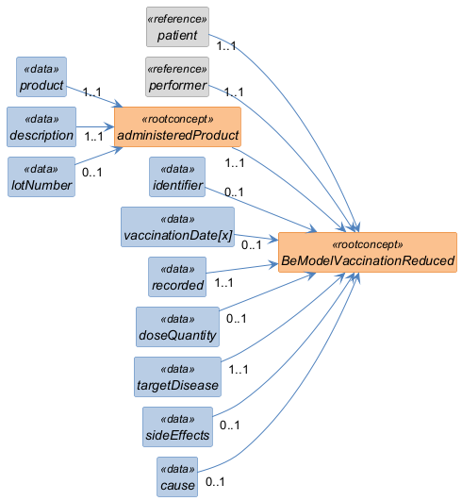

Structure
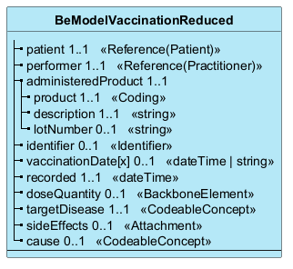

Elements
Element | Card. | Type | Value set | Description
patient | 1..1 | Reference(Patient) |  | The patient that received vaccination.  The patient that has received the vaccination.
performer | 1..1 | Reference(Practitioner) |  | The professional that administered the medication  The professional that administered the medication. Use code "unknown" if not known.
administeredProduct | 1..1 |  |  | The details of the product that was administered.  The details of the product that was administered
product | 1..1 | Coding |  | The code of the product that was administered.  The code of the product that was administered. This can be just text (not desired), or a code (e.g. 1696392 = Neisvac C Dos 0,5ml).
description | 1..1 | string |  | The description of the product that was administered.
lotNumber | 0..1 | string |  | The lot number
identifier | 0..1 | Identifier |  | The business identifier(s) for the vaccination entry  The business identifier(s) for the vaccination entry - This is an optional attribute, used for example to track an entry throughout its lifecycle, or across vaults.
vaccinationDate[x] | 0..1 | dateTime | string |  | The date and time when the vaccination has been administered  The date and/or time when the vaccine administration has been administered or presumed to be administered
recorded | 1..1 | dateTime |  | The date and time when the administration of the vaccine was recorded  The date and time when the administration of the vaccine was recorded - typically used when the vaccine event is recorded a posteriori.
doseQuantity | 0..1 | BackboneElement |  | The number or quantity of product(s) that was administered - e.g. 1/2 dose  The number or quantity of product(s) that was administered - e.g. 1/2 dose, etc.
targetDisease | 1..1 | CodeableConcept |  | The target disease for this vaccination.
sideEffects | 0..1 | Attachment |  | Any noted side effect from this vaccination.
cause | 0..1 | CodeableConcept |  | Is the vaccination due to pre or post exposition prophylaxis?

