Medication Line (model)
Name | MedicationLine
Title | Medication Line (model)
Canonical URL | https://www.ehealth.fgov.be/standards/fhir/medication/StructureDefinition/BeModelMedicationLine
Version | 1.1.1
Status | active
Parent model | Base
Publisher | eHealth Platform

Logical data model for medication line.

Class diagram
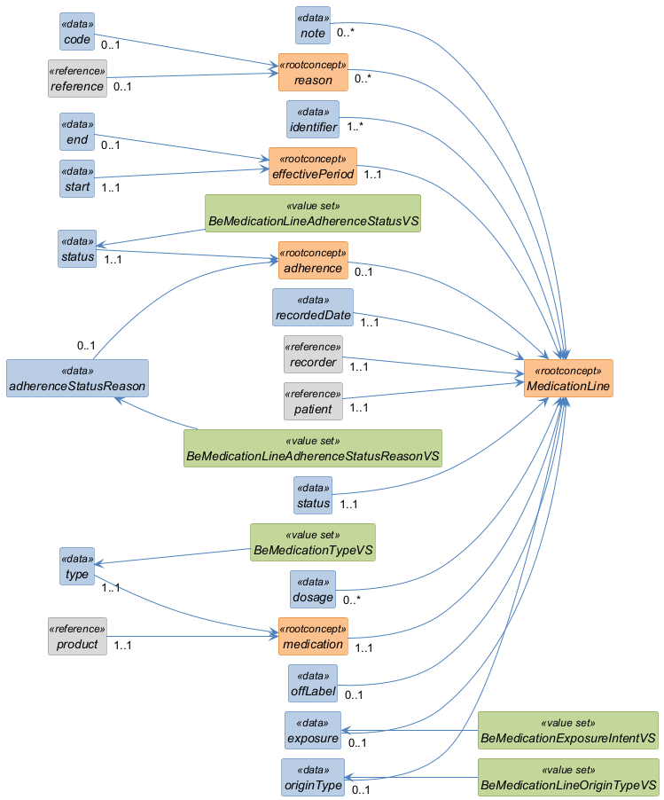

Structure
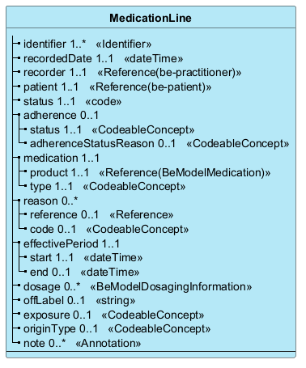

Elements
Element | Card. | Type | Value set | Description
identifier | 1..* | Identifier |  | Unique identifier  A unique identifier for the medication line. This identifier alone may be the same for different versions of the medication line.
recordedDate | 1..1 | dateTime |  | Timestamp the medication line content was recorded or last updated.
recorder | 1..1 | Reference(be-practitioner) |  | Recorder
patient | 1..1 | Reference(be-patient) |  | Patient
status | 1..1 | code |  | Status of the line entry
adherence | 0..1 |  |  | Whether the patient is known to be taking the medication
status | 1..1 | CodeableConcept | BeMedicationLineAdherenceStatusVS | The status - taking, not taking,...
adherenceStatusReason | 0..1 | CodeableConcept | BeMedicationLineAdherenceStatusReasonVS | Reason for the adherence status
medication | 1..1 |  |  | The product or substance
product | 1..1 | Reference(BeModelMedication) |  | Product reference, identifier or name
type | 1..1 | CodeableConcept | BeMedicationTypeVS | Type of medication - magistral, medicinal product, non-medicinal product
reason | 0..* |  |  | Reason for the medication treatment
reference | 0..1 | Reference |  | Reference to existing condition or reason
code | 0..1 | CodeableConcept |  | Code of the condition, or free text
effectivePeriod | 1..1 |  |  | Period of medication treatment
start | 1..1 | dateTime |  | The begin of the medication line
end | 0..1 | dateTime |  | The end of the medication line
dosage | 0..* | BeModelDosagingInformation |  | Structured Dosage
offLabel | 0..1 | string |  | Reason for Off-label use or dosage override
exposure | 0..1 | CodeableConcept | BeMedicationExposureIntentVS | Therapeutic, Prophylactic
originType | 0..1 | CodeableConcept | BeMedicationLineOriginTypeVS | The origin of the line - hospital, ambulatory
note | 0..* | Annotation |  | A note captured by a professional

